**DevOps Project1**  
  
Description:  
In this project we will create Jenkins pipeline to deploy a code change related to a java application to change the background of the app.  
  
Requirements:

|  |  |  |
| --- | --- | --- |
| No of VMs | Server Type | Tools / Services |
| 2 | Jenkins Master and Slave |  |
| 1 | SonarQube |  |
| 1 | Nexus Repository |  |
| 2 | K8s 1 Master 2 Slave Nodes |  |
|  |  | Aqua Trivia for Docker image scan. |
|  |  | OWASP for Dependency check. |

1. Creation of VMs: We will create 3 VMs initially for Jenkins, SonarQube and Nexus.
2. Follow the instructions below.
3. Login to AWS > Go to EC2 > Click on Instances > Launch 3 instances with below shown detail.

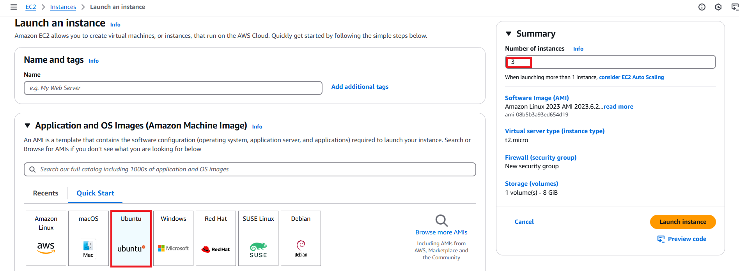

1. Choose the below shown options.  
   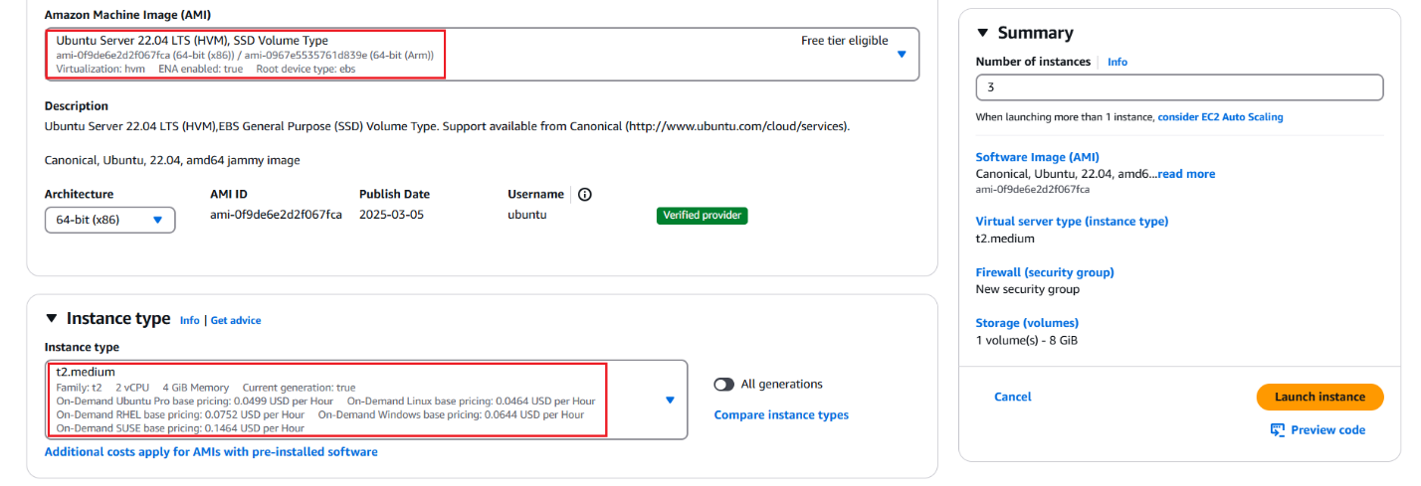
2. Create new keypair and create new SG or select the existing one.
3. In this project I have created a new one.  
   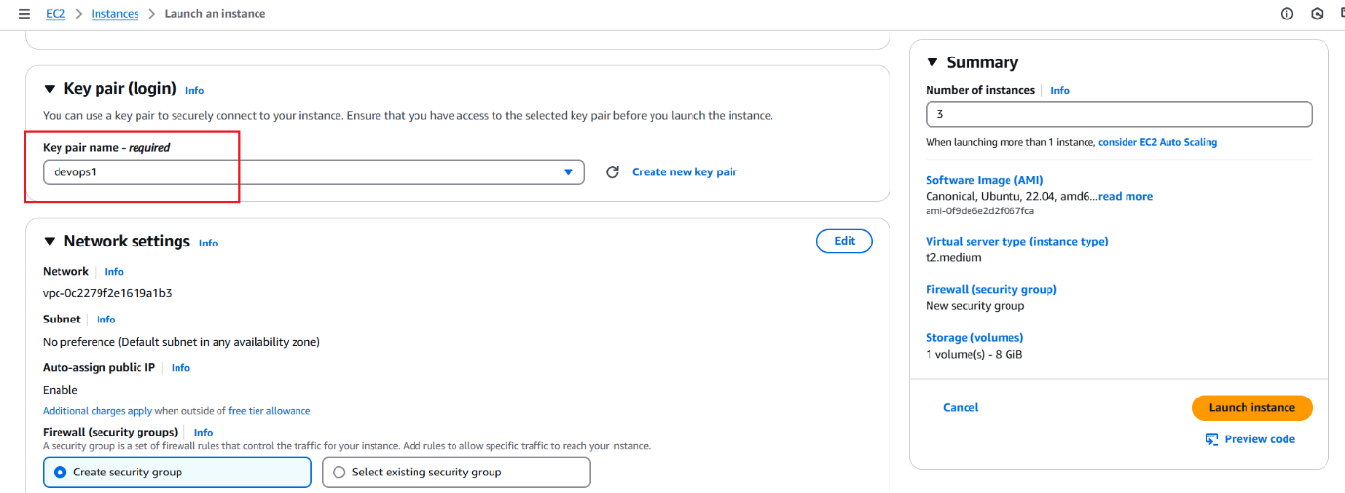
4. Set below shown settings and click on Launch Instance.  
   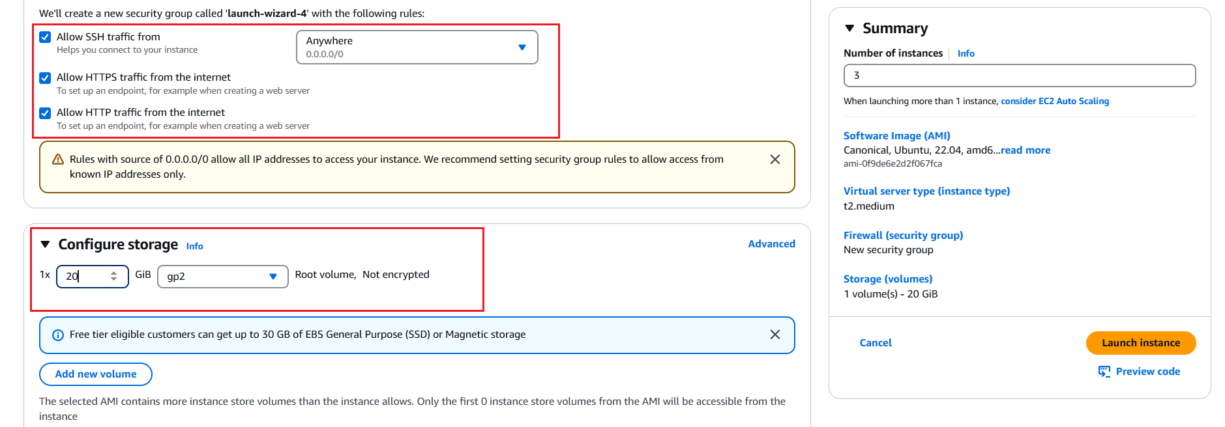
5. Instance creation will complete and you will see this message on the console.  
   
6. Once the instances are ready, we have to name them as shown below.  
   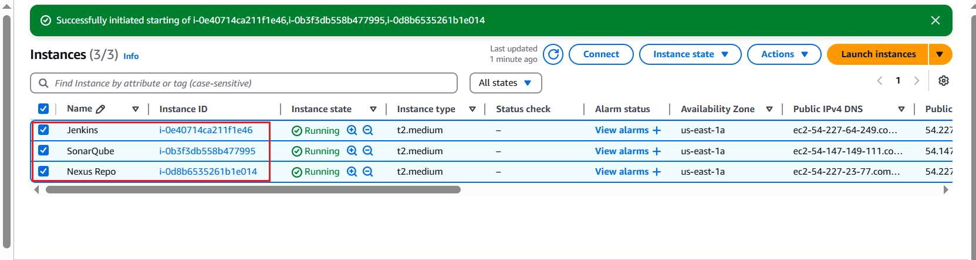
7. Open the Security Group which we are going to use and enable the below shown ports.  
   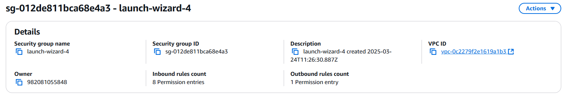  
   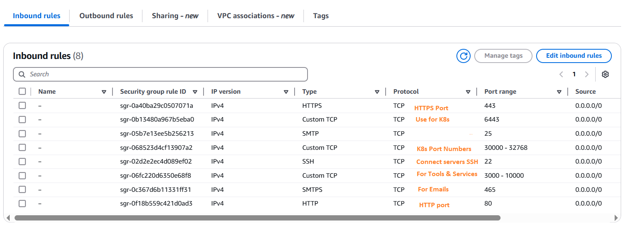
8. Connect to the servers through MobaXterm.
9. Download home edition and install it on your machine.
10. After download, now connect like shown below.
11. Click on Sessions > SSH  
    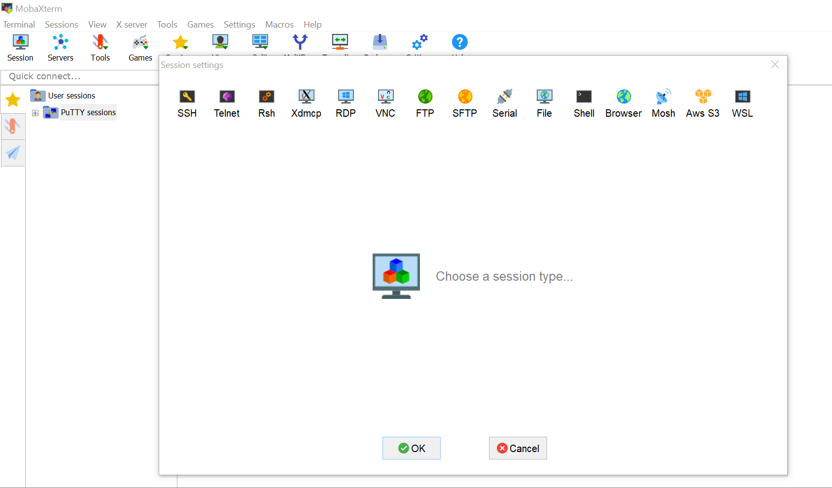
12. Add Public IP > Give Username > Select the download .pem key file as shown below.  
    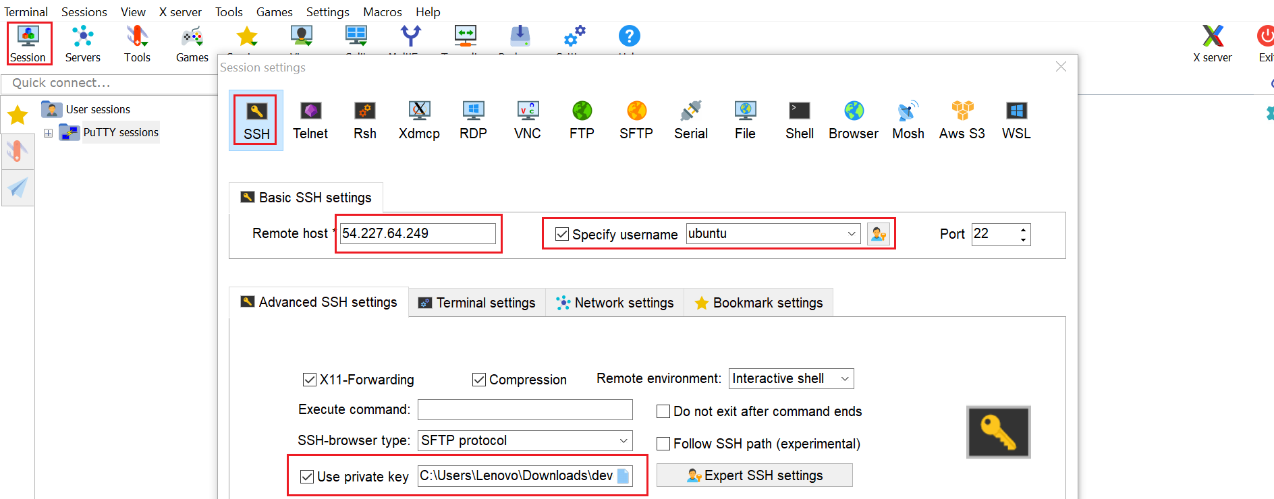  
    
13. Click on OK.
14. The instance will be connected as shown below.  
    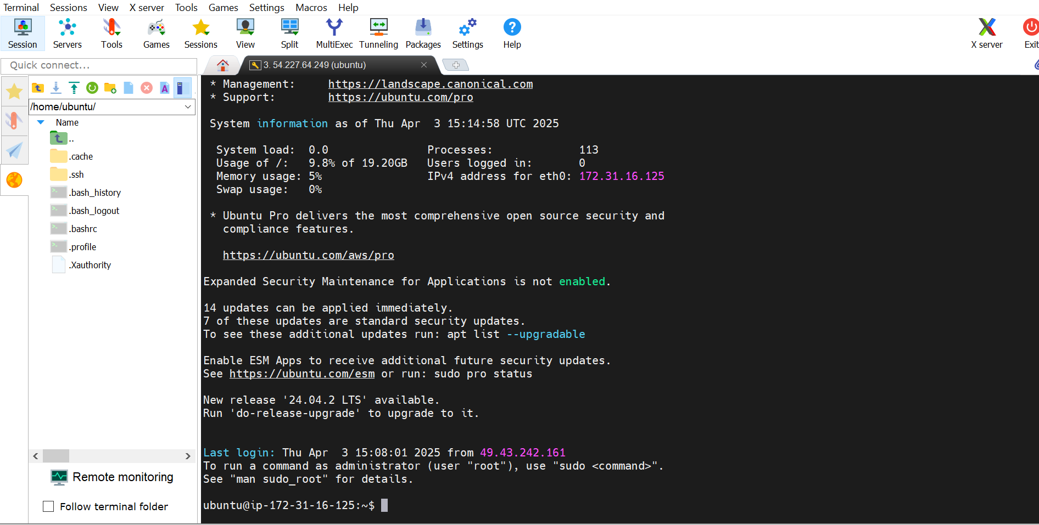
15. Rename the sessions to better understanding and clarity.  
    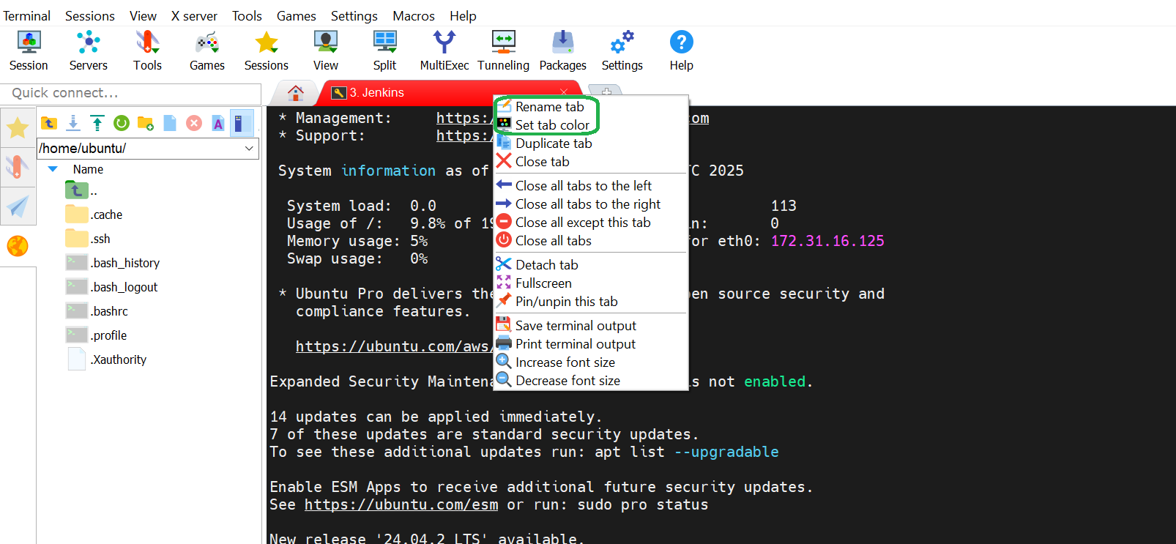
16. Right click Home button on MobaXterm window and then right click on Jenkins session.
17. Click on Duplicate session > Name it to SonarQube > Change the color code > Change Public IP.
18. Same we need to do for Nexus Repository.  
    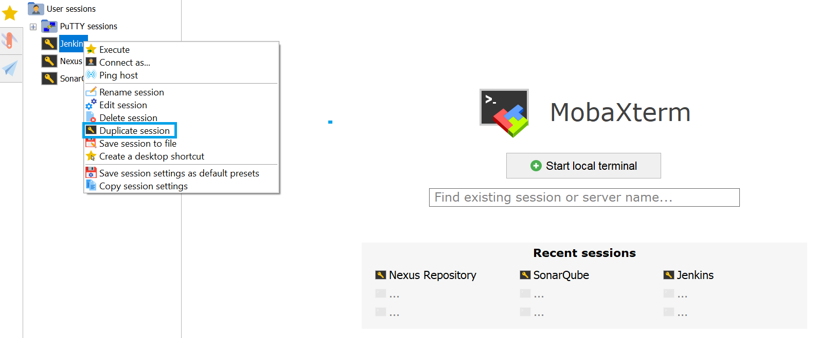
19. Click on Edit session and add values like Public IP and the Color code.

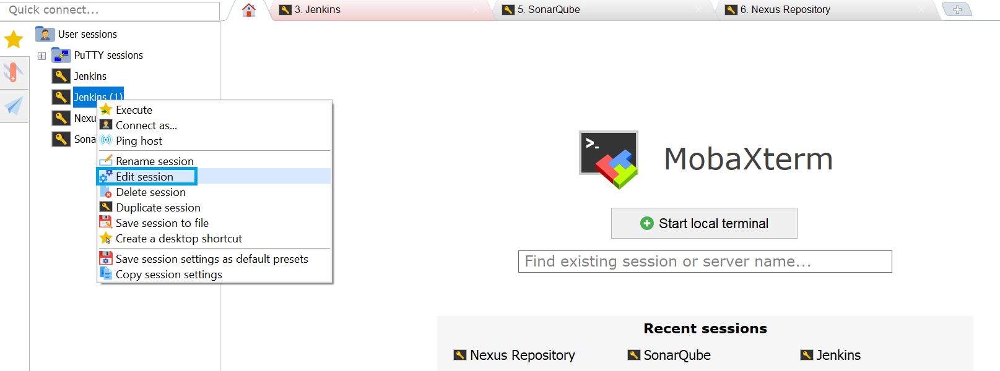

1. Make changes as shown and Click on OK
2. 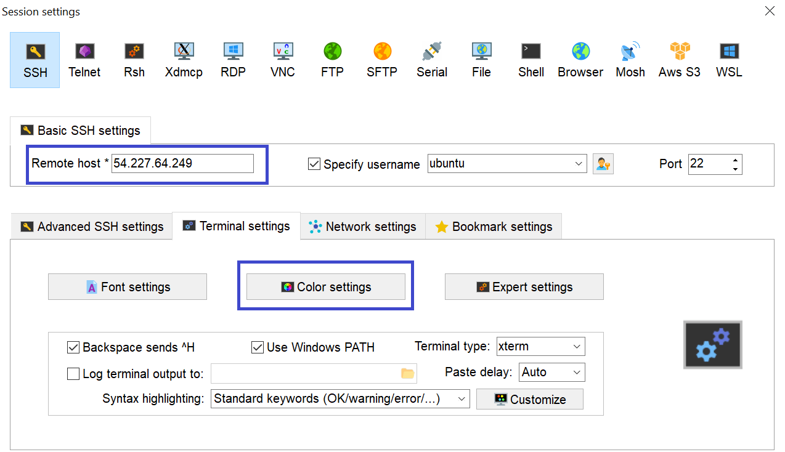  
   
3. Now, we have to start with the installations on each server.
4. Begin with Jenkins, we need “java” as prerequisite.
5. Run the command to check “java” version and if it does not available, then we need to install it.

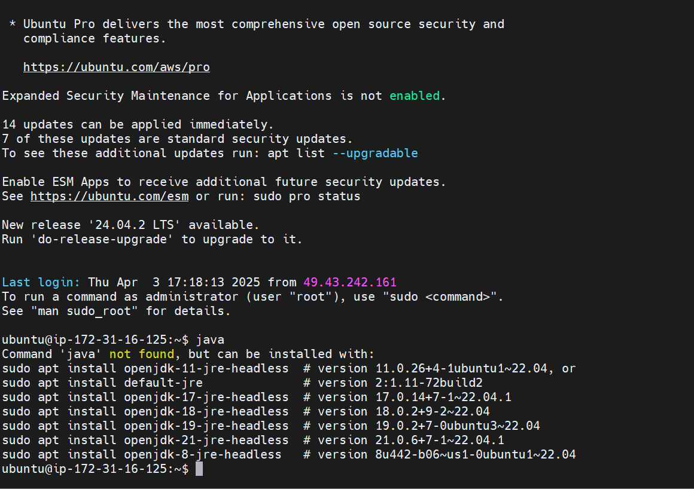

1. “java” is not installed. We have to run below shown command to install “java”.
2. “OpenJDK” is getting deprecated, hence we will install “openjdk-18”.  
   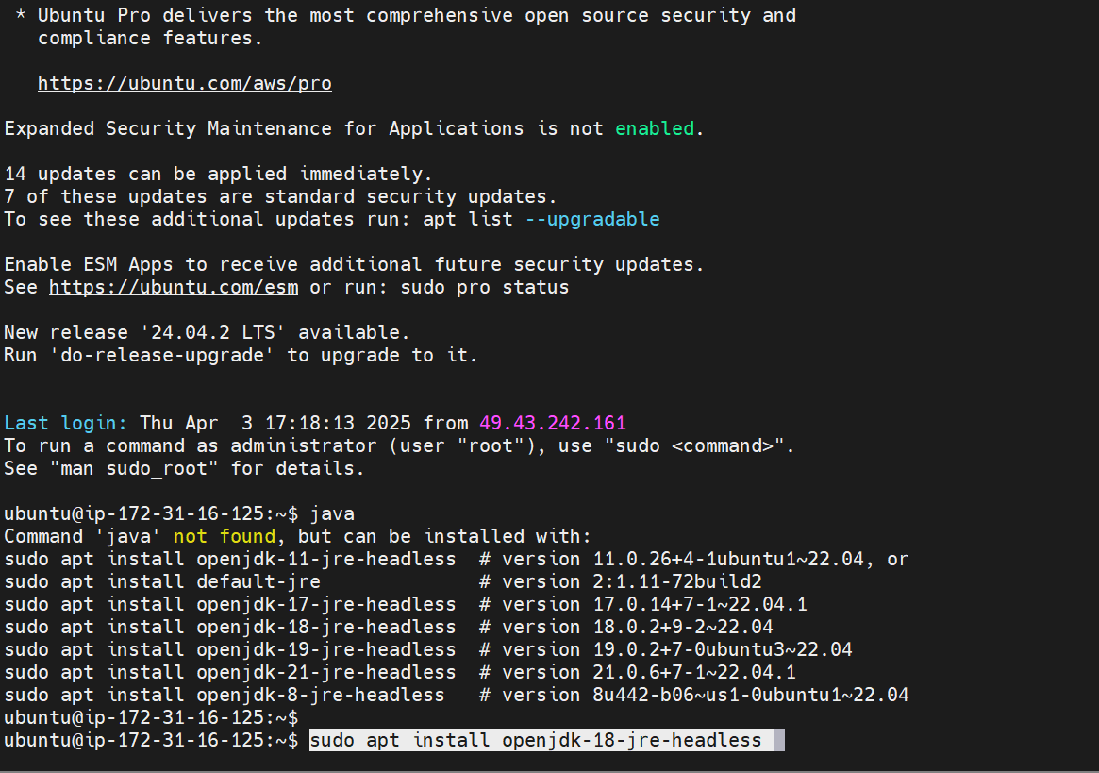
3. Once installation is completed, you will see below image.  
   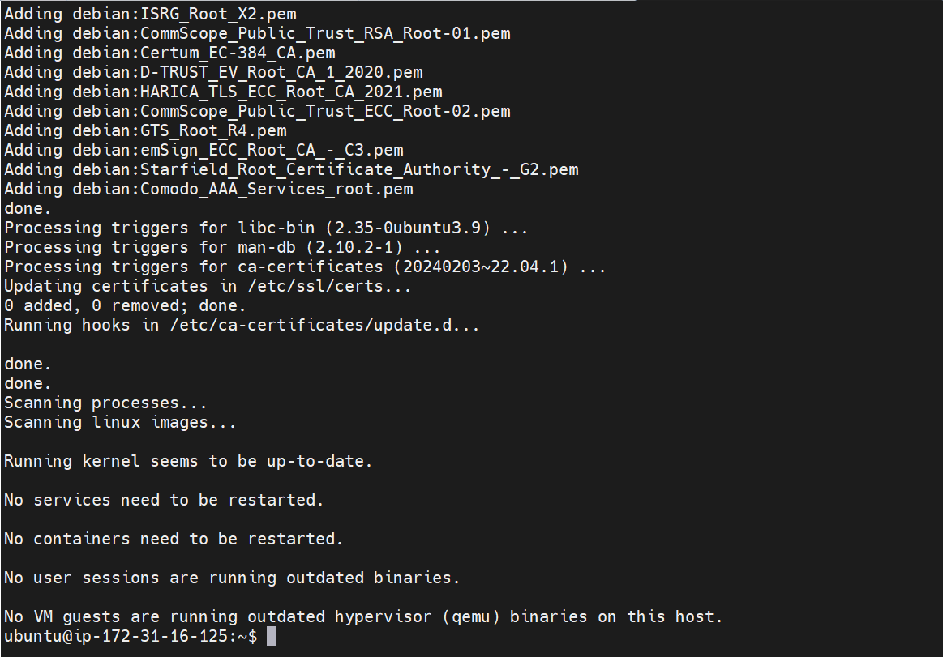  
   **NOTE:** We also need to run “sudo apt update -y” to update all the packages.
4. We will now install Jenkins by following the instructions from the official documentation page.
5. We will follow the instructions for ubuntu OS.
6. This is the official link [**LINK**](https://www.jenkins.io/doc/book/installing/linux/#debianubuntu)

Select the options as shown below > Copy the code and run it as it is in Jenkins server.  
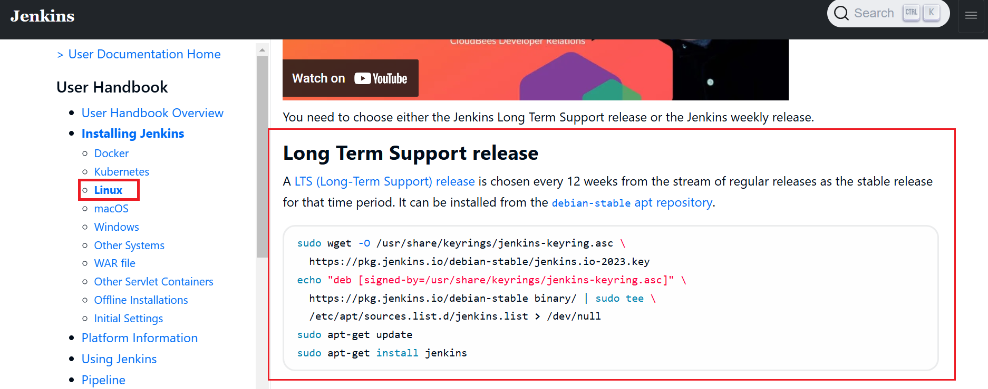  
**NOTE:** Use LTS version. It’s called **Long Time Support release**.  
  
**Jenkins: Installation, Setup & Configuration**

1. Once the installation completes, we will see below output/message on the prompt.  
   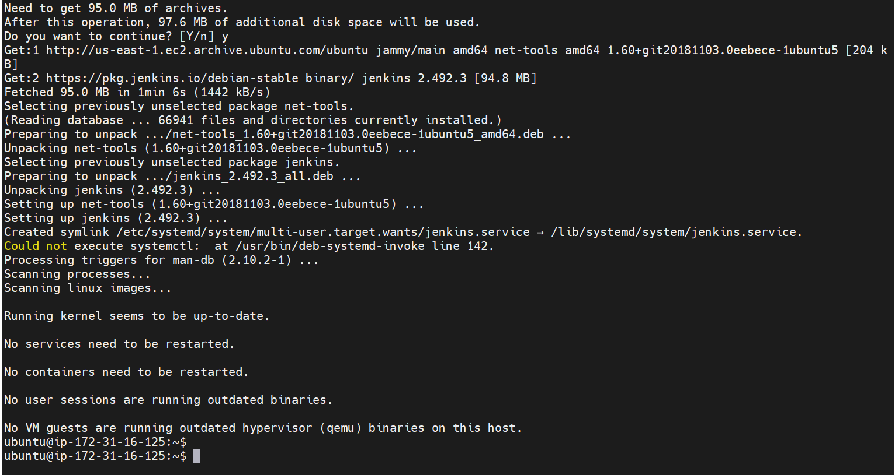
2. Start Jenkins by running the below shown commands.

|  |  |
| --- | --- |
| Enable Jenkins | sudo systemctl enable jenkins |
| Start Jenkins | sudo systemctl start jenkins |
| Check Status Jenkins | sudo systemctl status jenkins |

1. After enabling the Jenkins, when I tried starting Jenkins, I got the below shown error message.  
   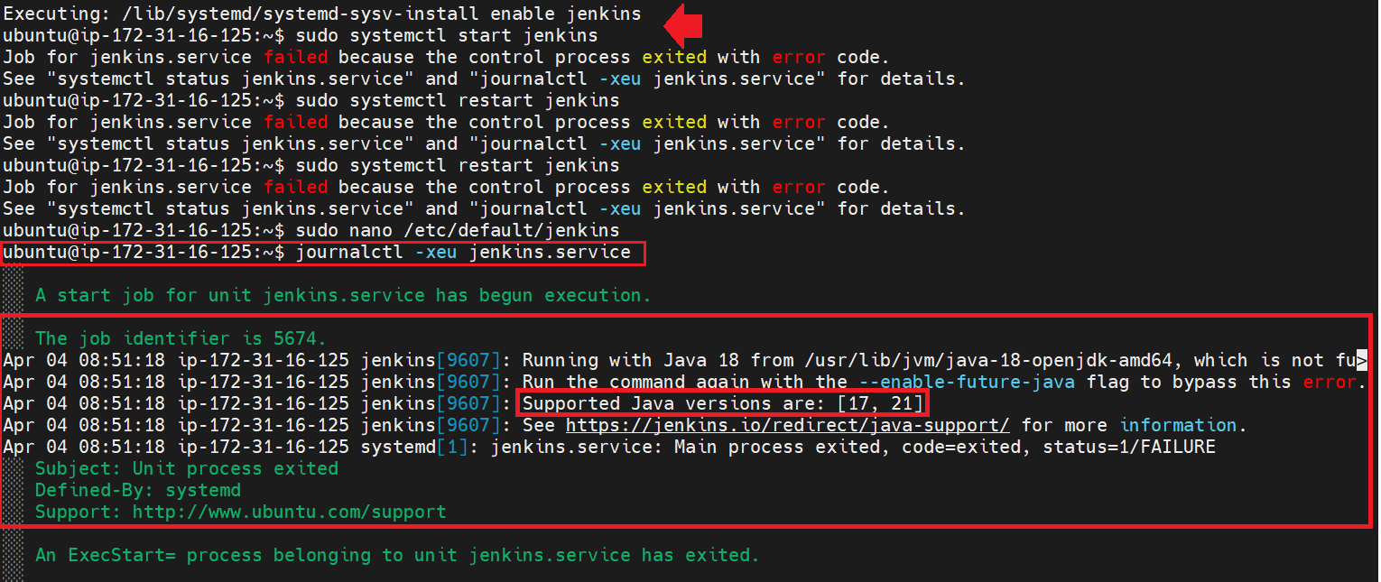
2. To check the exact error, run this command journalctl -xeu jenkins.service. See above image.
3. As per the error, it says the supported version of Java for Jenkins is either 17, 21.
4. So, its suggested to uninstall Java 18 and install Java 17 and try to start Jenkins.
5. I tried below steps to remove/uninstall Java manually.  
     
    (i) Check path for java installation.

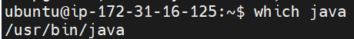  
(ii) cd to the path and ls to check file(s).  
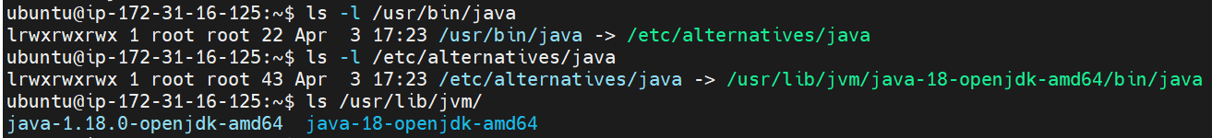

(iii) ran sudo rm -rf command as below to manually delete the jdk 18 folder.

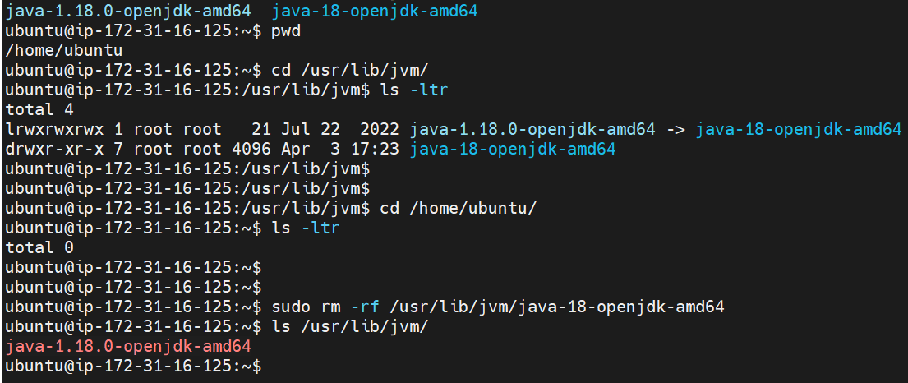

(iv)  
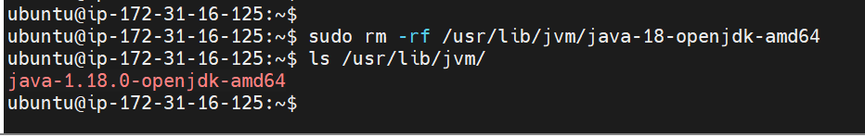

(v) Update system package and install Java 17 as shown below.  
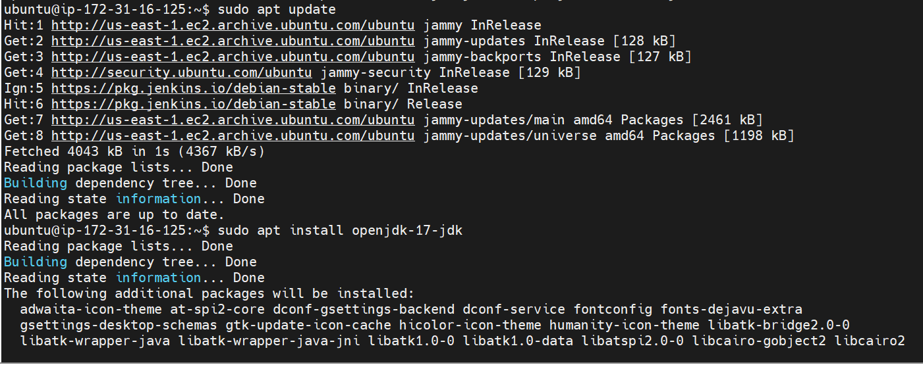

(vi) Check Java version  
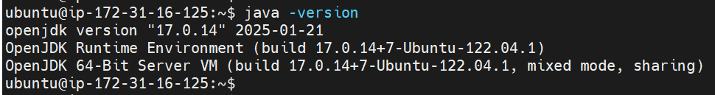

(vii) Enable and start Jenkins and the check the status.  
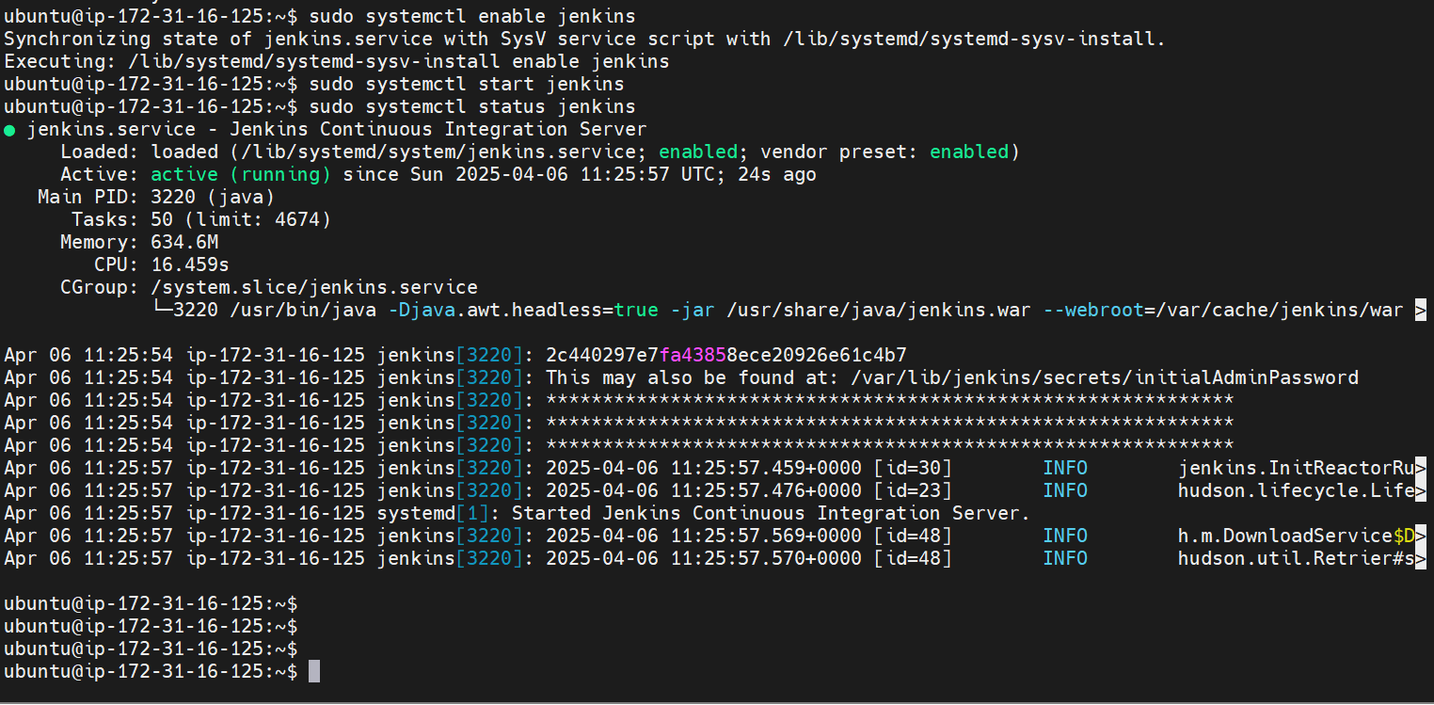

1. Now, Jenkins is up, active and running.  
     
   **NOTE:** **For Jenkins to work, we should either 17 or 21st version.**
2. We will configure Jenkins online, for that copy the Public DNS and use port 8080 to open it.  
   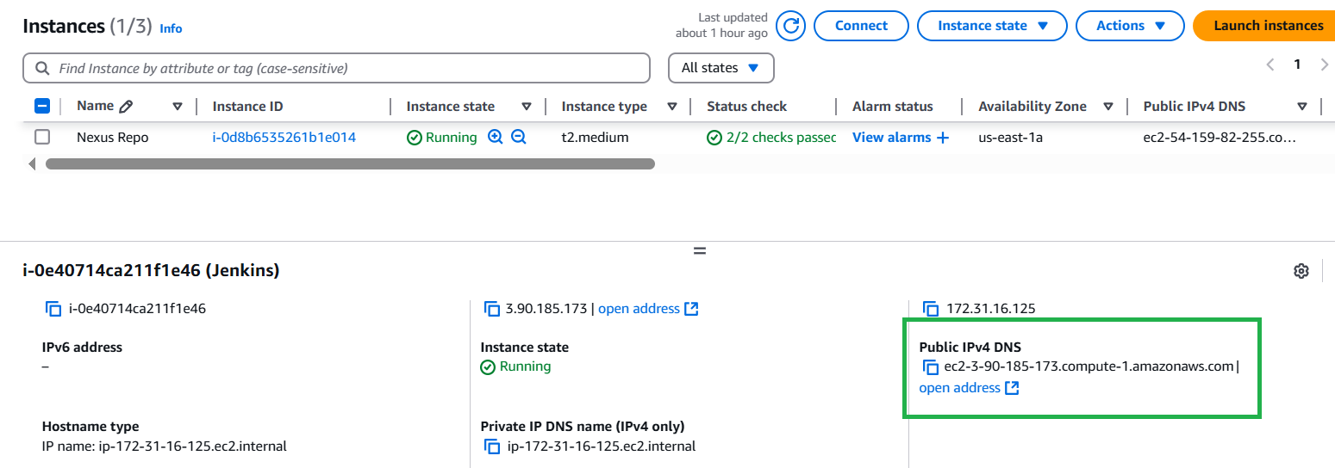
3. The web page will open as shown below.  
   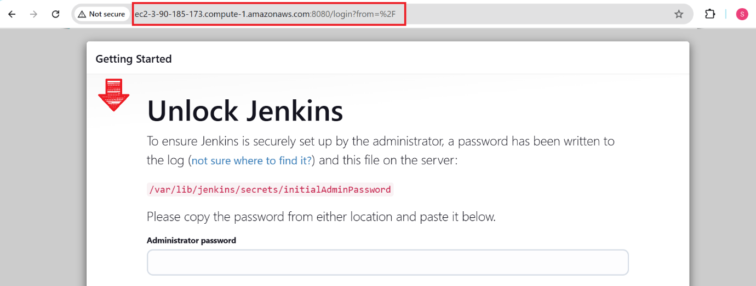
4. Now, we have to navigate to the below shown path and get password from there.  
   /var/lib/jenkins/secrets/initialAdminPassword
5. This is how we can check the password  
   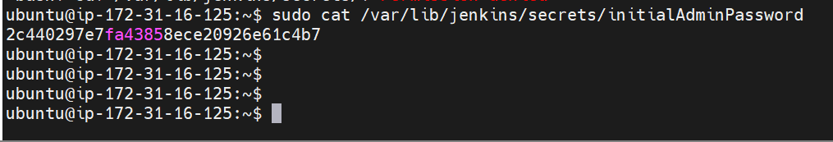
6. Paste the password and click on Continue button.  
   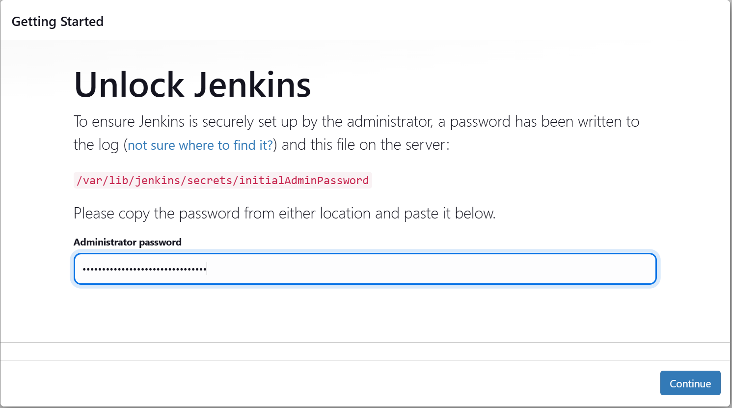
7. Click on “Install Suggested Plugins”  
   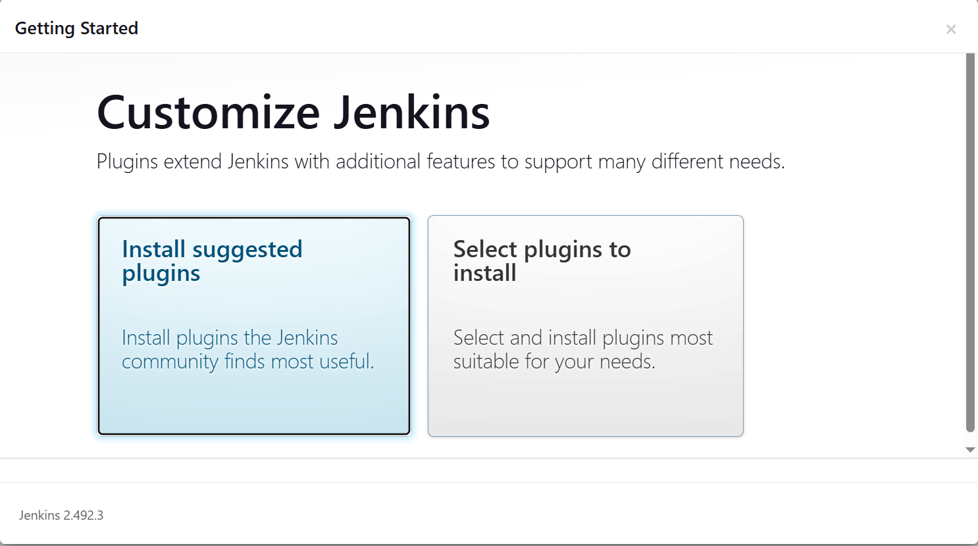
8. It will install all the required plugins in Jenkins.  
   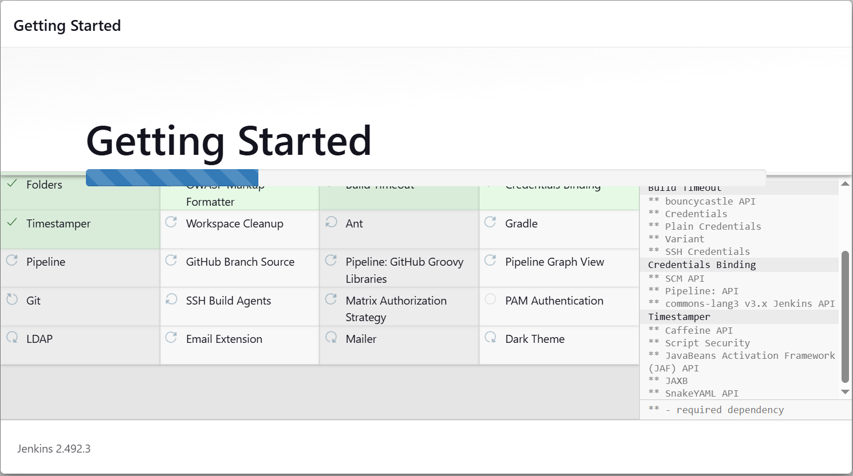
9. After installation we have to setup “username” & “password”  
   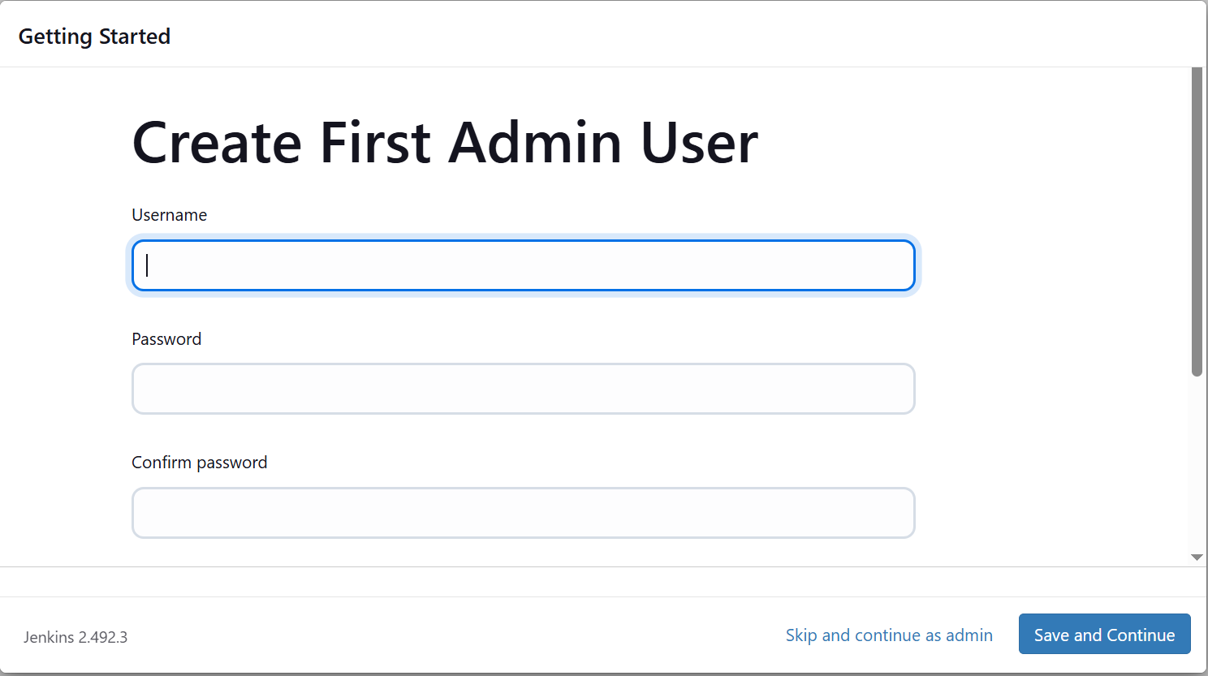
10. Define the credentials and click on Save and Continue.  
    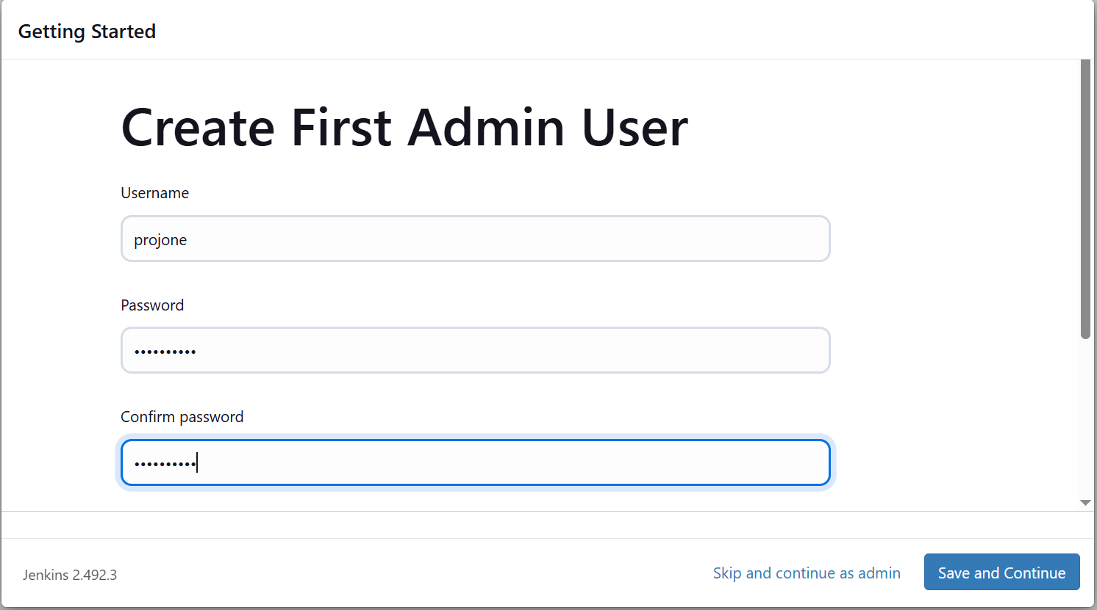  
      
    Specify email address also and click on Save and Continue.  
    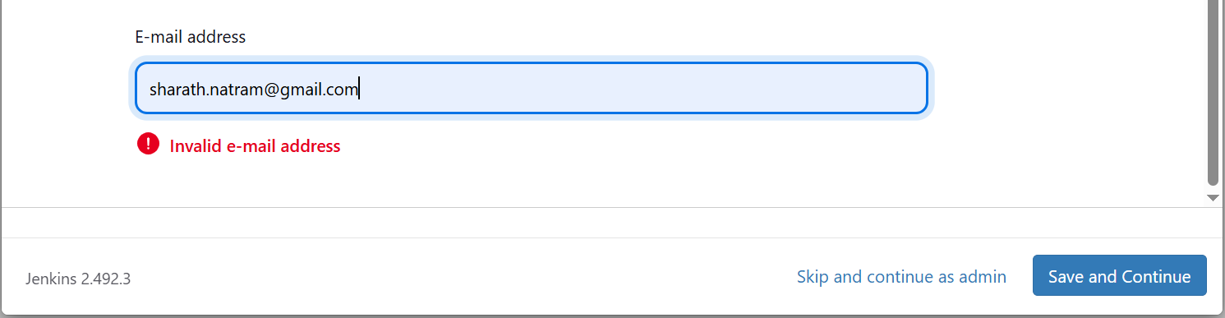
11. To access Jenkins, this is the URL http://ec2-3-90-185-173.compute-1.amazonaws.com:8080/  
    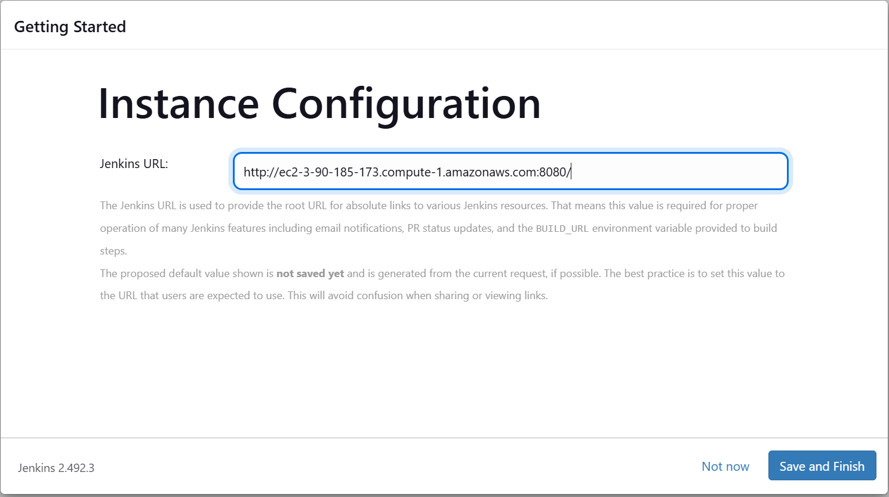
12. Jenkins is ready for use.  
    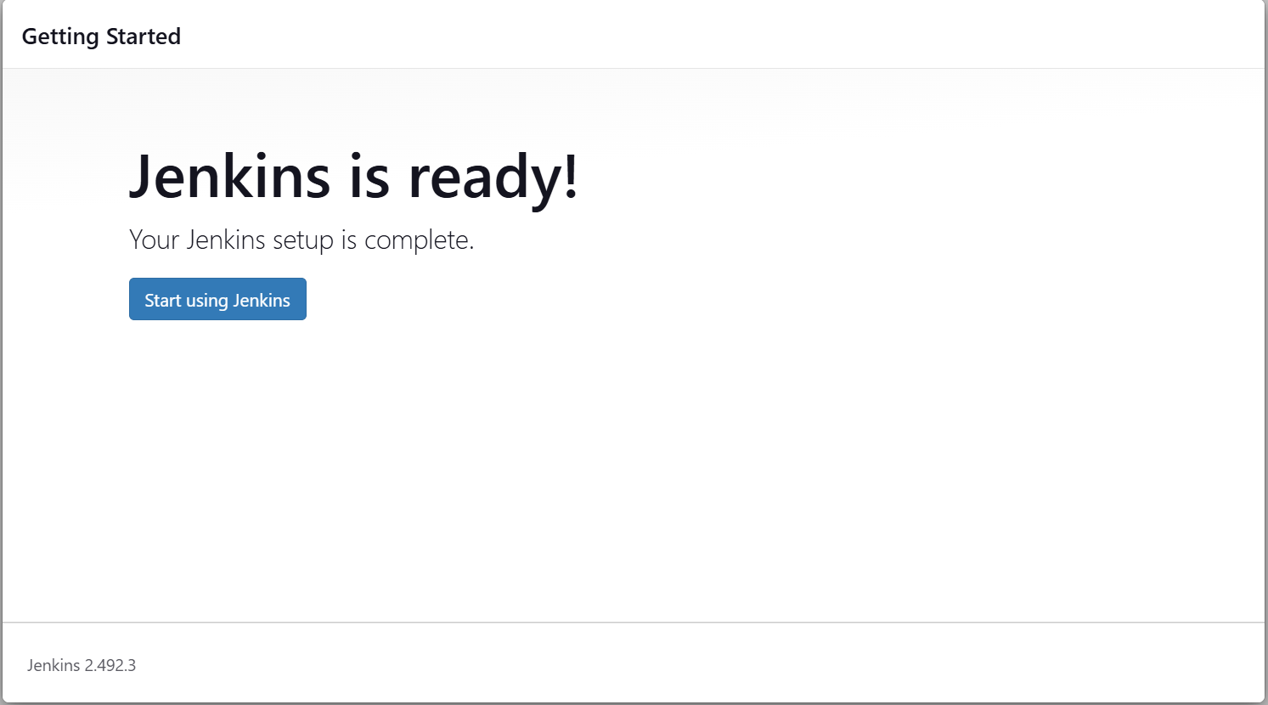
13. Jenkins dashboard will be available to use.(**Username**: projone **Password**: Welcome123)  
    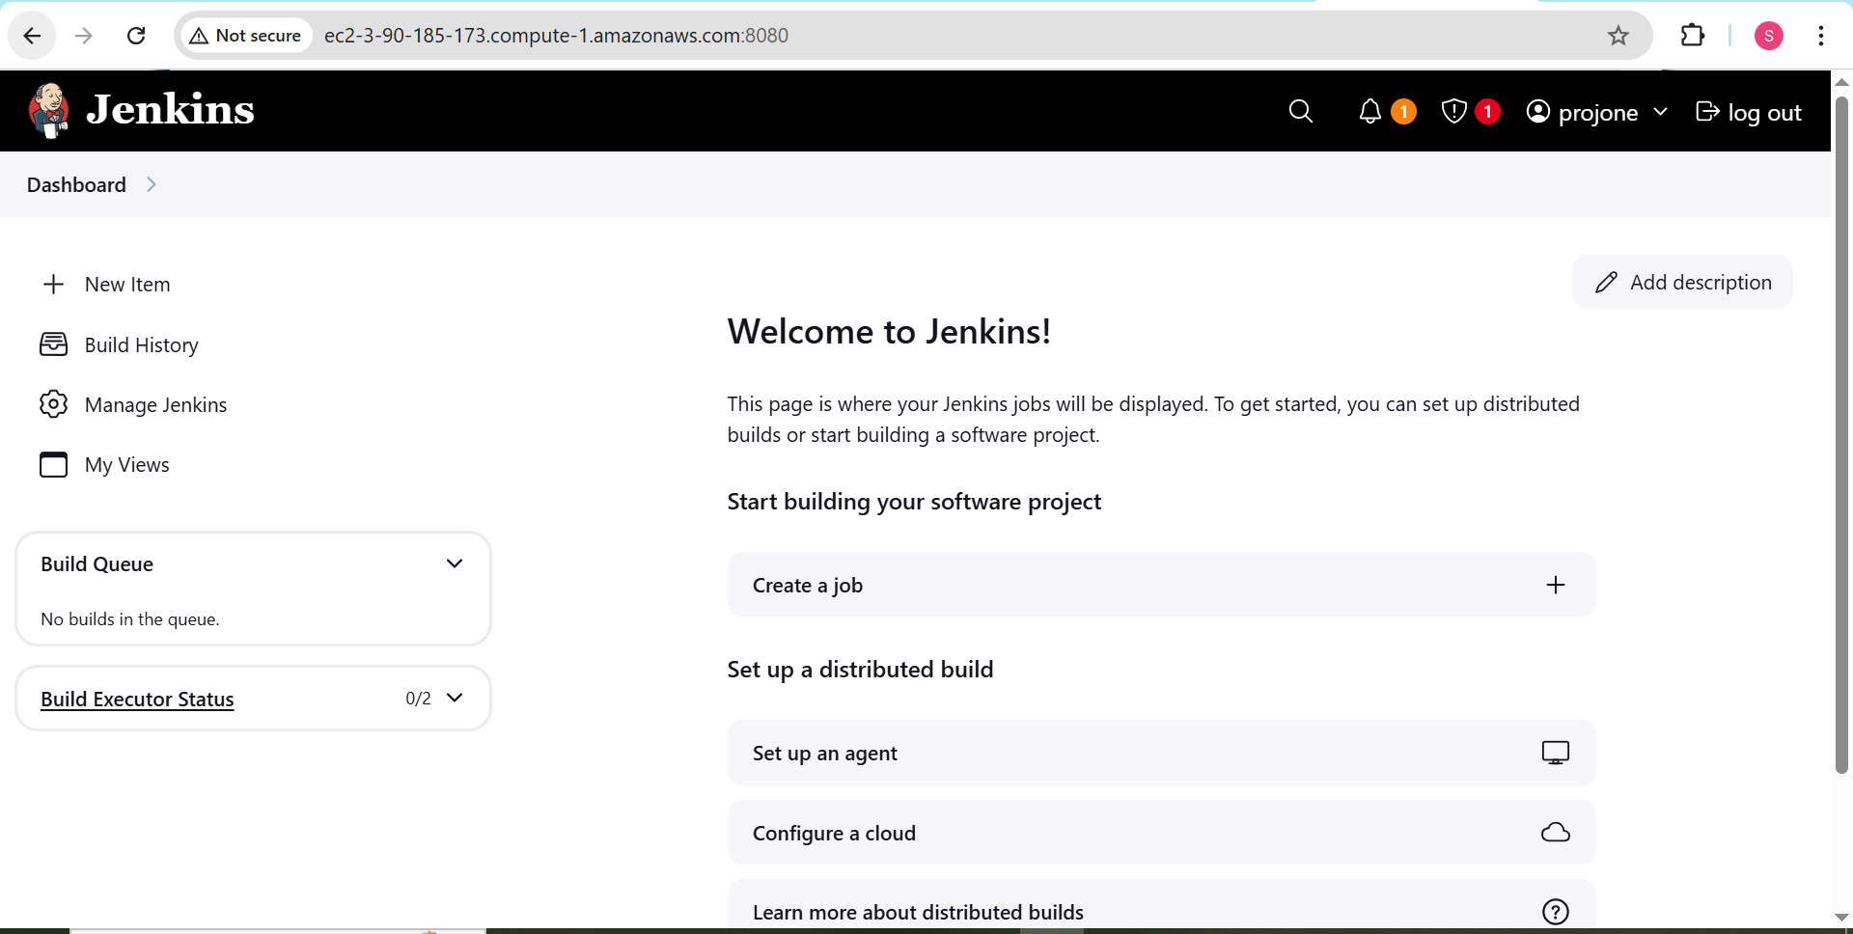

**SonarQube: Installation, Setup & Configuration**

1. Login to SonarQube server and run “sudo apt update” command.  
   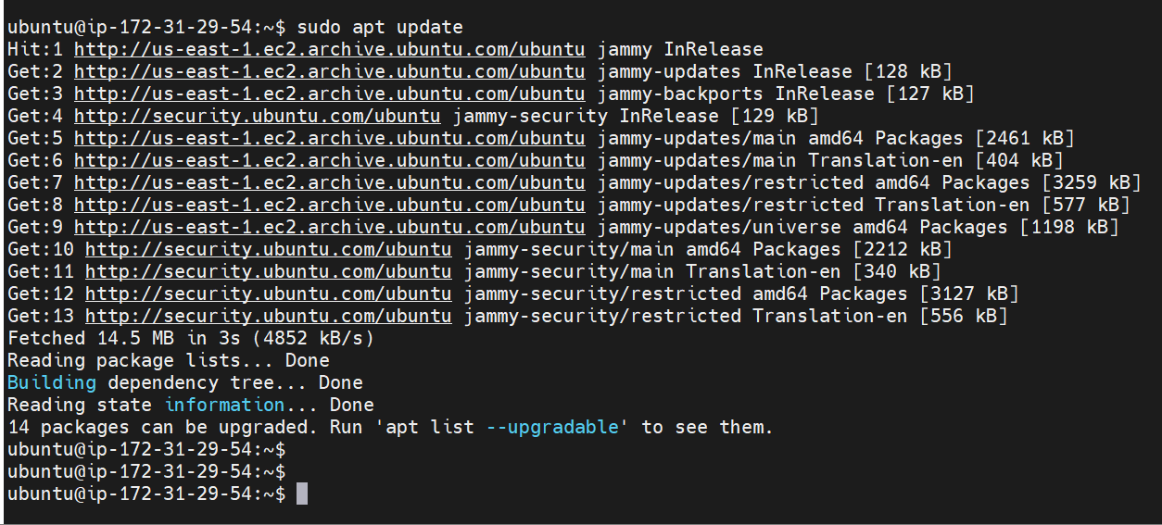
2. Now, we need to install “Docker” because to use SonarQube we will use docker image.
3. Run this command to first install Docker <sudo apt install docker.io>  
   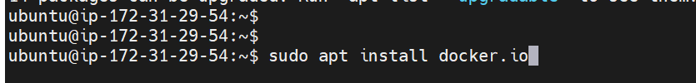
4. After installation, we run Docker in the detached mode to reduce logs & background process
5. Run this command:  
   **docker run -d -p 9000:9000 sonarqube:lts-community**  
   *1st port is Host port 2nd port is Container port  
   *Two versions of SonarQube available. Community and Developer.  
   *Developer is paid and Community is free.  
   *So, we will install Community version.
6. After installation, we will see the below message.  
   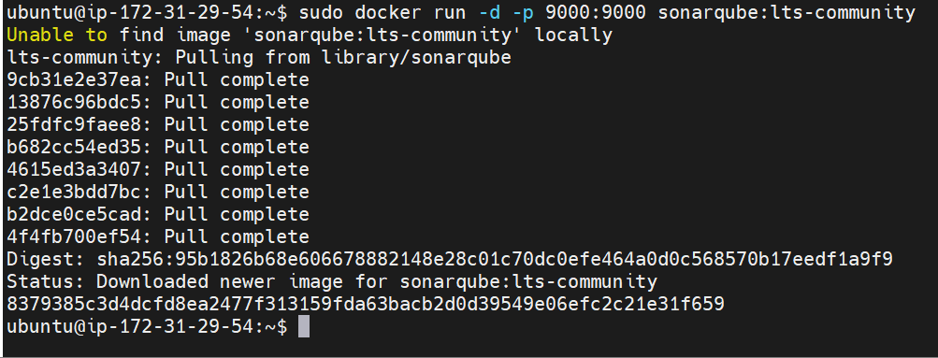
7. To check status of docker, run this command “docker ps”.  
   
8. Real time pointers:

|  |
| --- |
| * Jenkins master & slave both should have 4GB of RAM  * Slave should have more storage as compared to Master. |

1. Now, try to open SonarQube in a browser.
2. Copy the Public DNS with port 9000 (Host) and see if we get the login screen.
3. This is the URL ec2-18-215-151-49.compute-1.amazonaws.com:9000  
   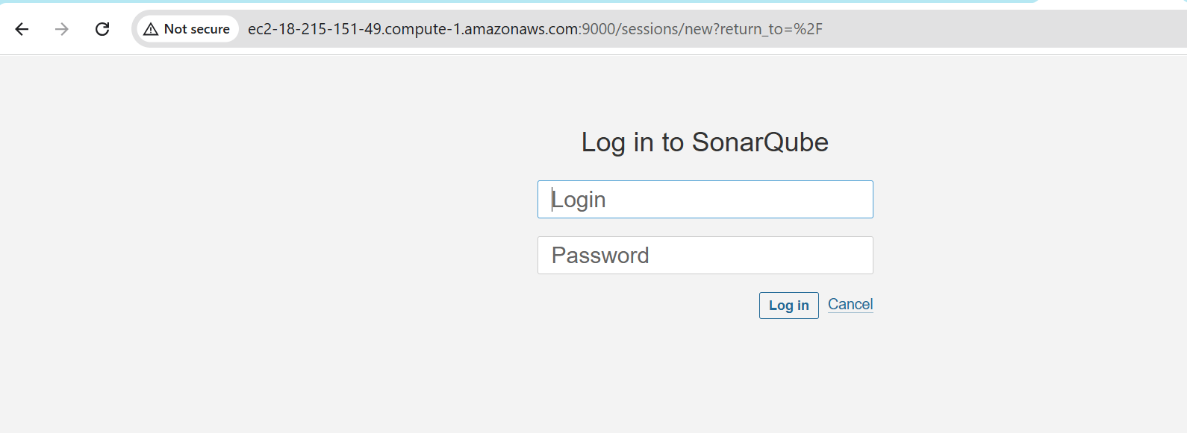
4. Default username and password will be admin/admin.
5. Login screen.  
   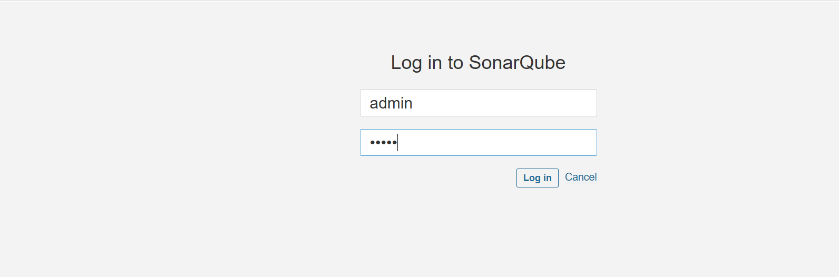
6. At first login change the password.  
   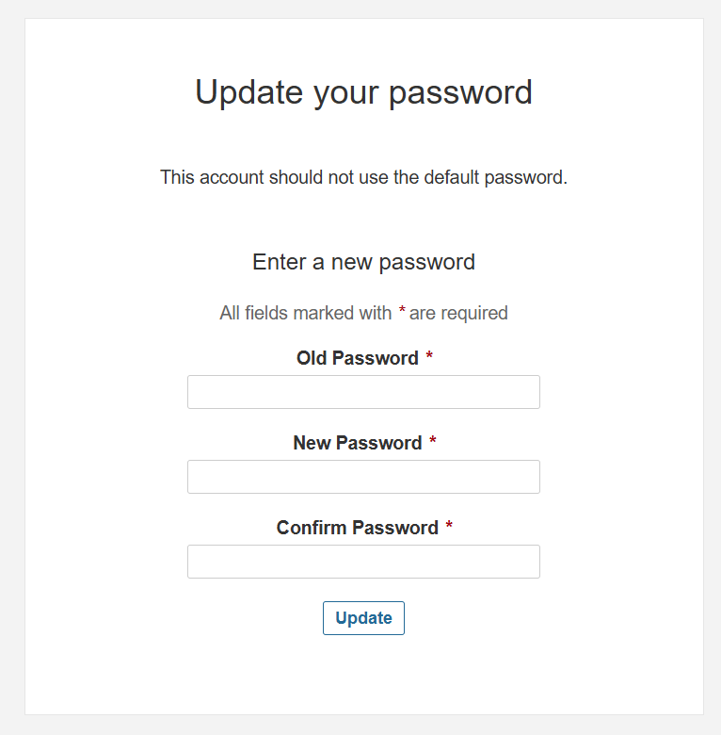
7. Jenkins and SonarQube password is **“Welcome123”**. Click “Update” after changing.
8. SonarQube dashboard will open.  
   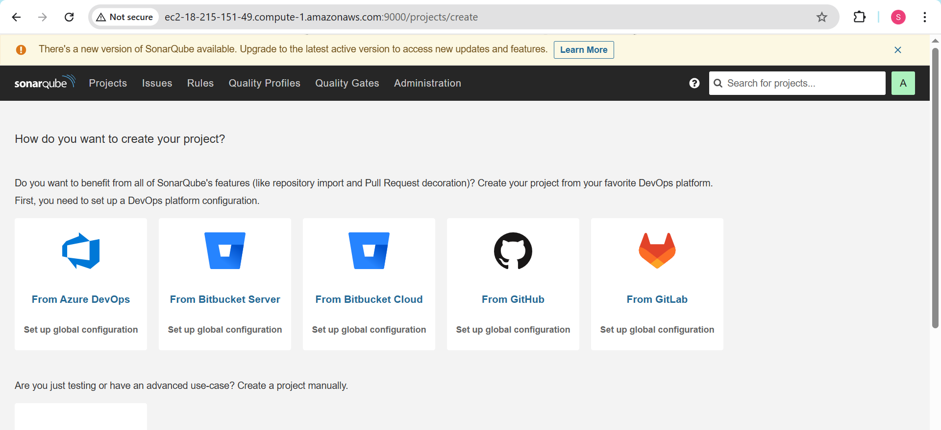
9. SonarQube Server Setup is now completed.  
     
   **NOTE: If after restart of VM the user is not able to login to SonarQube, then type “admin” as old password and reset it to again Welcome123  
   *Its related to this project work\***

**Nexus Repository: Installation, Setup & Configuration**

1. Login to Nexus Server and run these commands.
   1. sudo apt update
   2. sudo su <To switch to “root”> and install “Docker”.
2. Refer below image.  
   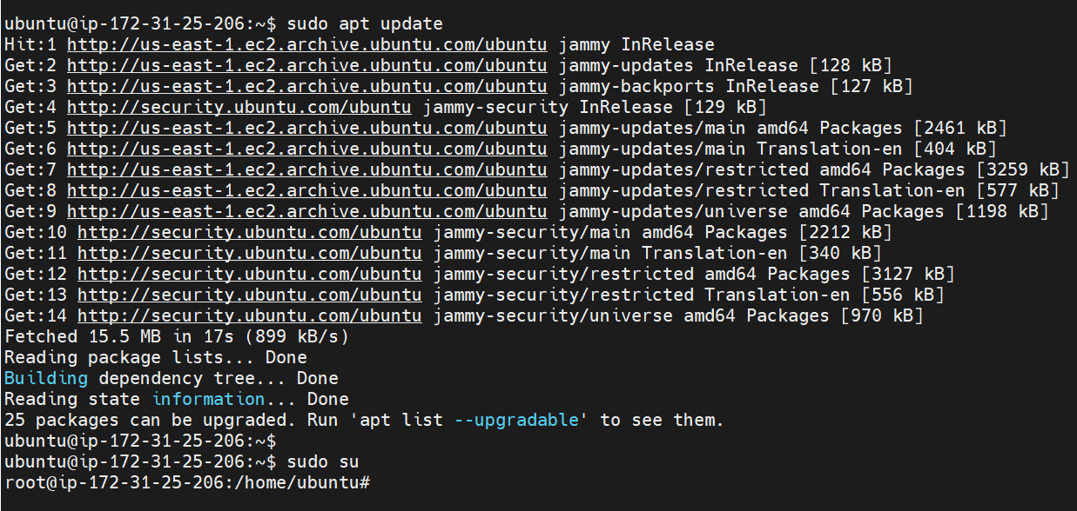
3. Install Docker  
   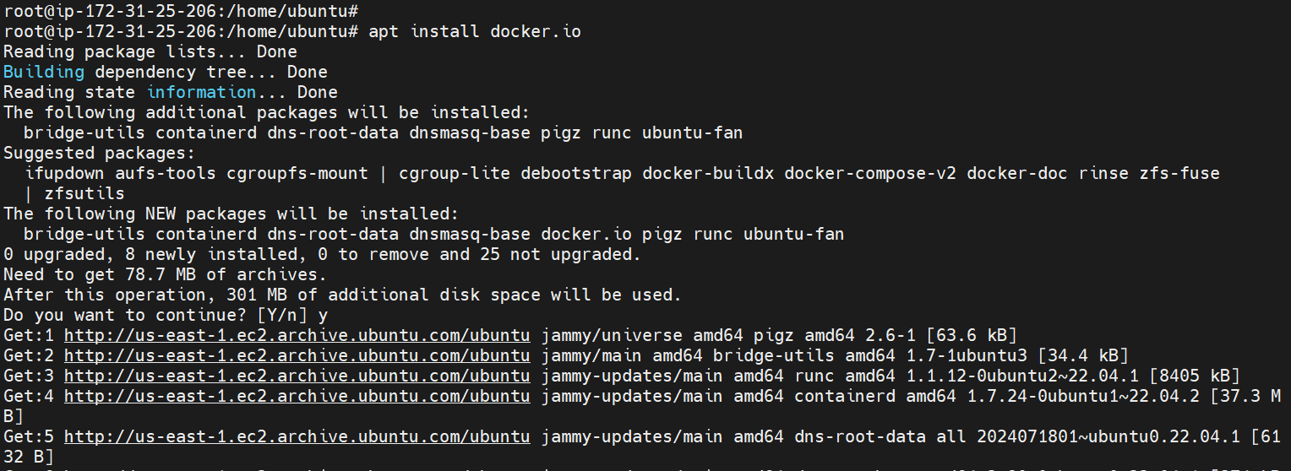
4. Now, we have to install Nexus by running this command:  
   **docker run -d -p 8081:8081 sonatype/nexus3**
5. Nexus installation completed  
   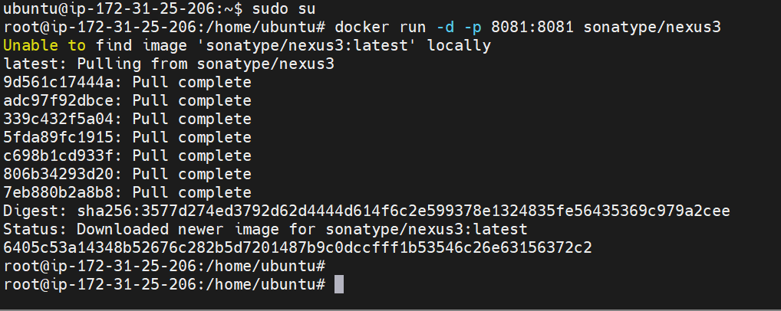
6. Docker container is up and running.  
   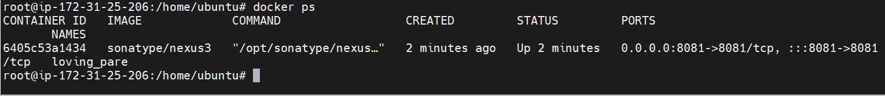
7. Now, we have to connect to the container.
8. Run this command: docker exec -it <imageID> /bin/bash  
   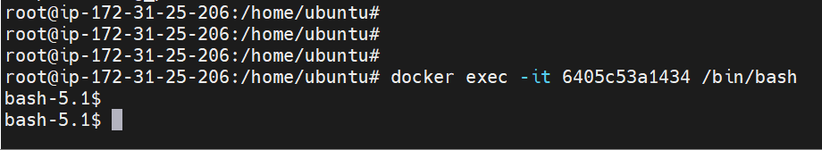
9. We connect to the Nexus container to know the password.
10. Now open Nexus Repo URL in the browser.
11. Nexus Dashboard will open  
    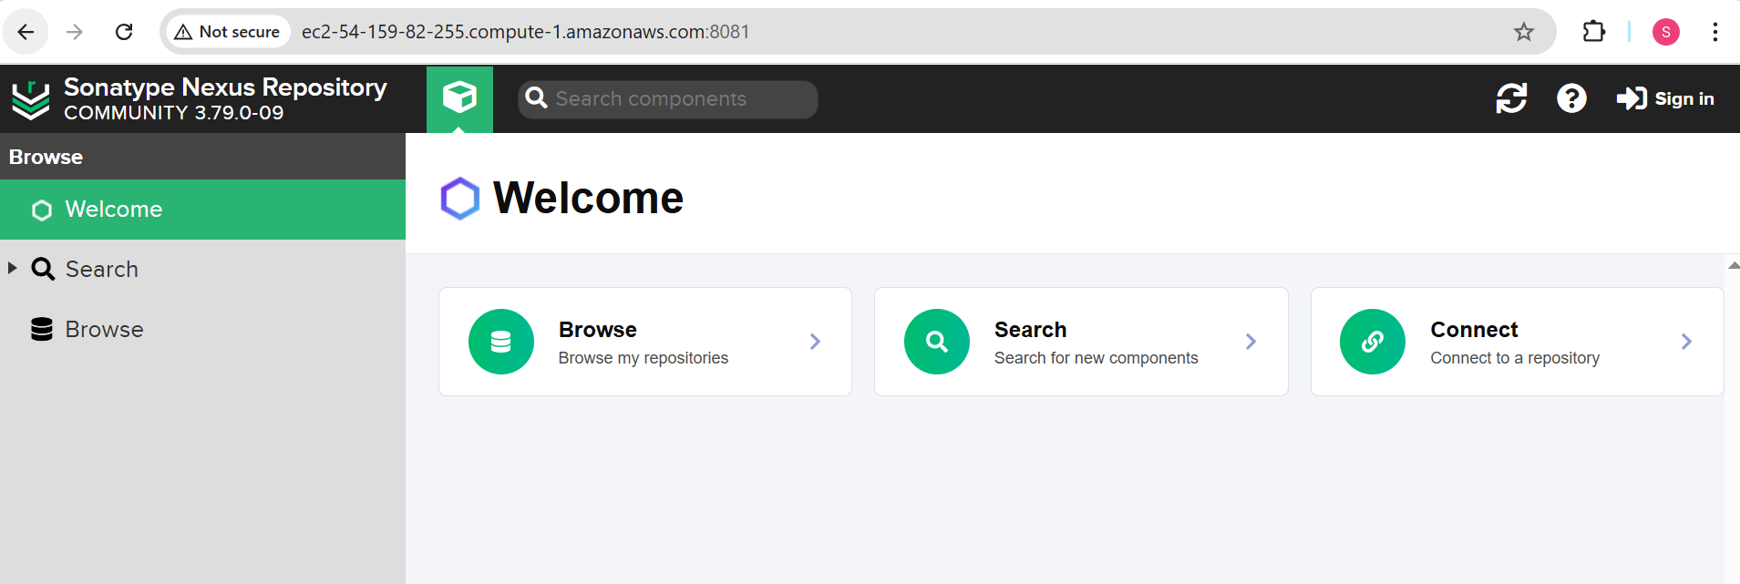
12. Now, we have to search for admin.password file inside Nexus server.
13. Go to the below shown path and search for “admin.password” file.  
    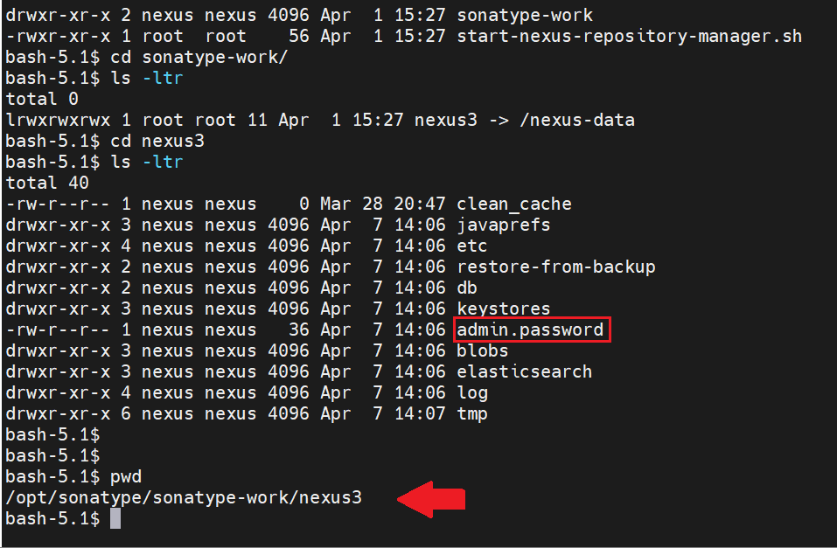
14. We have to run command cat admin.password and we can see the password.  
    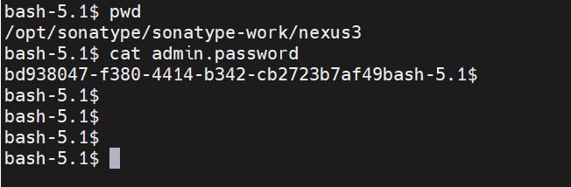
15. bd938047-f380-4414-b342-cb2723b7af49  
    **NOTE**: Always go to this path to get the latest “admin-password”  
    /opt/sonatype/sonatype-work/nexus3  
    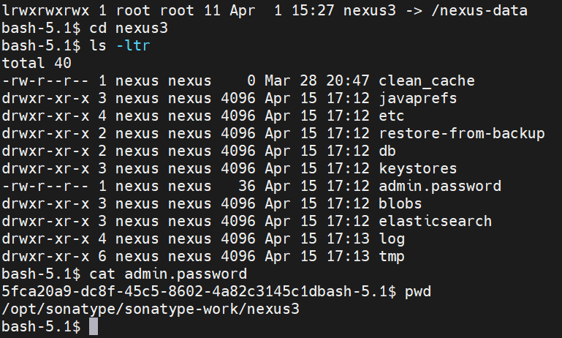
16. Using this password, we will login as “admin”. Click on Sign-In  
    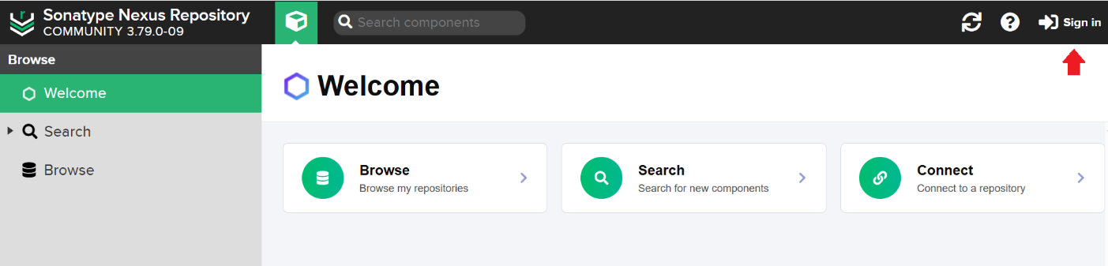
17. Login with admin and the password we got from the server as shown below.
18. Now, login with the new “admin-password” as shown above and then it will ask to reset.  
    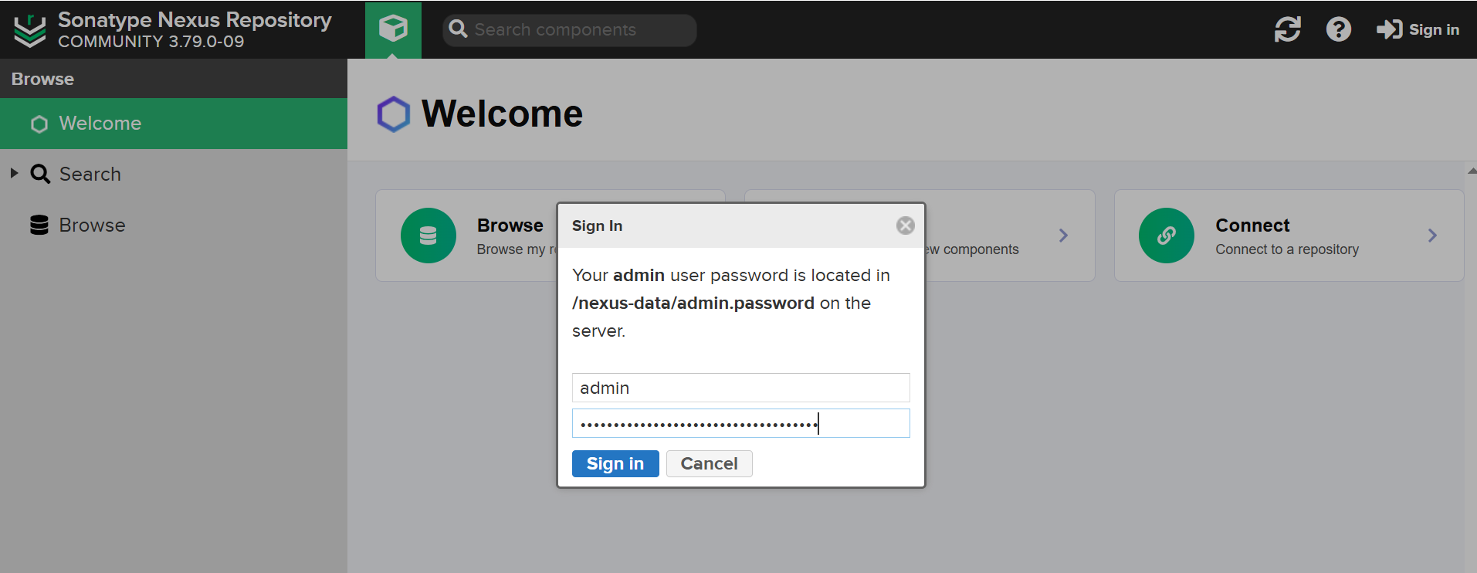
19. We will see a welcome message as shown below.  
    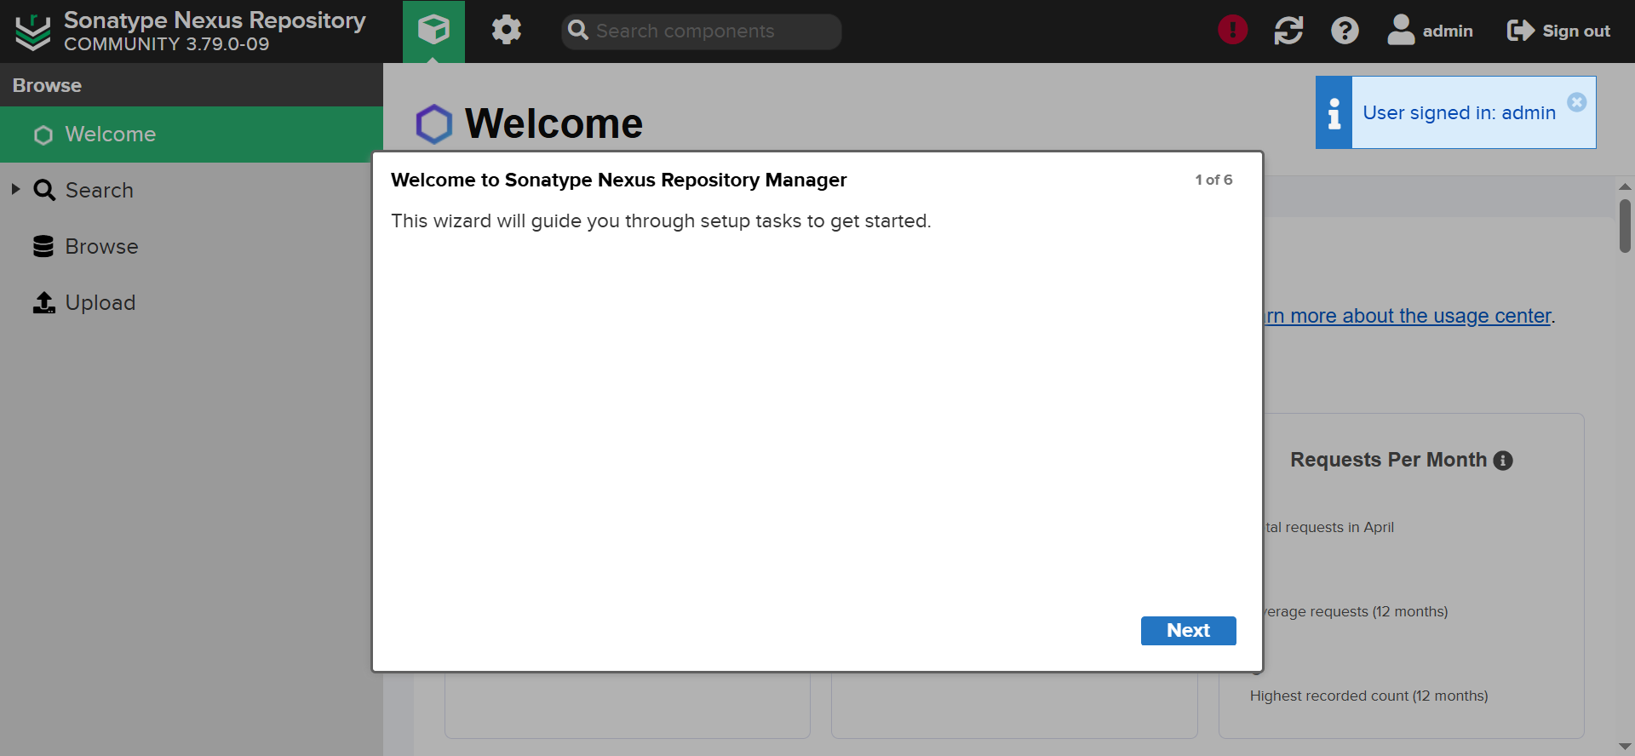
20. Click on Next and set new password in the next window. (Welcome123)  
    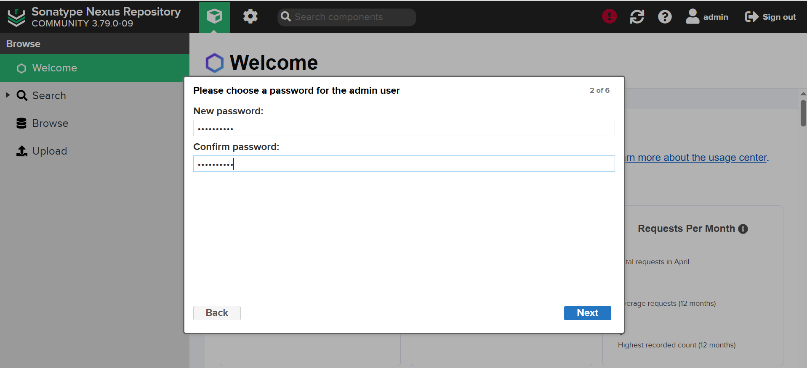
21. Once password reset done, we will see below screen.  
    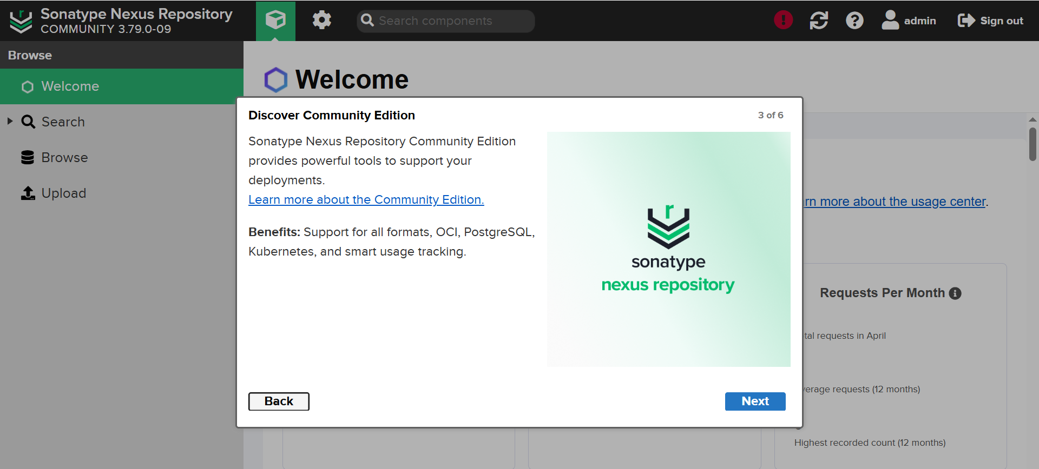
22. Click Next to get User agreement. Accept it. Click on Agree.  
    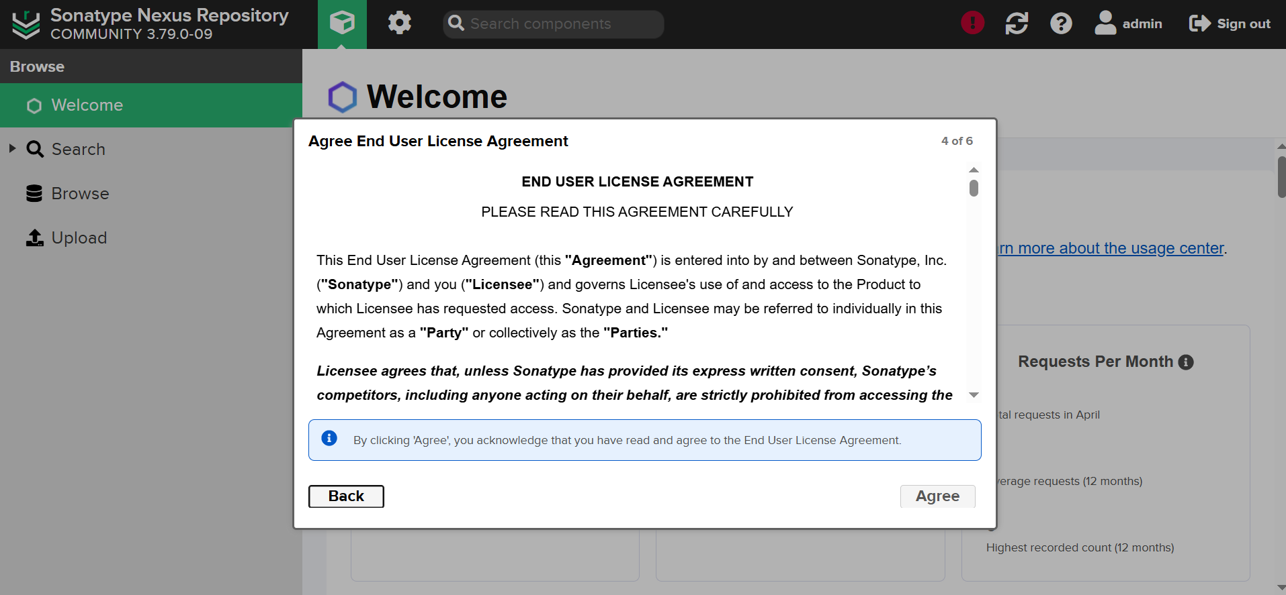
23. Select Enable Anonymous Access. Click on Next.  
    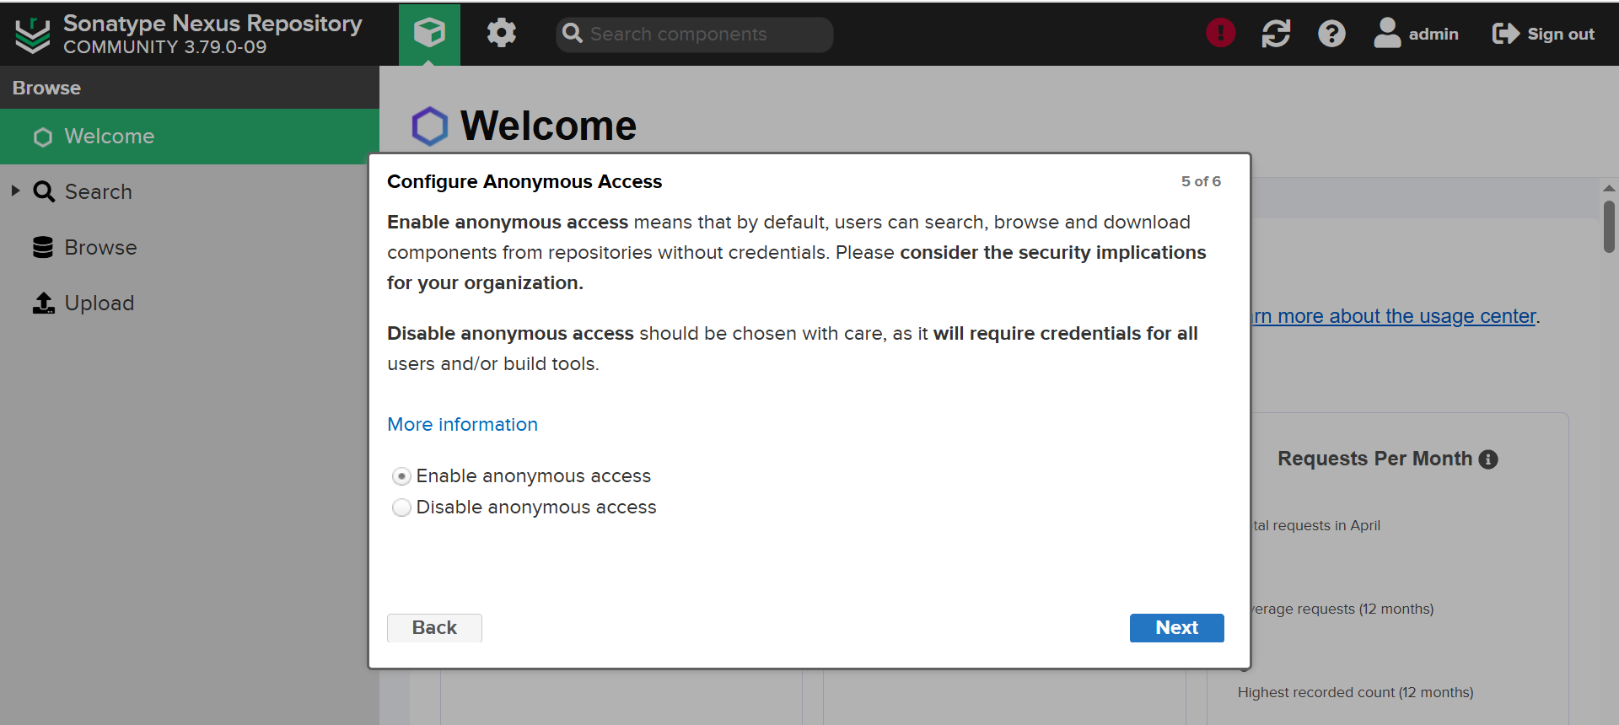
24. Click on Finish.  
    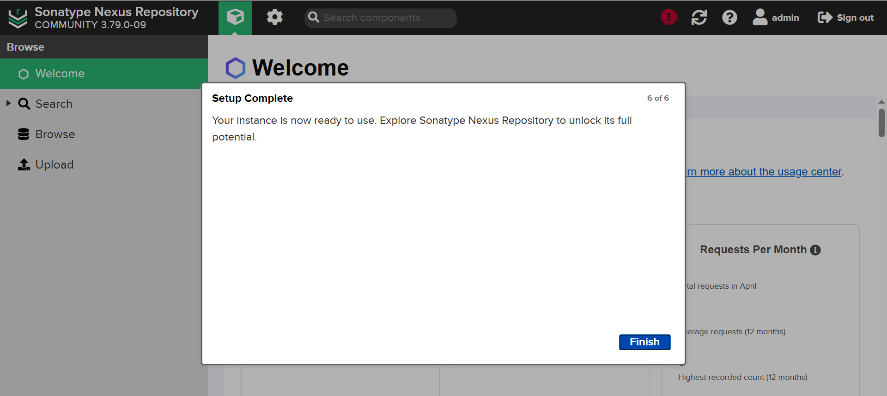
25. Nexus dashboard is now up and running.  
    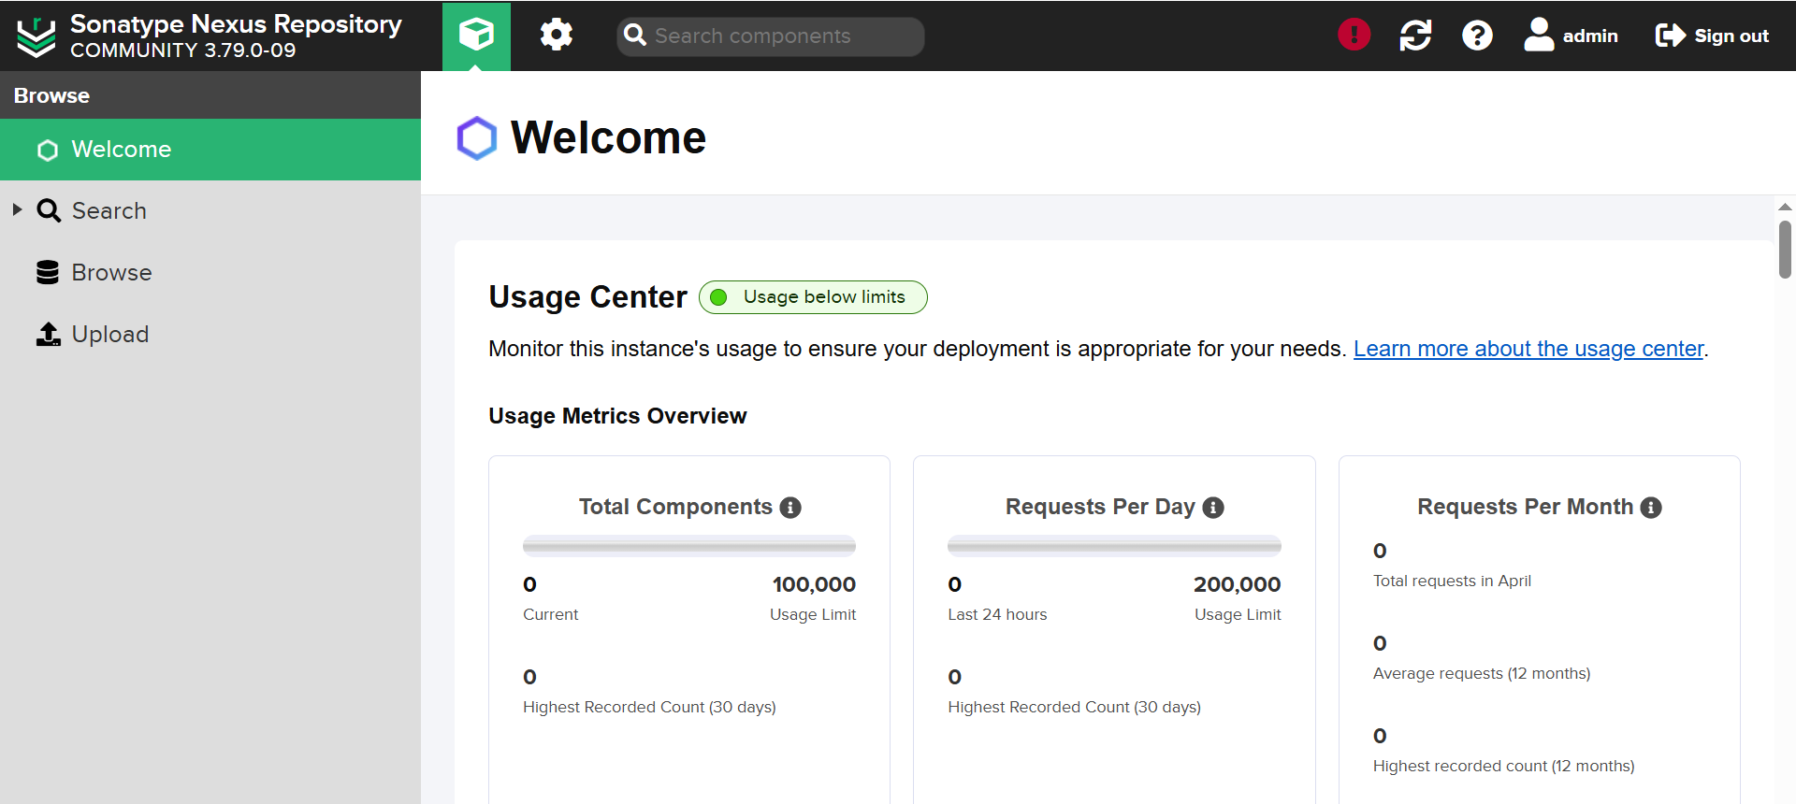

**PRO-TIP**

When you're setting up and configuring **Nexus Repository** in a real-time **DevOps project**, the **recommended** approach is to:

**🔒 Disable Anonymous Access**

**✅ Why Disabling Anonymous Access is Recommended (Best Practice)**

1. **Security and Access Control**
   * Disabling anonymous access **forces authentication**, so only authorized users or CI/CD tools can interact with the repo.
   * You can **track who uploaded/downloaded** what and when — useful for **auditing** and **compliance**.
2. **Prevent Unauthorized Access**
   * If you leave it open to anonymous access, anyone who knows the URL could potentially:
     + Download your private artefacts (jars, wars, Docker images).
     + Upload malicious code or artefacts.
     + Flood the repo (DoS-style).
3. **Compliance Requirements**
   * Many companies follow **ISO, SOC2, or internal security policies**, where anonymous access is not allowed in production.
4. **Fine-Grained Permission Control**
   * Disabling anonymous access lets you assign **roles** (read, deploy, delete) to users/groups — critical in a DevOps pipeline.

**❗️When Is Anonymous Access Okay?**

Only in **non-production environments** or **public repositories** for:

* Testing or training environments.
* Hosting public libraries/packages where open access is intentional.
* Internal PoCs (Proof of Concepts).

Even in these cases, it's better to **restrict access via IP or internal firewall rules**.

**🔧 Real-Time DevOps Practice**

In your CI/CD setup (e.g., Jenkins + Nexus):

* Use **Nexus credentials in a secure credentials store** (like Jenkins credentials).
* Configure **Nexus roles**:
  + Developers: Read + Deploy access.
  + Build servers (like Jenkins): Deploy access only to certain repos.
  + QA/Users: Read-only access.

**🔐 Bonus Tip: Use Repository Connectors Securely**

* Enable **HTTPS** on Nexus if it's accessible over a network.
* Use **strong passwords** and **API tokens** instead of plaintext credentials.

**Summary**

| **Setting** | **Recommendation** | **Reason** |
| --- | --- | --- |
| Anonymous Access | ❌ **Disable** | For better security and control |
| Authenticated Access | ✅ **Enable** | Track usage, enforce RBAC, audit access |
| Exceptions | ✅ Dev/Test/Public only | With restricted IPs or firewall |

1. We can see lots of default repositories available for use. We can choose any one of them.  
   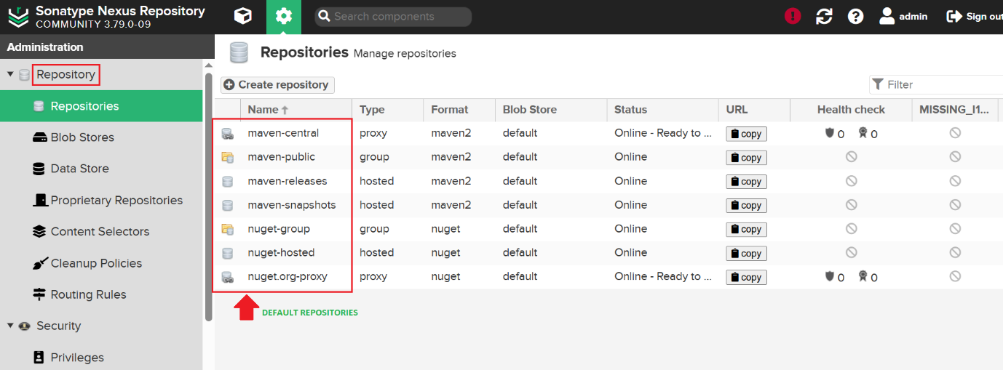
2. Now Nexus Repository is all set to use.
3. We also, need to install “Docker” inside “Jenkins” server because we will run docker comm.
4. After installing Docker, we need to make “ubuntu” user to run docker commands.
5. Refer the below steps.  
   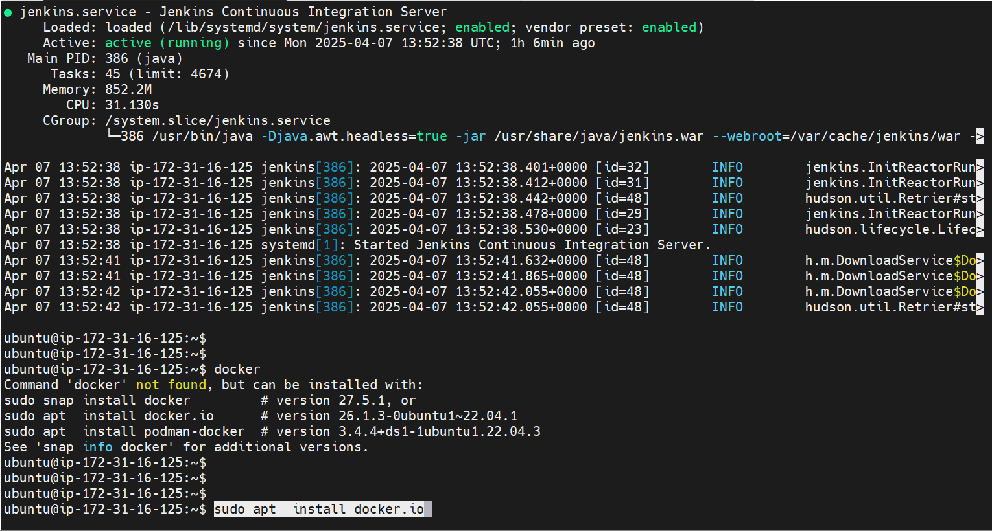
6. Install Docker by running the above shown command.  
   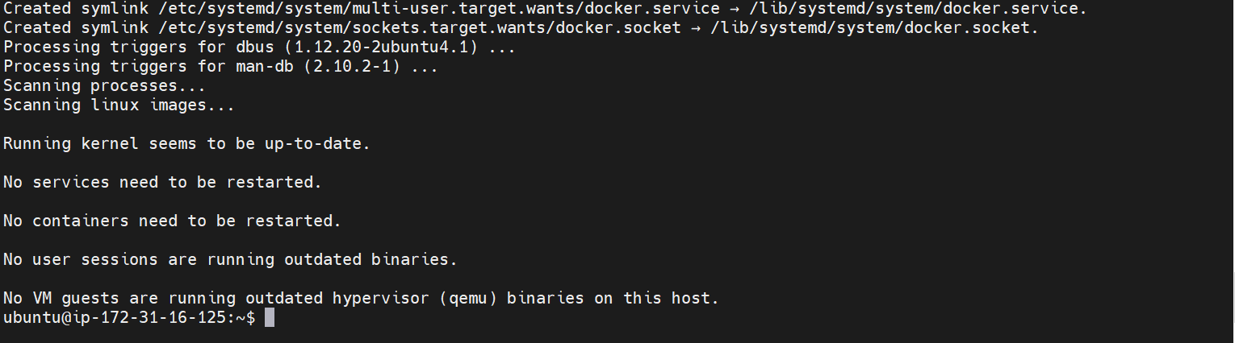
7. Run the below command to make “ubuntu” user to run docker commands in this server.  
   **sudo chmod 666 /var/run/docker.sock**  
   This command is bit risky as it opens lots of vulnerability issues. But for practice we will use.
8. 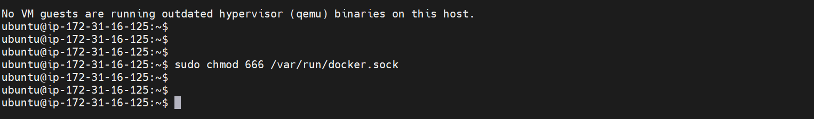
9. Now, other users of Jenkins can also run “Docker” commands. (**Not recommended**).
10. Jenkins, SonarQube & Nexus all successfully setup and configured.

**Jenkins: Other Setup & Configurations**

1. We have to install some plugins in Jenkins.
2. Log into Jenkins > Go to Manage Jenkins > Plugins. Below are the plugins we need.
   1. Sonar Scanner
   2. Nexus Artifact Uploader
   3. Docker pipeline
   4. Cloudbees Docker Build and Publish
   5. OWASP Dependency Check
   6. Eclipse Temurin Installer
3. Install “Sonar Scanner” as shown  
   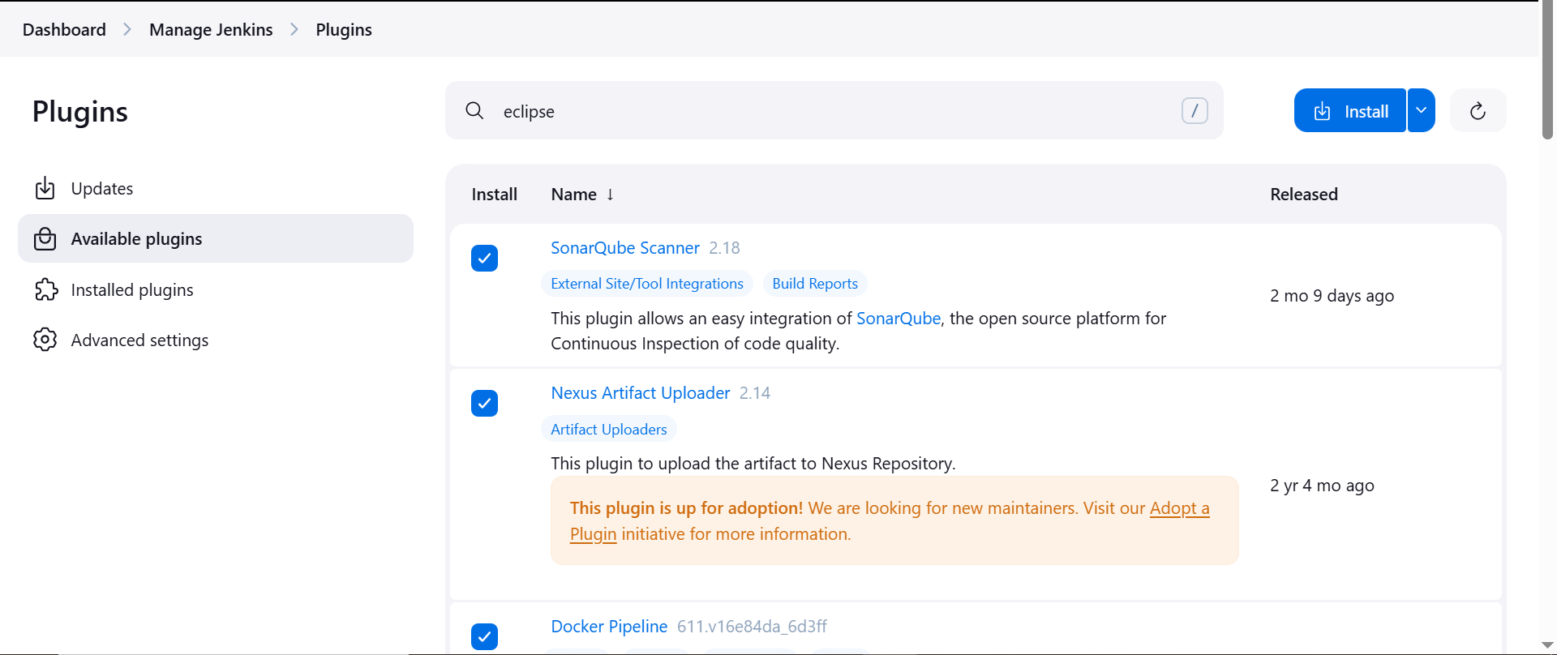  
   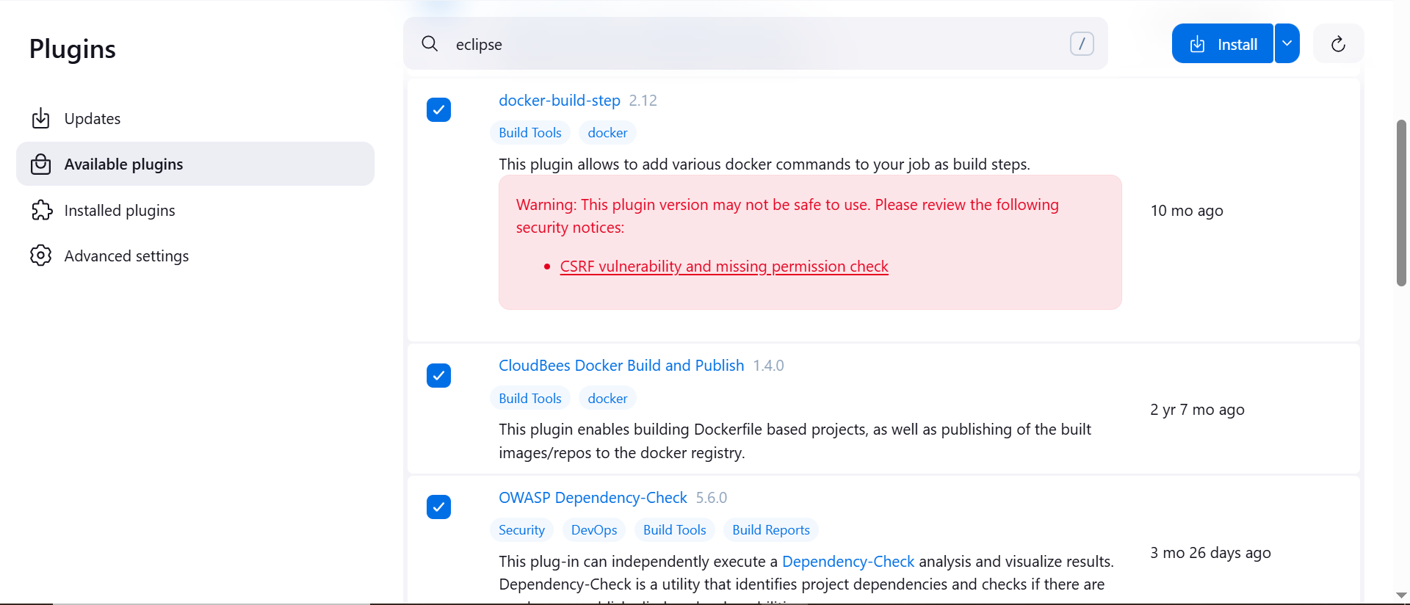  
   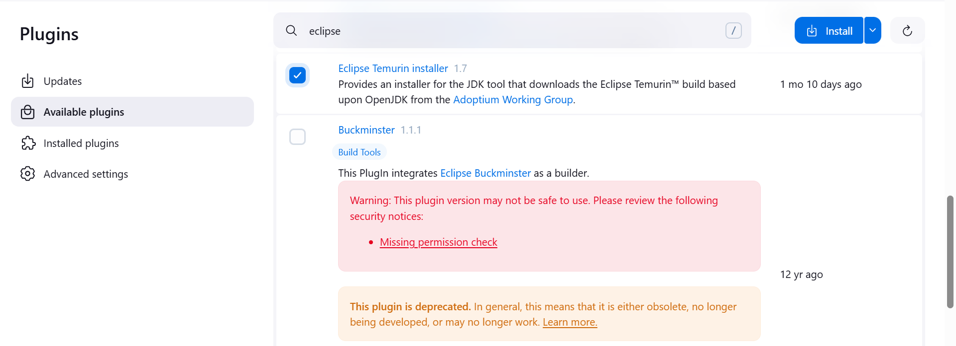
4. Click on “Install” on the top right corner. It will take to download and install all plugins.  
   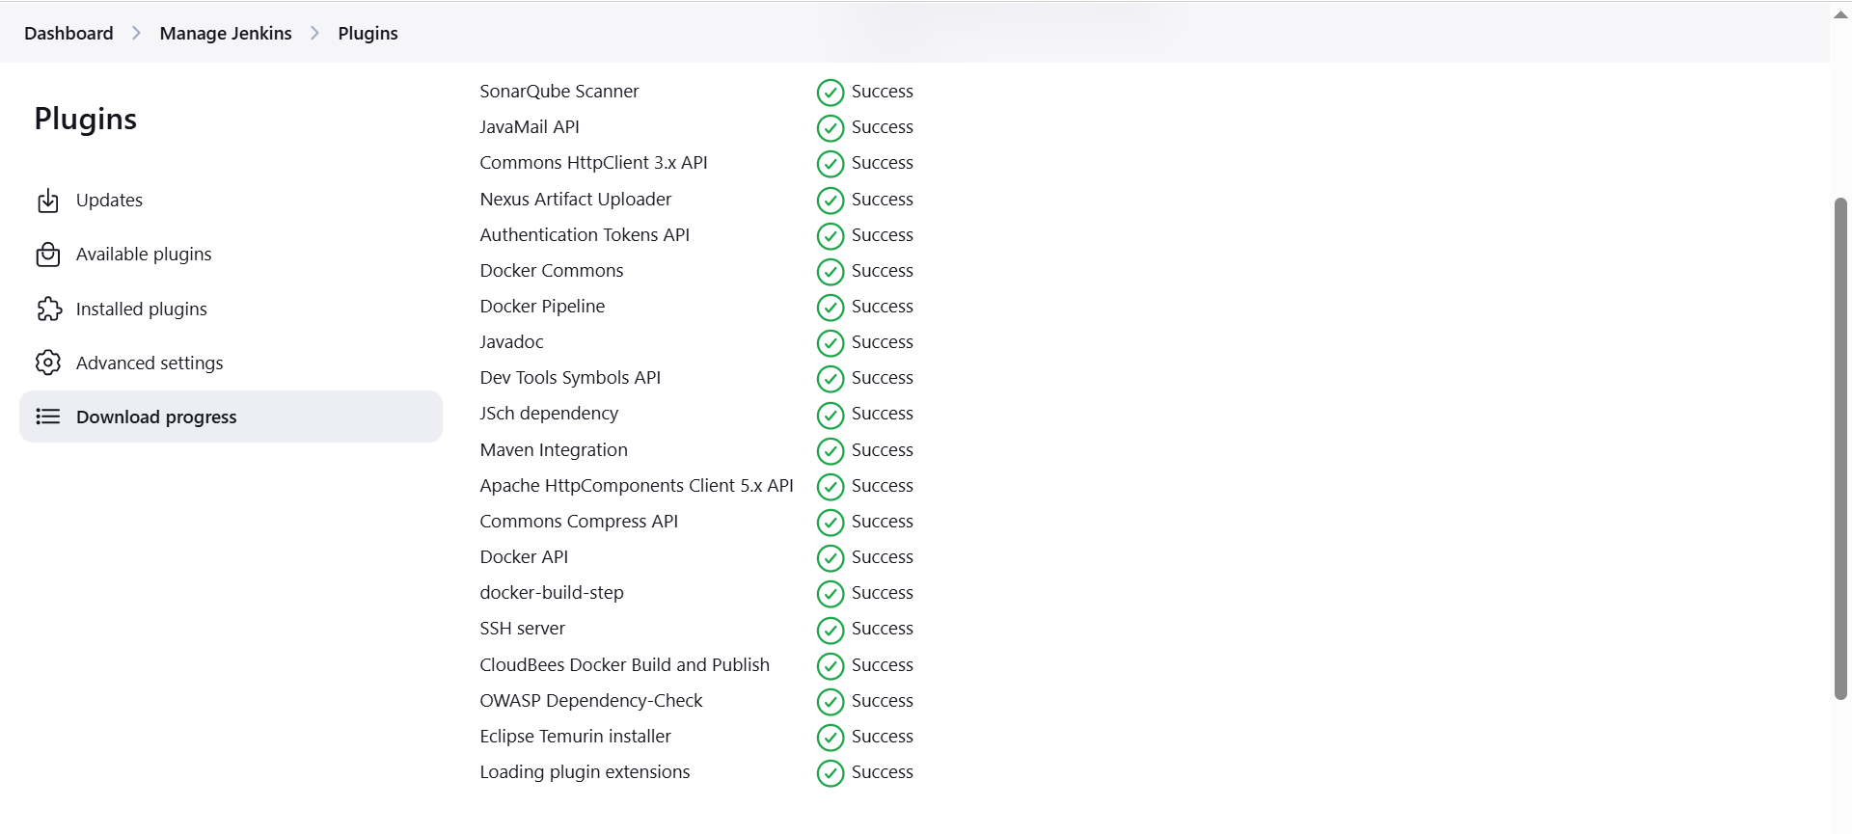
5. After plugins installation completes, we have to configure them.
6. Go to Manage Jenkins > Tools
7. First, setup JDK with below details. Install both JDK 11 and 17 both as shown below.  
   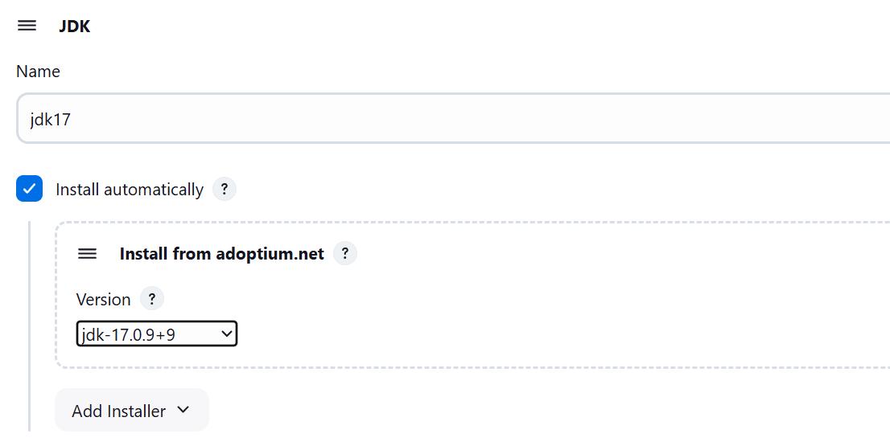
8. Install JDK11 as well  
   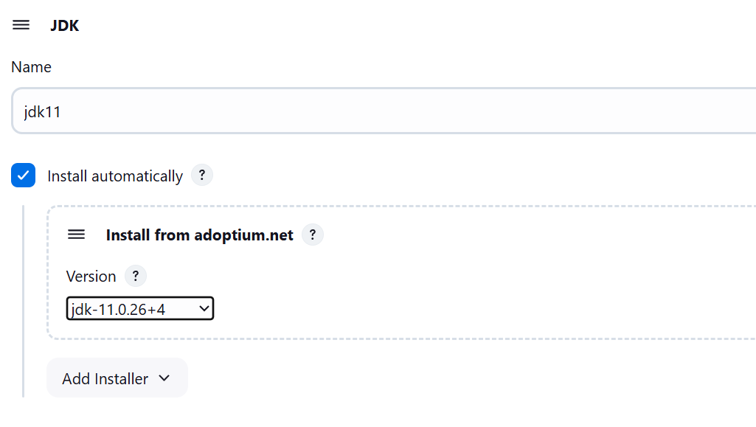
9. SonarQube configuration.  
   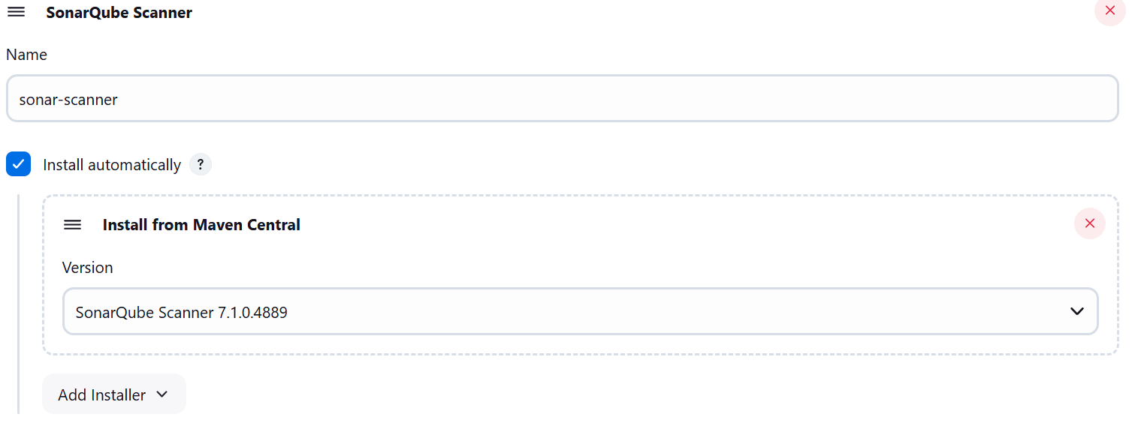
10. Maven Configuration  
    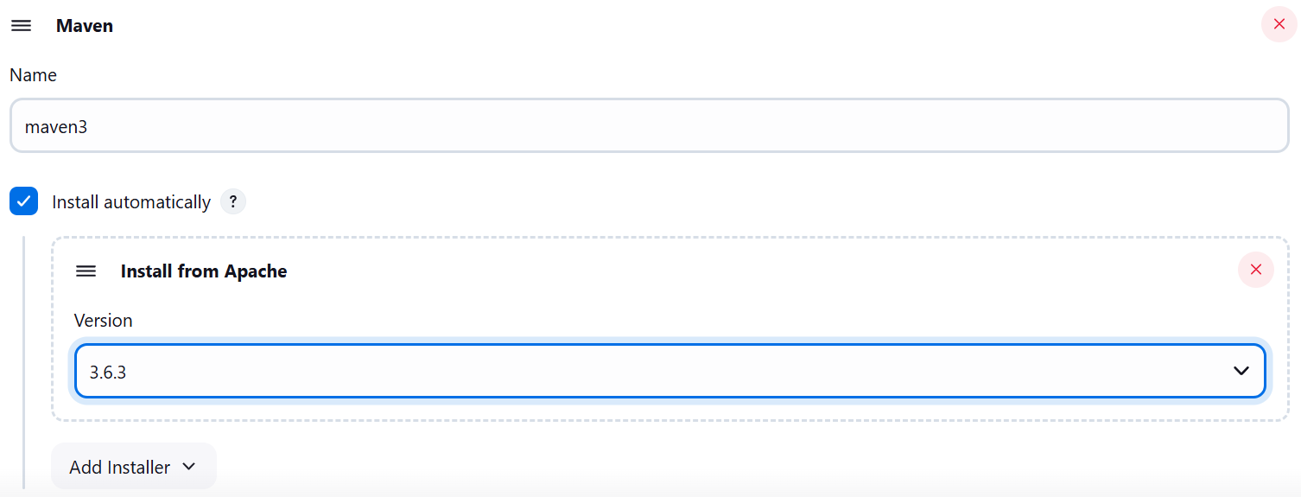
11. Configure Dependency Check  
    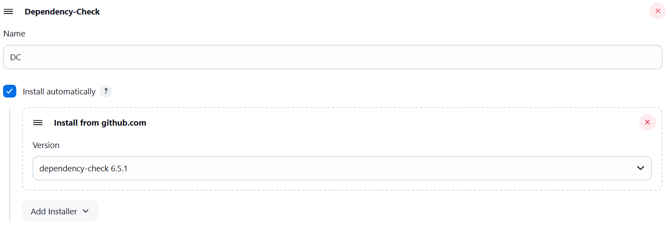
12. Docker configuration  
    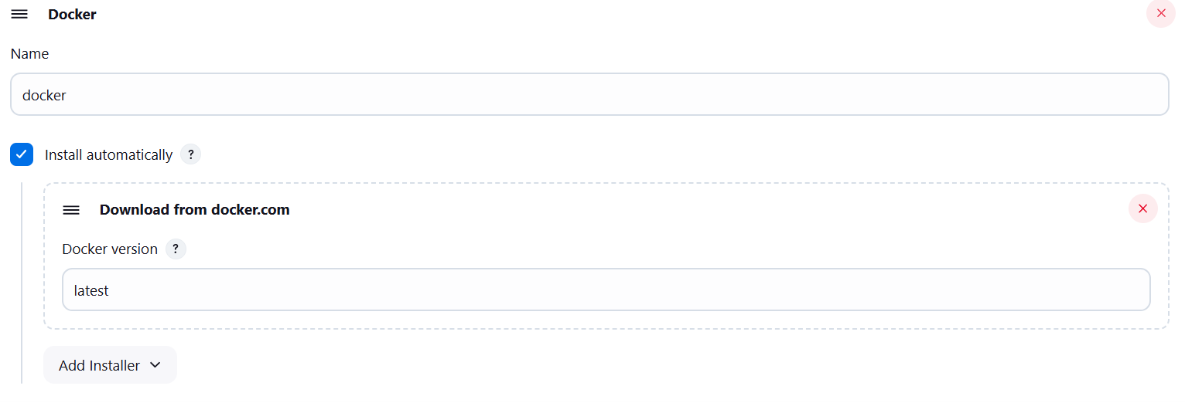
13. Click on Save and Apply after adding these configurations  
    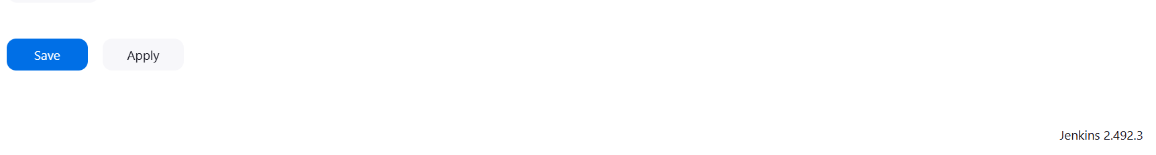
14. Now, we have to connect “SonarQube” with “Jenkins
15. First login to SonarQube website and go to this navigation.
16. SonarQube > Administration > Security > Users > Token  
    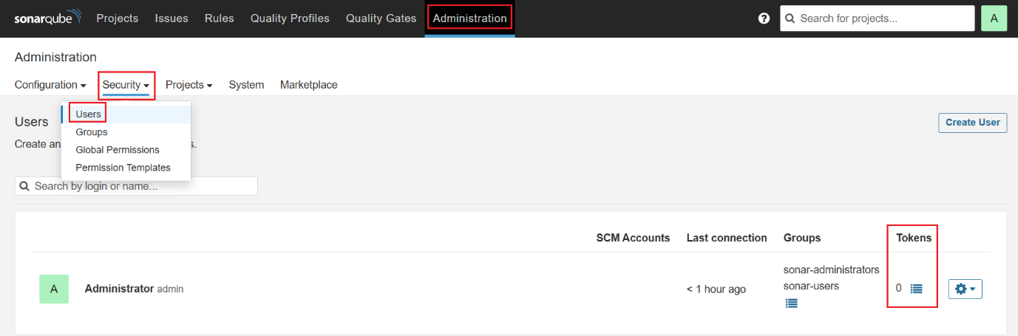
17. Give any TokenName > Generate a token > Set expires after 30 days.  
      
    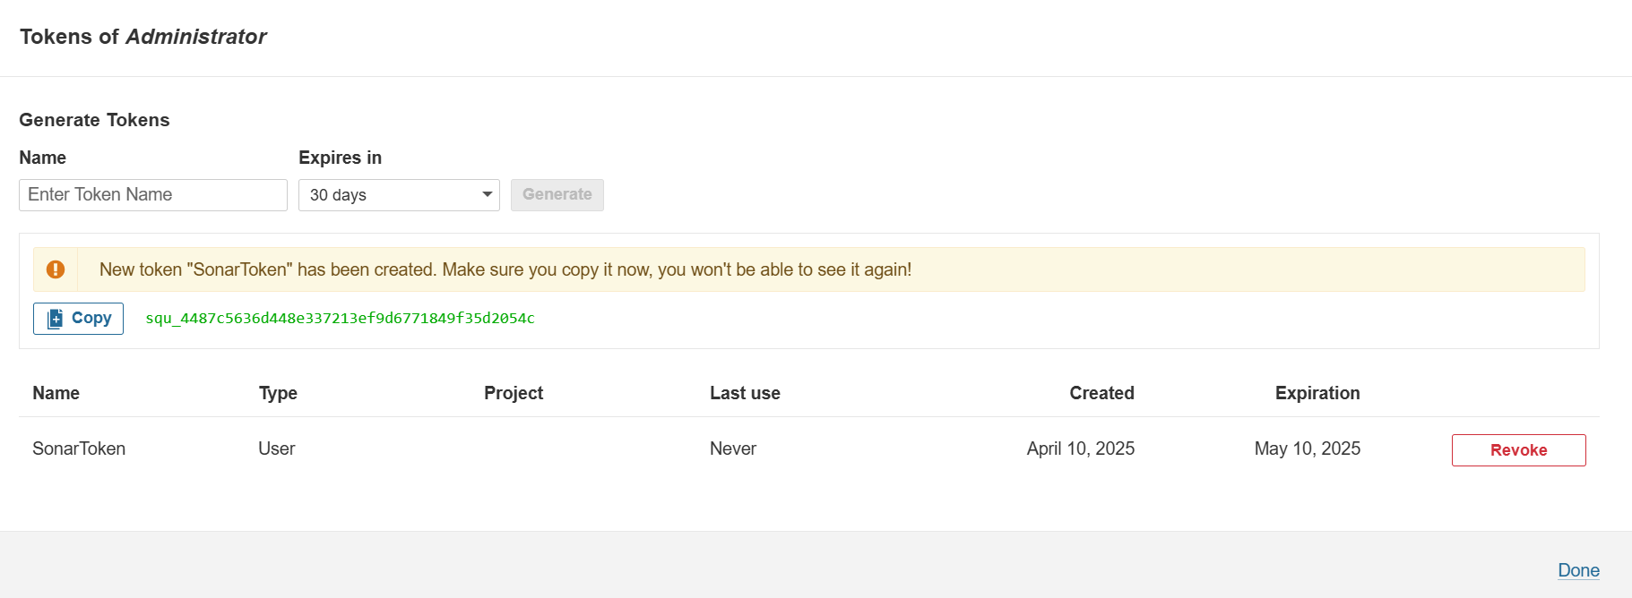  
    squ_4487c5636d448e337213ef9d6771849f35d2054c  
    squ_190eaa164a696f978468fd425e55e07e929dadbc Latest (20th Apr 2025)
18. Go to Jenkins > Manage Jenkins > Credentials > Global Credentials  
    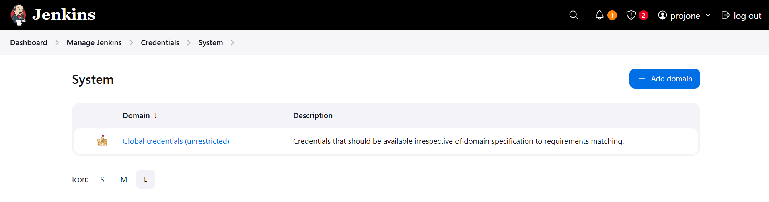
19. Fill in details as shown.  
    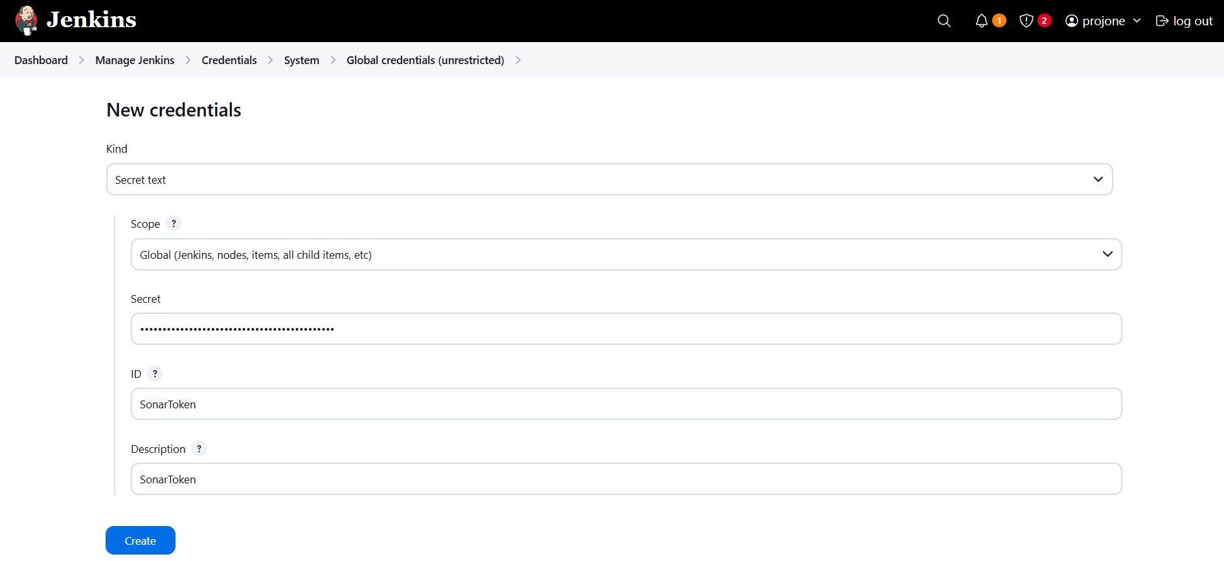
20. Click on Create. Below page will be displayed.  
    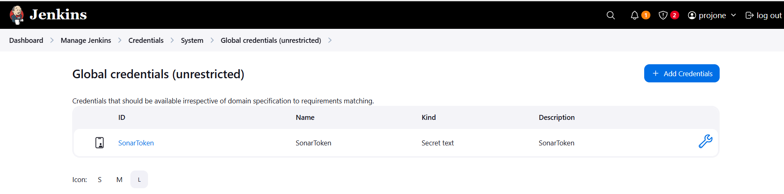
21. Now, add Docker credentials. We will follow same process. Click on Add Credentials again.
22. Fill in details as shown. I have used my Jenkins login credentials here for Docker.  
    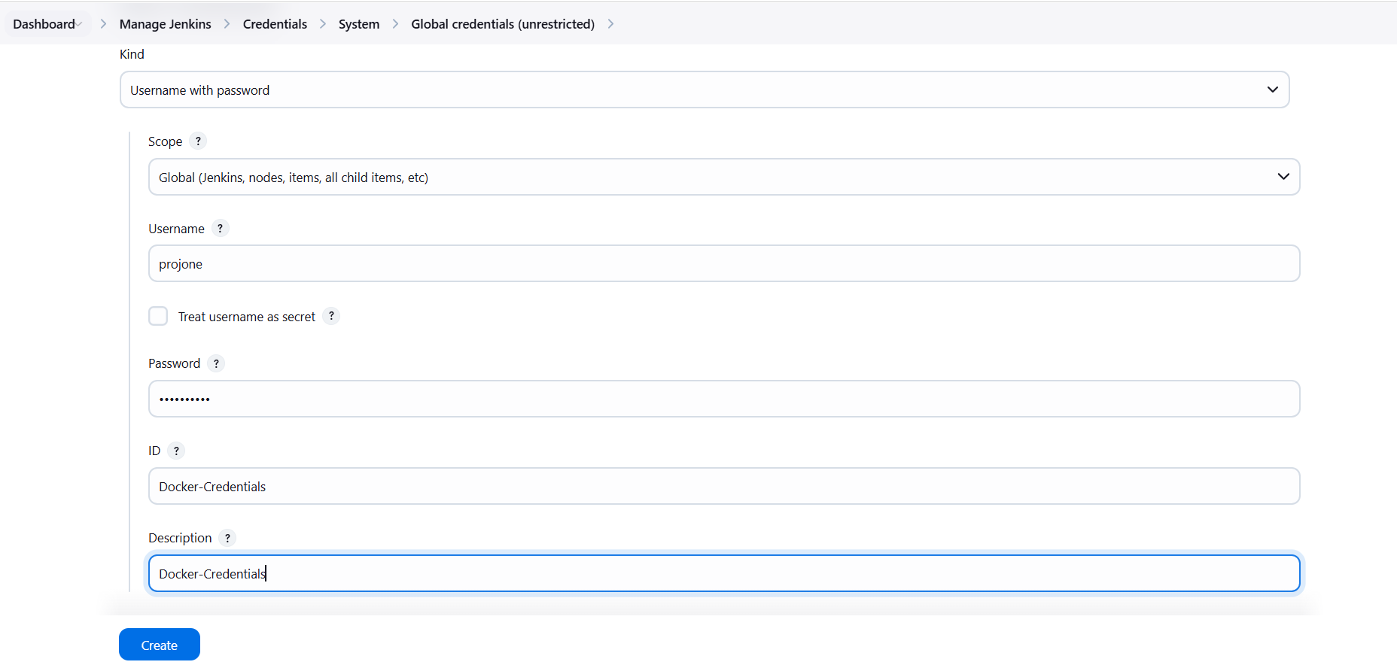
23. Now we have two credentials added.  
    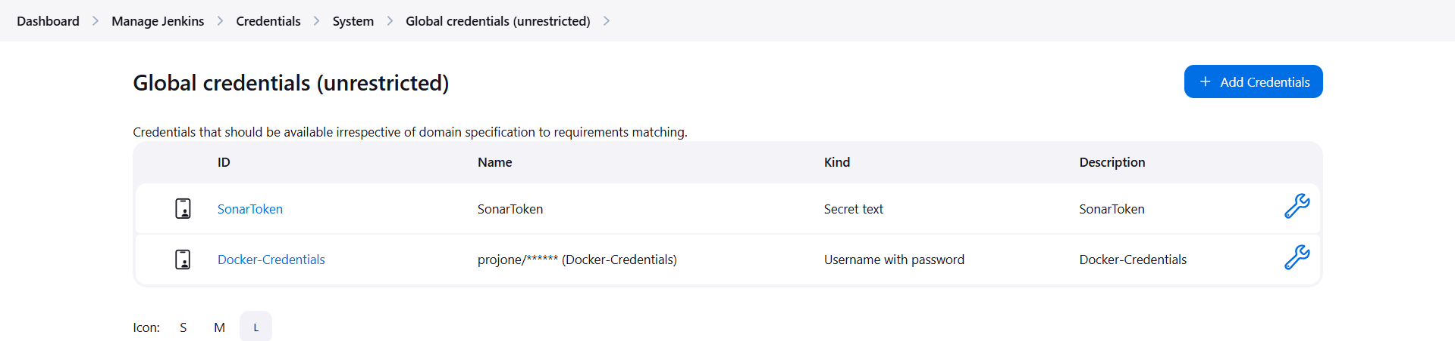
24. Now we have to add/configure servers in Jenkins.
25. Jenkins > Manage Jenkins >System.  
    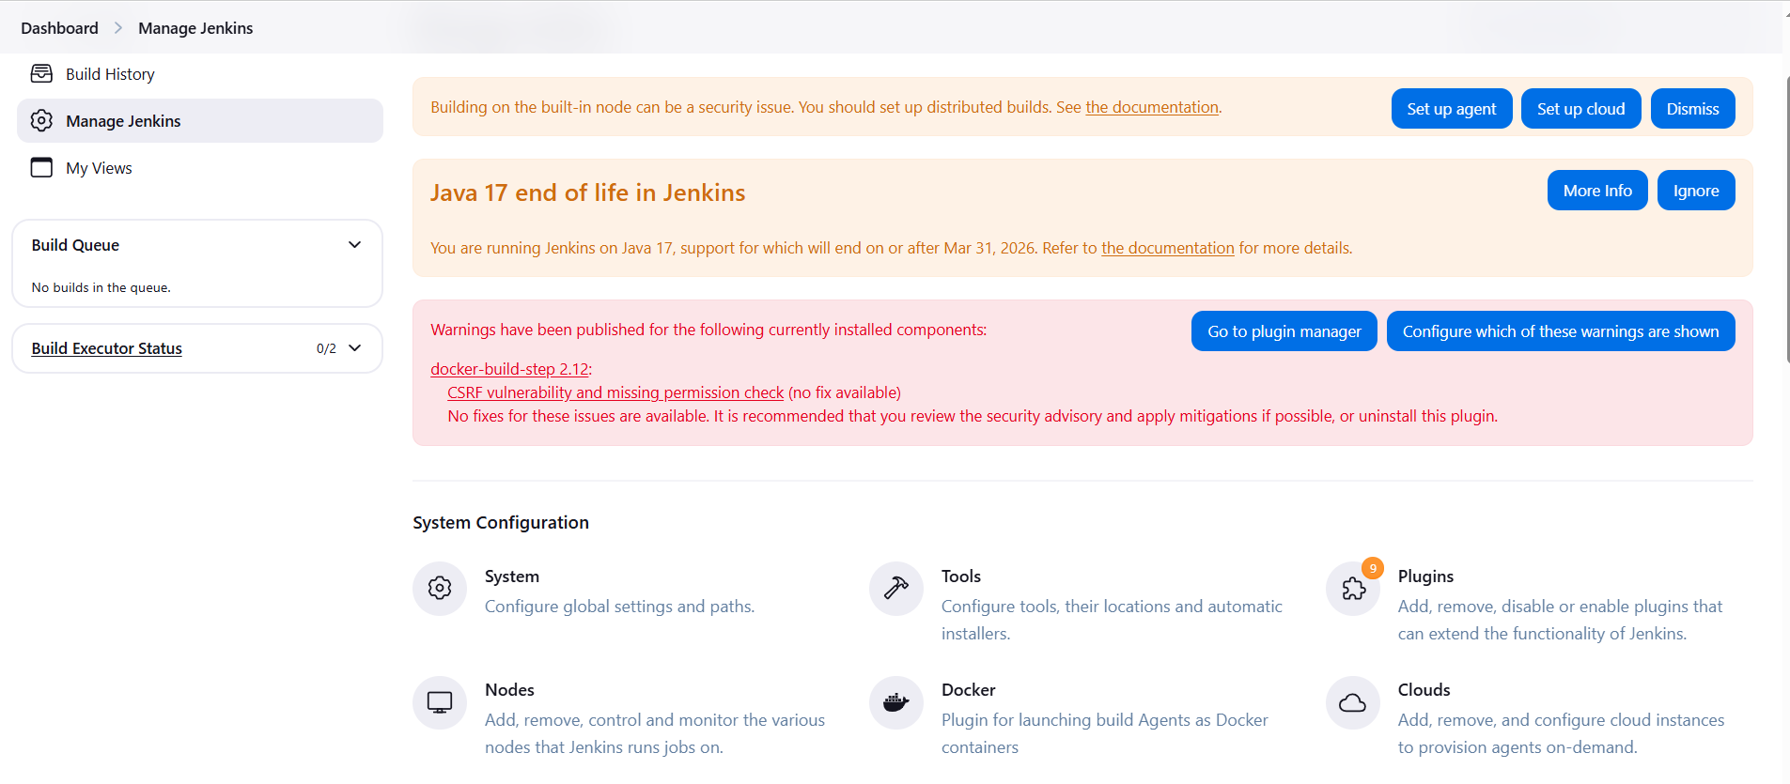
26. The reason we have SonarQube server because we have installed its plugin in Jenkins.  
    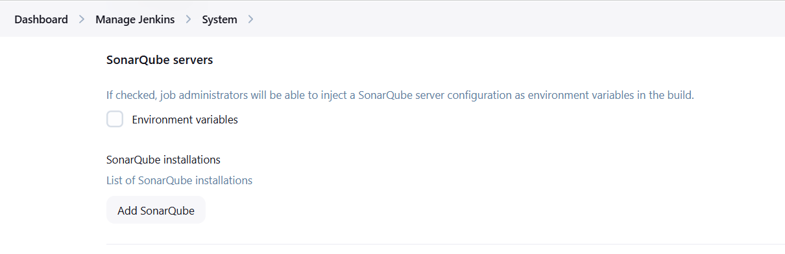
27. Fill in details > Click on Save & Apply.  
    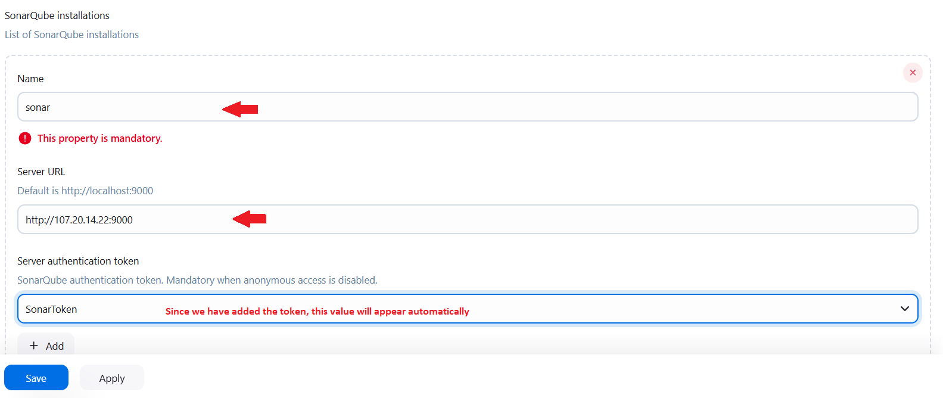
28. Now, we have to setup “Nexus” in Jenkins, follow the below shown process.
29. Install a plugin called “Config File Provider”

**PRO-TIP**

💡What is "Config File Provider" Plugin in Jenkins?

The **Config File Provider Plugin** allows you to:

✅ Store configuration files (like `settings.xml`, `nexus-settings.xml`, `.npmrc`, `.ssh/config`, etc.) inside Jenkins.

✅ Inject these config files into your build workspace (temporarily) **during a Jenkins job**.

So instead of manually placing config files on every Jenkins agent or hardcoding them into your build, Jenkins will handle them cleanly and securely.

💡Why is this useful for Nexus?

When you use **Maven** or **Gradle** or any other build tool in Jenkins, the tool often needs to:

**Upload build artifacts** to Nexus (like `.jar`, `.war`, or `.zip` files).

**Download dependencies** from Nexus.

For this, Maven uses a special configuration file: `settings.xml`.

This file tells Maven:

- Nexus URL.

- Repository credentials.

- Custom repository policies.

💡Why you need Config File Provider before Nexus setup?

Because your Jenkins pipeline or freestyle job needs to point to the **correct `settings.xml` file** (or any other config) to communicate with Nexus.

Without this plugin, Jenkins won't know how to inject that file into the build workspace, and your builds will fail with errors like:

[ERROR] Failed to deploy artifacts: Could not transfer artifact to Nexus

⚙️ 💡Simple Example:

Imagine this scenario:

- You have a Maven project in Jenkins.

- You want to deploy build artifacts to Nexus.

- Maven requires `settings.xml` with Nexus username/password and repository URL.---

✅ Without Config File Provider:

You would have to manually place `settings.xml` in:

/var/lib/jenkins/.m2/settings.xml

...on every agent or master node.

❌ Risky, error-prone, hard to manage, credentials may leak.

✅ With Config File Provider:

1. You install the **Config File Provider Plugin**.

2. You go to Jenkins:

Manage Jenkins -> Managed Files -> Add a new Config -> Maven Settings.xml

3. Enter your Nexus server details, credentials, repository URLs in this UI and save.

4. In your Jenkins job or pipeline, you inject it like:  
groovy

configFileProvider([configFile(fileId: 'nexus-settings-xml-id', targetLocation: 'settings.xml')]) {

sh 'mvn deploy --settings settings.xml'

}

💡 Now your job will always use the correct Nexus configuration **without hardcoding or manual placement**.

Summary:

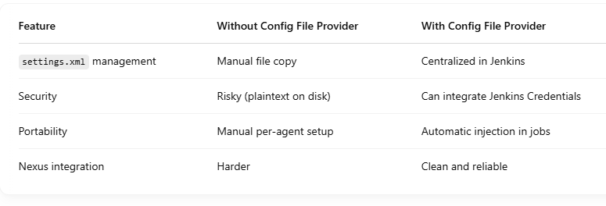

1. To install “Config File Provider” go to Jenkins > Plugins > Available Plugins and install it.  
   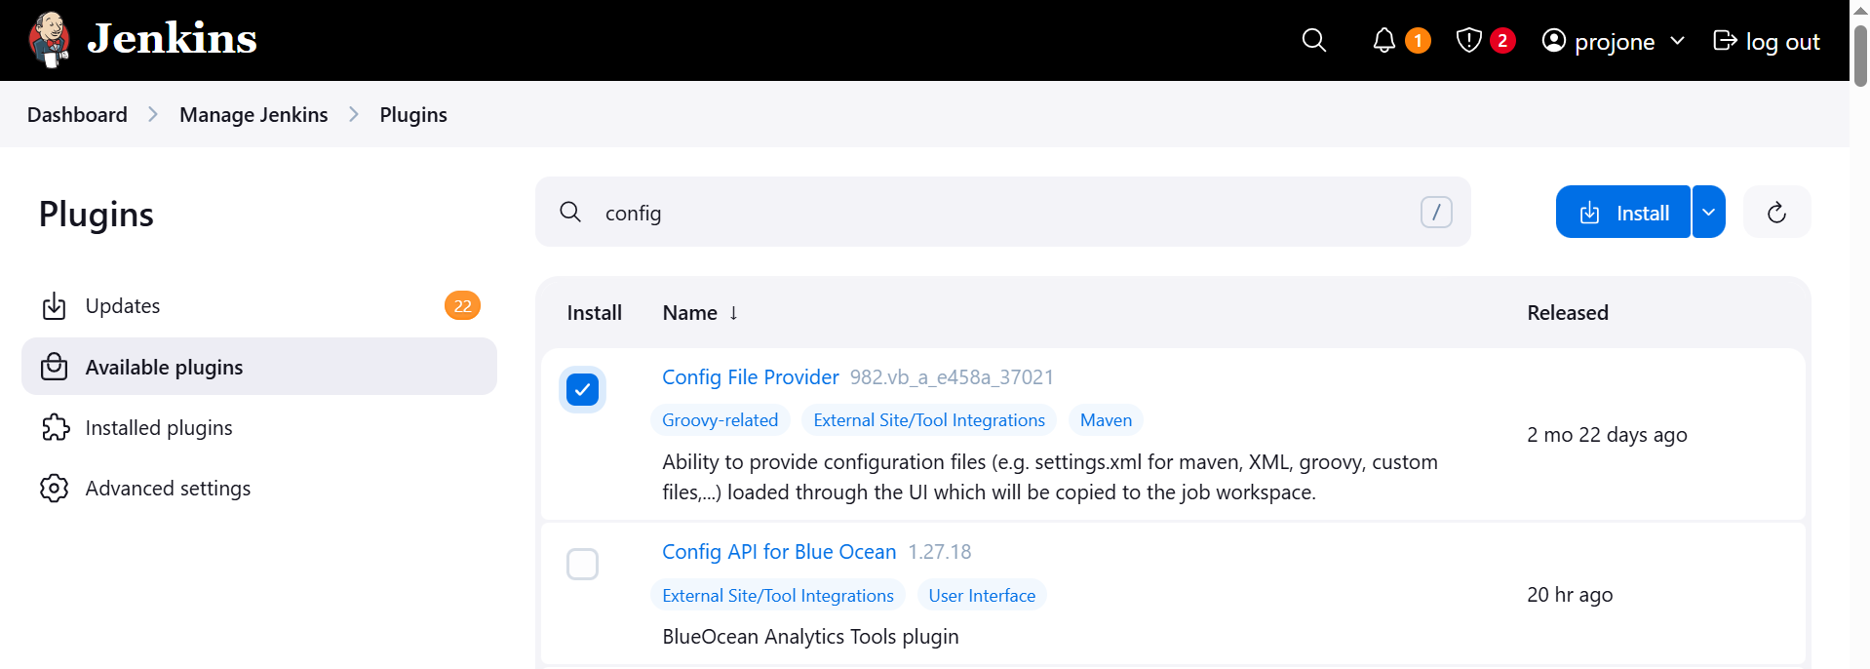  
   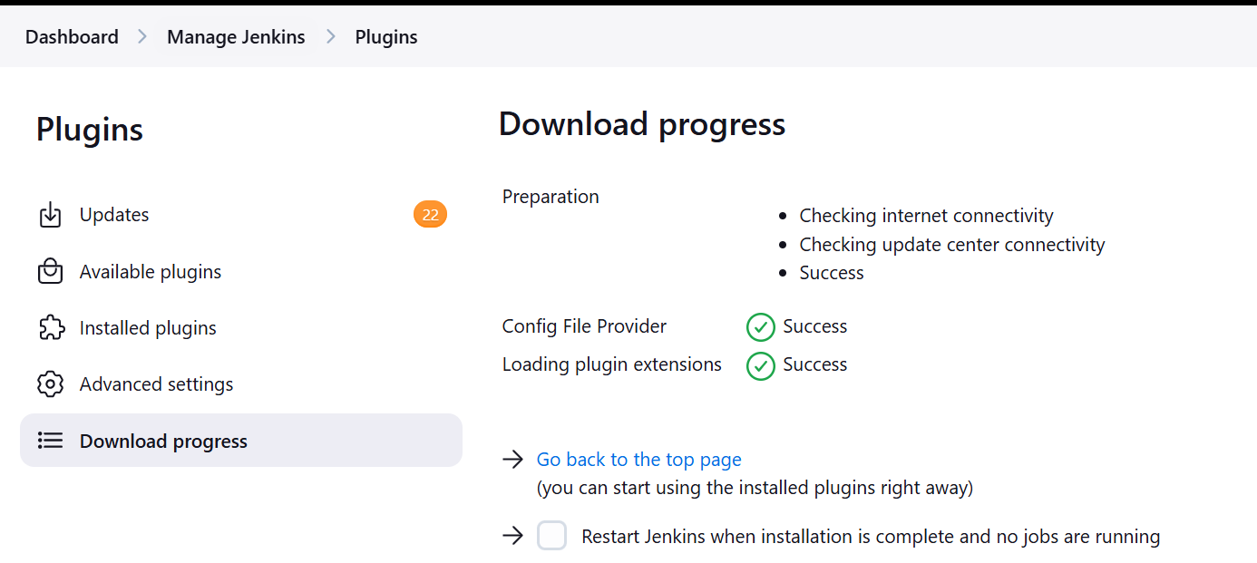
2. After installation “Manage Files” option will be available in Manage Jenkins.  
   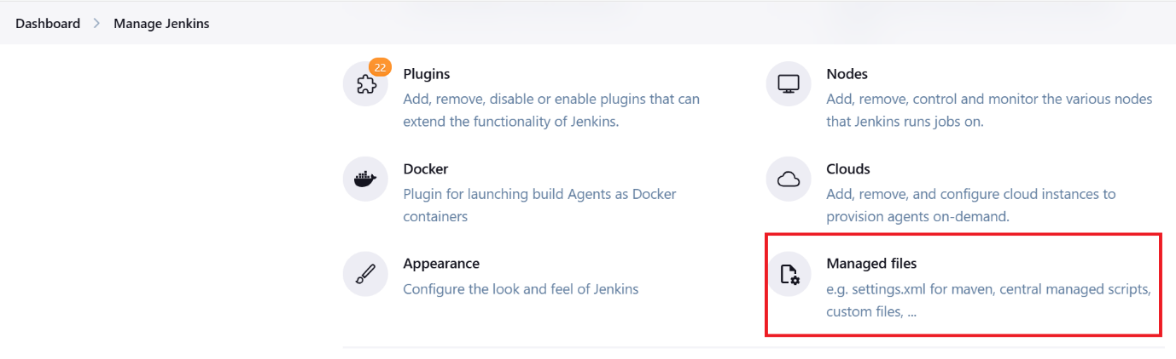
3. Open it and click on “Add Config File”  
   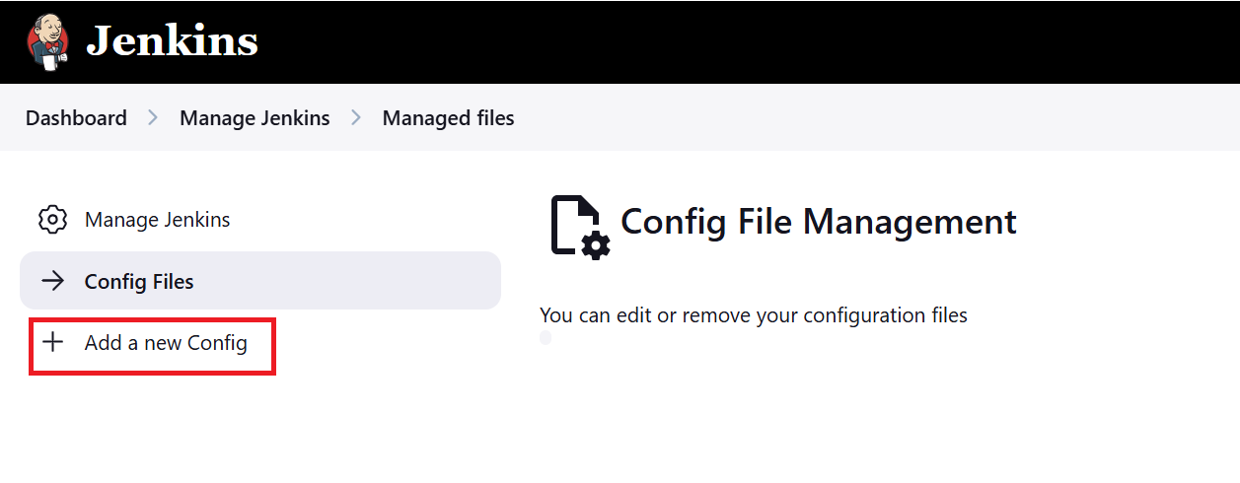
4. Select Global Maven and add the ID  
   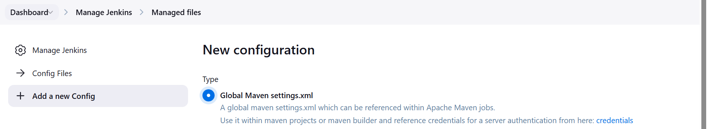  
   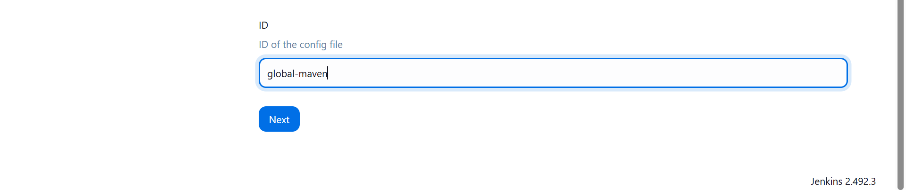
5. Click on Next and provide Nexus Server credentials as shown.
6. We will be using “maven-release” & “maven-snapshot” from Nexus.  
   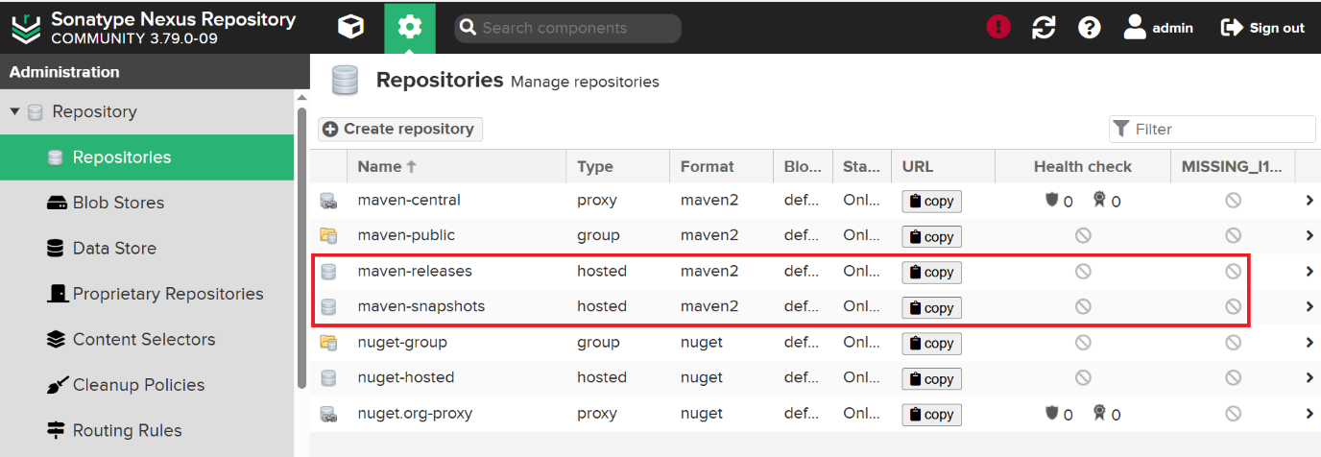
7. We have to take the IDs of both the repositories. Click on “maven-releases”
8. Copy the ID as shown.  
   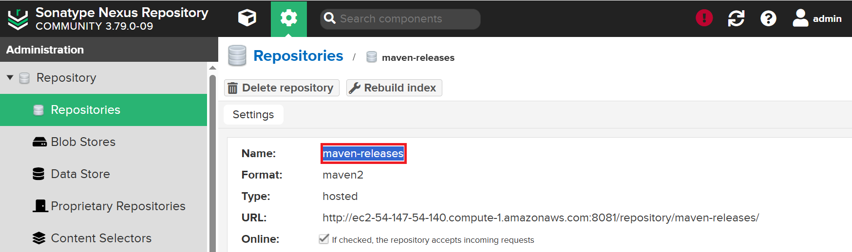
9. Come back to Jenkins > Managed Files > New Confg > Add Confg
10. Add credentials. There are 2 ways as shown below.  
    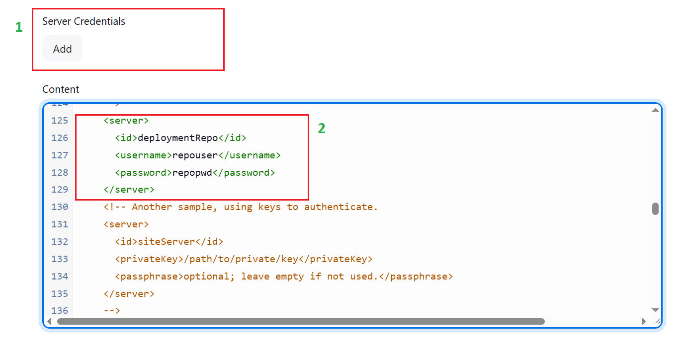
11. In Option 2 the credentials will be visible. As a best practice we can choose Option 1.
12. Add credentials as shown below and click on Submit button  
    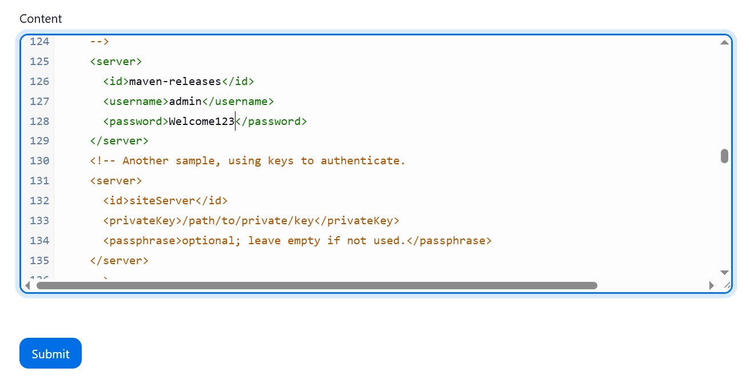

**PRO-TIP**

**Maven Release vs. Maven Snapshot (Nexus Repository)**

When you develop Java projects using **Maven**, you create **builds** (packages like `.jar` or `.war`) — and these builds can be of two types:

---

1. Snapshot

- **Meaning: ** A "work in progress" or **under-development** version.

- **Version Naming: ** Ends with `-SNAPSHOT`.

👉 Example: `myapp-1.0-SNAPSHOT.jar`

- **Purpose: ** You expect to make changes frequently. Every time you build, the Nexus Repository will **overwrite** the old one.

- **Behavior: **

- Maven and Nexus treat it as "always changing."

- When you run `mvn deploy`, the same `1.0-SNAPSHOT` version can be uploaded many times.

- Good for testing, daily development, and early feedback.

---

2. Release

- **Meaning: ** A **final and stable version** ready to be used in production.

- **Version Naming: ** Does **NOT** have `-SNAPSHOT`.

👉 Example: `myapp-1.0.jar`

- **Purpose: ** You don't expect changes — it's "frozen."

- **Behavior: **

- Once deployed to Nexus, **cannot be overwritten** (by default).

- Used when you are sure the code is tested, stable, and ready for users.

---

💡 **Simple Analogy: **

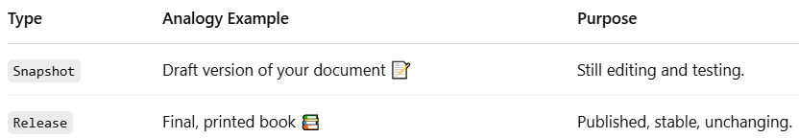

---

💡 **Summary: **

- Use **Snapshot** while you are still developing or testing.

- Use **Release** when the code is finished, tested, and ready for use.

---

✅ **In Nexus:**

- `Snapshots` are usually stored in a **snapshot repository**.

- `Releases` are stored in a **release repository**.

Nexus will not allow you to mix them, and it manages them differently:

- Snapshots can be cleaned up or replaced.

- Releases are permanent and versioned.

1. This is how we need to add the credentials for “Release” & “Snapshot”  
   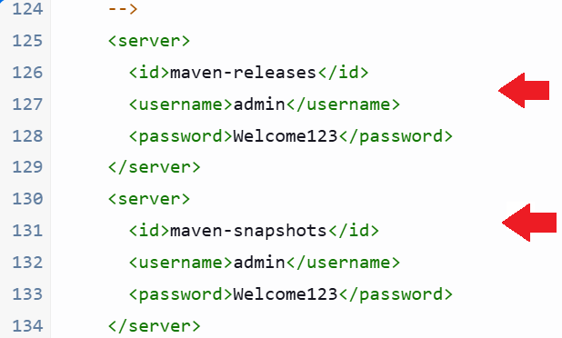
2. Now, we have to make some changes in the below GITHub Repository.  
   <https://github.com/jaiswaladi246/Ekart/blob/main/pom.xml>
3. For Nexus we have defined the credentials inside Jenkins.
4. But we have to define the Nexus Repository URL in the pom.xml file  
   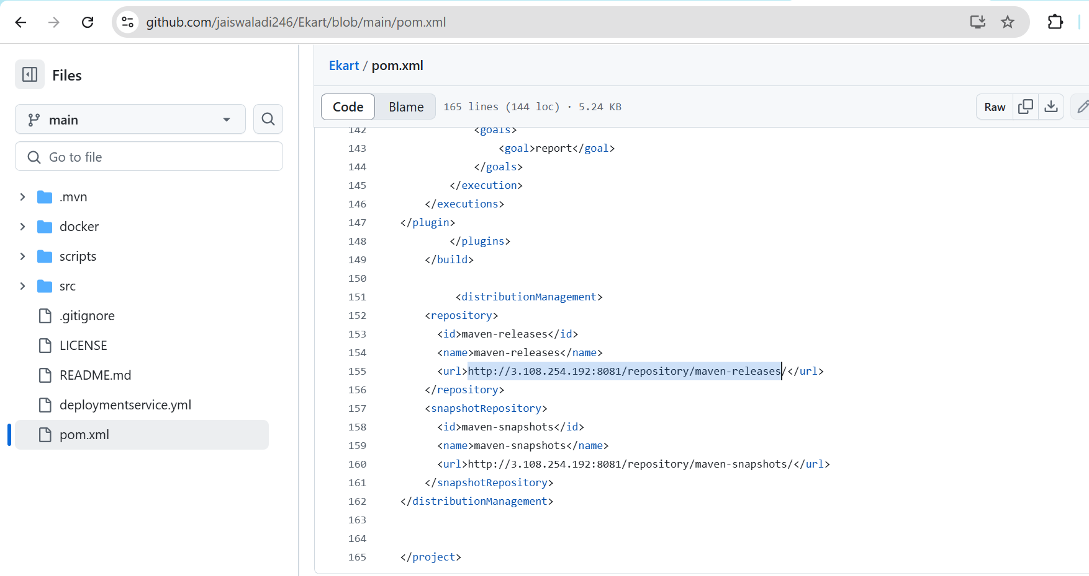
5. We have to update the both URLs i.e “maven-release” & “maven-snapshot” as shown above.
6. Remember, we have to “Fork” the Ekart repository to our GitHub account in case if Edit access is not there.

### ****Steps to Fork the GitHub Repository****

1. **Log in to GitHub**  
   Go to: <https://github.com> and sign in to your account.
2. **Open the Repository**  
   Visit this URL:  
   👉 <https://github.com/jaiswaladi246/Ekart>
3. **Click Fork**  
   On the top-right of the page, you will see a Fork button. Click it.
4. **Choose Your Account**  
   GitHub will ask: Where do you want to fork this repository?  
   Select your account or organization.
5. **Forking Complete!**
6. Now, we can see the changes done. This step is completed.  
   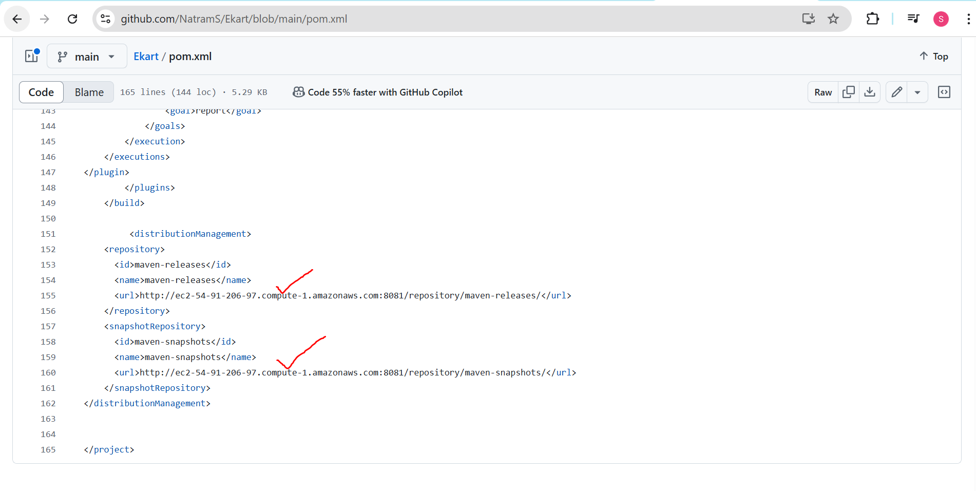
7. Now, lets create our pipeline in Jenkins > New Items  
   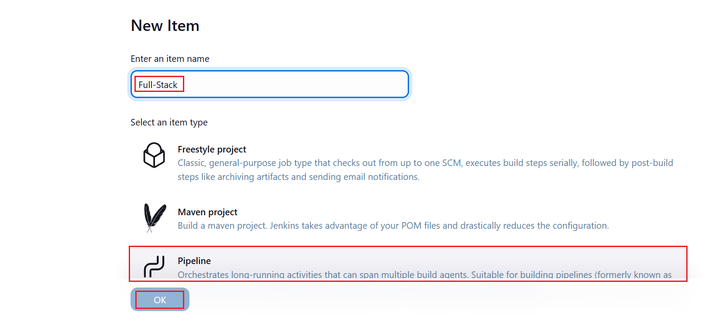
8. Fill in details as shown.  
   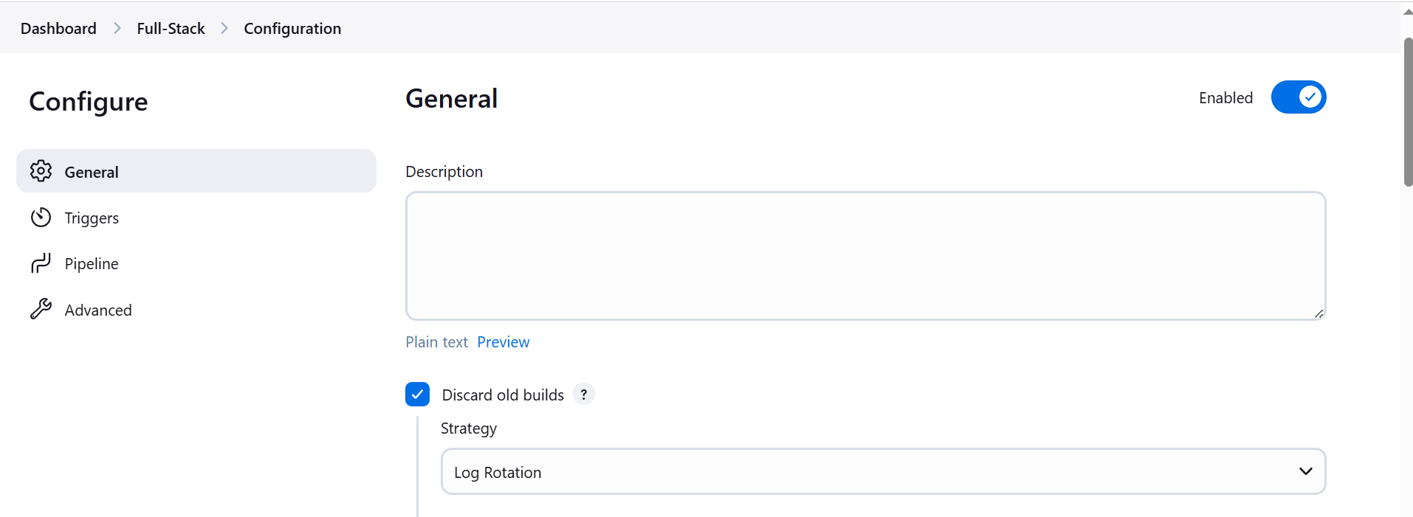  
   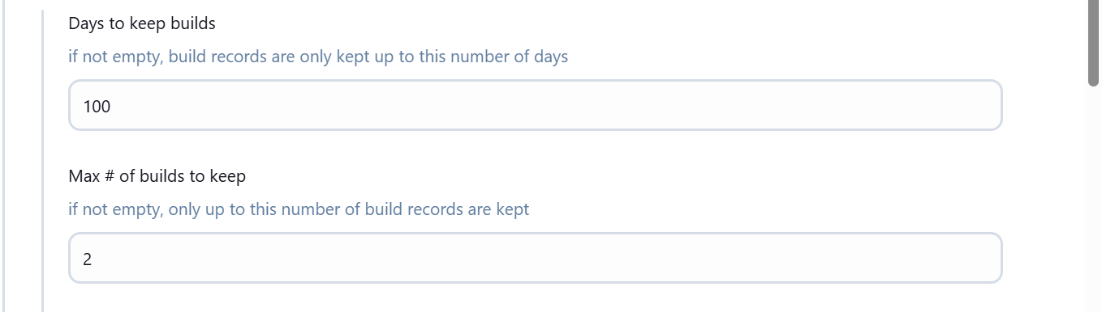  
   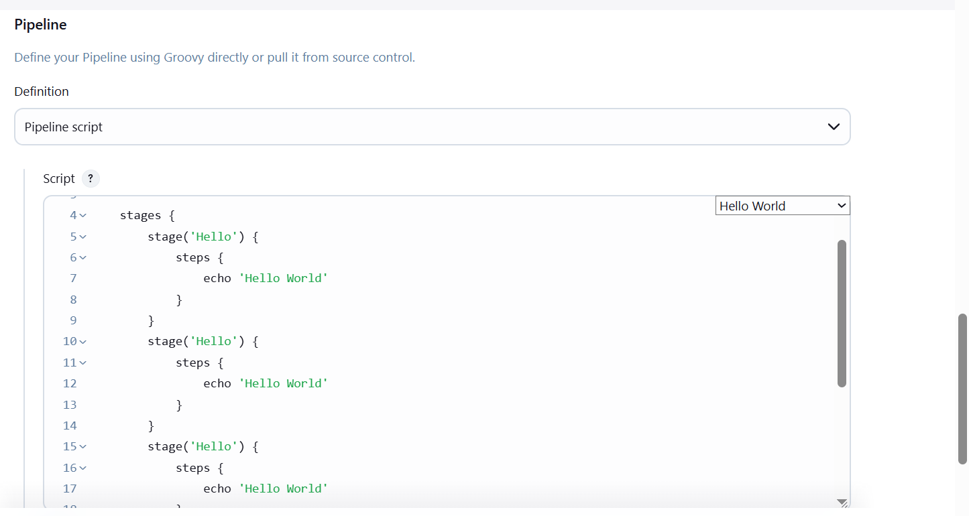
9. Select “Hello World” from the drop down. It will create the basic structure.
10. Now, copy-paste “Stages” 4 times.
11. First Stage will be Git Checkout. Creating local copy of source code in your Jenkins.
12. If you don’t know how to write syntax for Git Checkout then you click on Pipeline Syntax  
    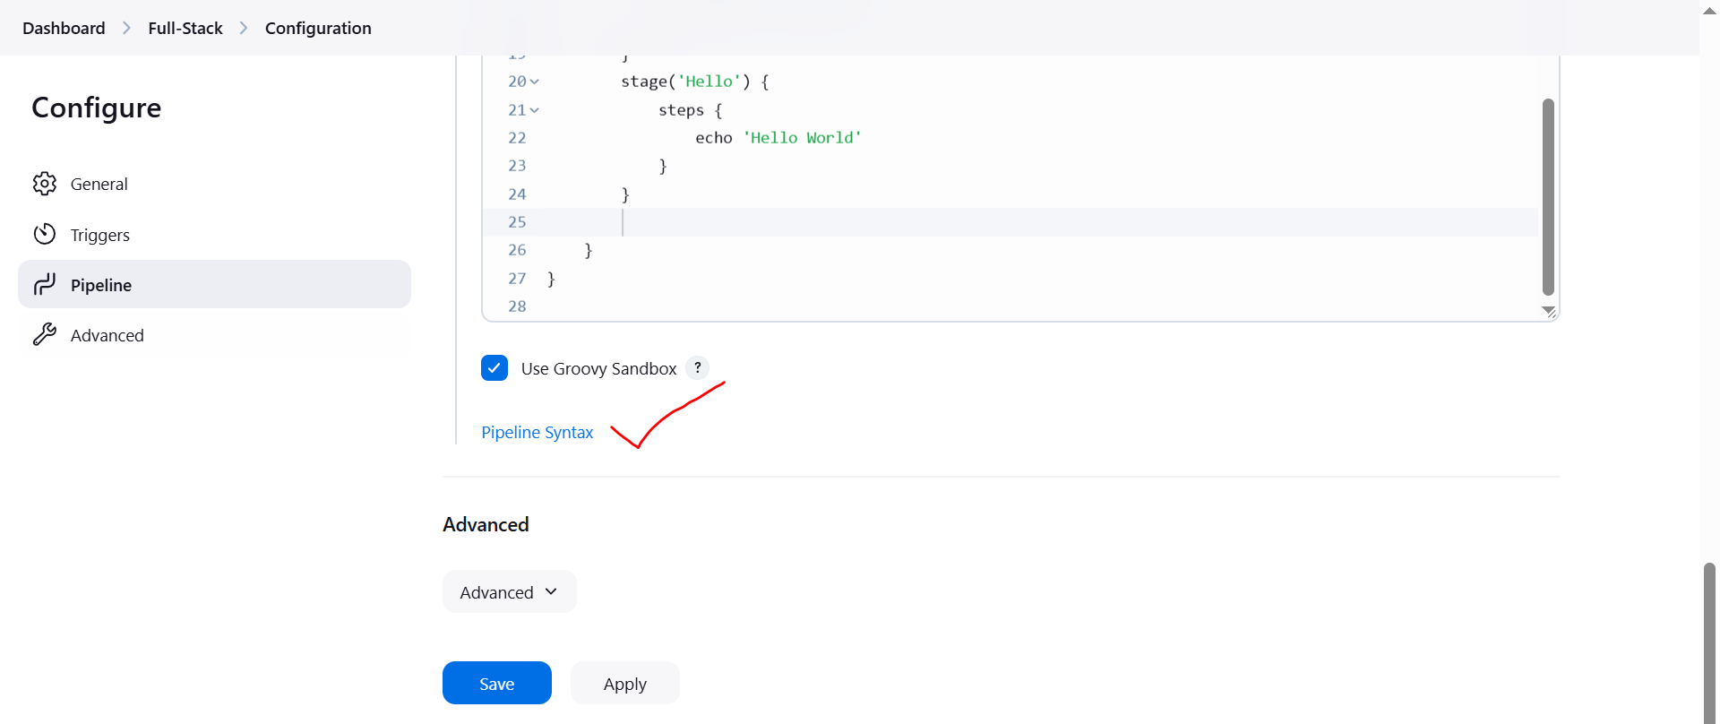
13. Fill in details as shown  
    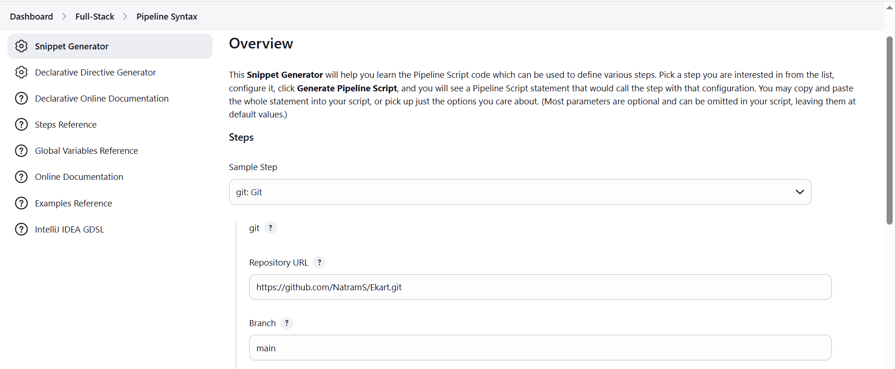  
    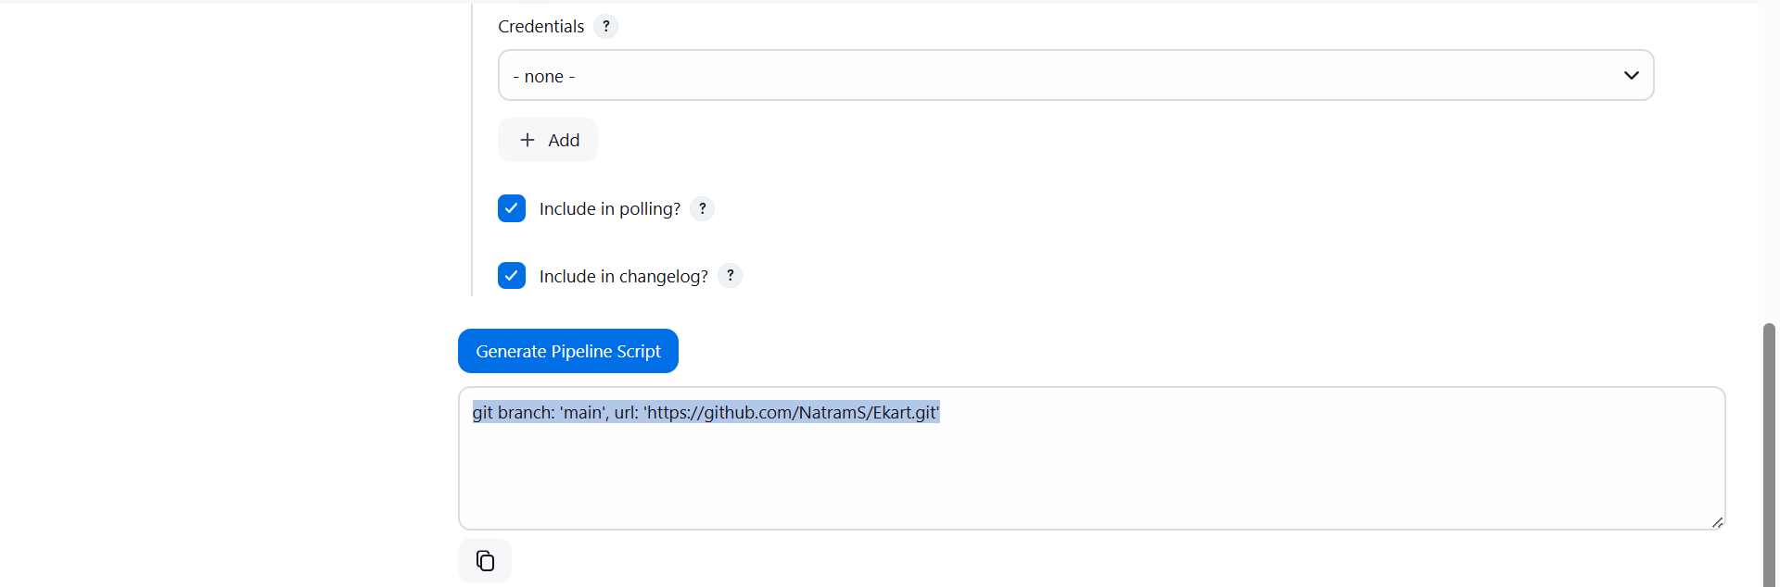
14. Credentials, none selected because we are taking code from Public repository.
15. If it would have been private repository then we need to select credentials.
16. Click on “Generate Pipeline Script” and copy it as shown above.  
      
    **NOTE:** Not all Stages should have same name.
17. Go back to Pipeline stage and paste it as shown for “Git CheckOut”.  
    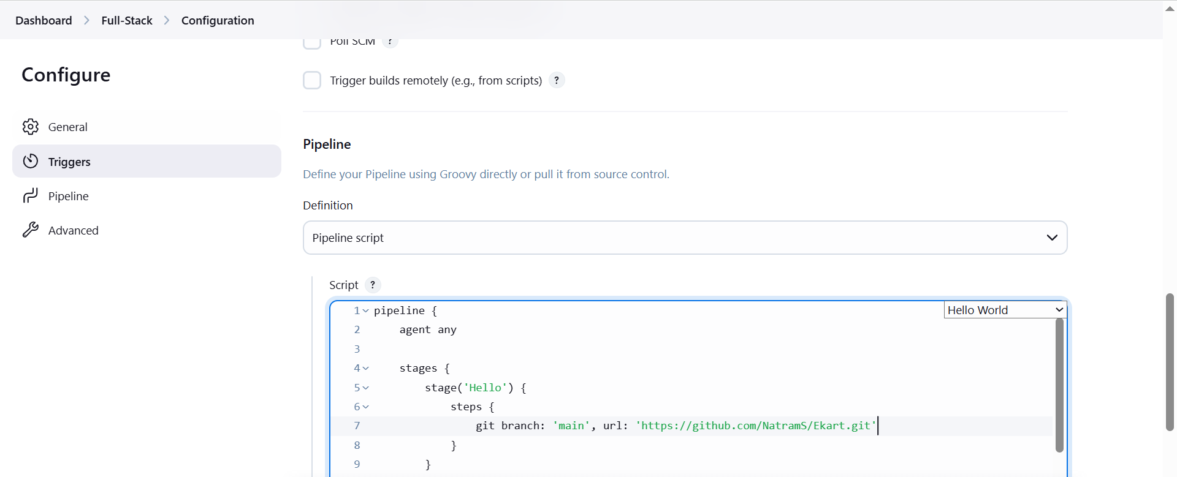



NOTE: Whenever we run the pipeline, everything all the stages will run. Due to this “Test” will fail. So to avoid this, we need to define one parameter as shown below.



We need to update Jenkins pipeline to use specific Java to use as shown below.

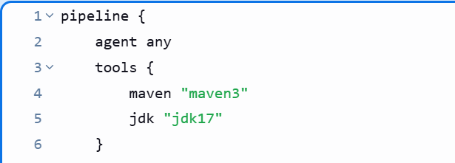

1. Next stage will be “OWASP” dependency check.
2. We have to define environment before using SonarQube scanner as shown below.  
   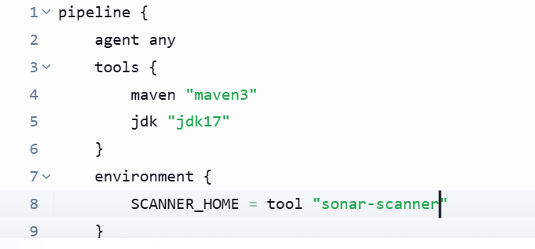
3. Go to Pipeline Syntax Generator and generate code for Sonar-Scanner as shown.
4. We can ignore the error shown in below screenshot.  
   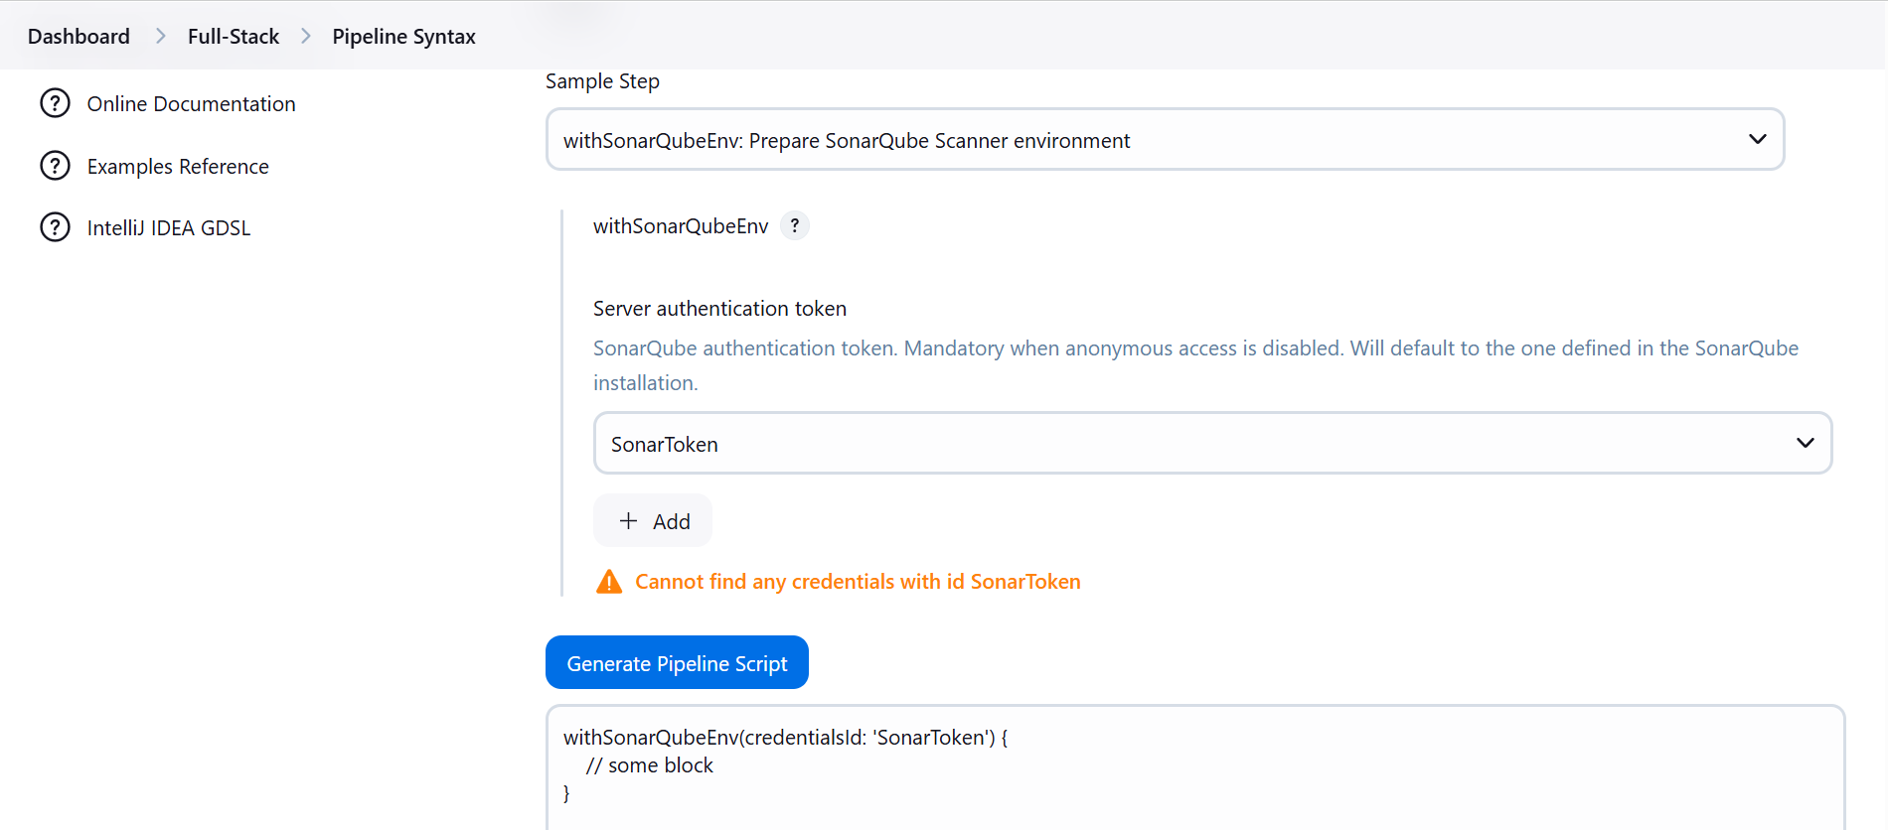
5. Instead of giving SonarQube credentials, we can define the server name as shown below.
6. This will take care of server and its credentials both.  
   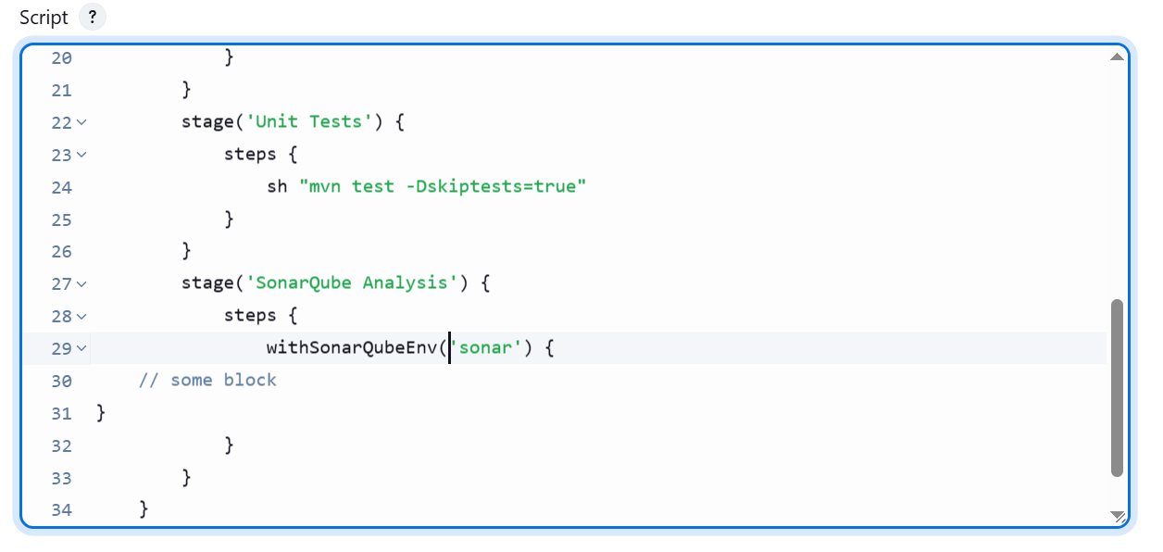

**NOTE:** To confirm the server name, we can navigate to Manage Jenkins > Systems > Check Sonar.

1. After completing the above Jenkins file, executed the pipeline but got lots of errors.
2. Complete end to end troubleshooting report is available in the same folder where this document is saved.
3. Now, we will setup OWASP dependency check inside the Jenkinsfile in Jenkins as shown.
4. Add the below shown code after SonarQube Analysis  
   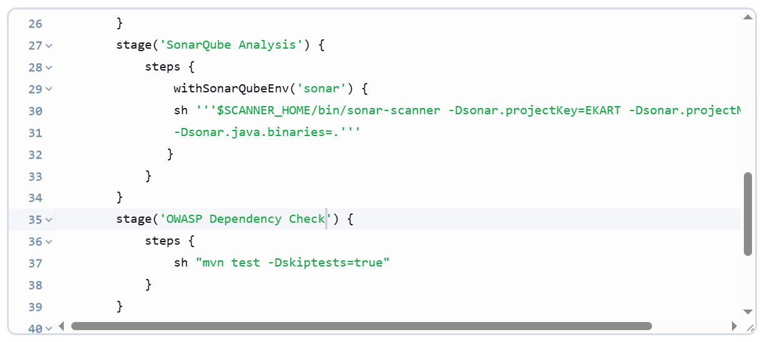
5. After adding this, we need to use “pipeline syntax”.   
   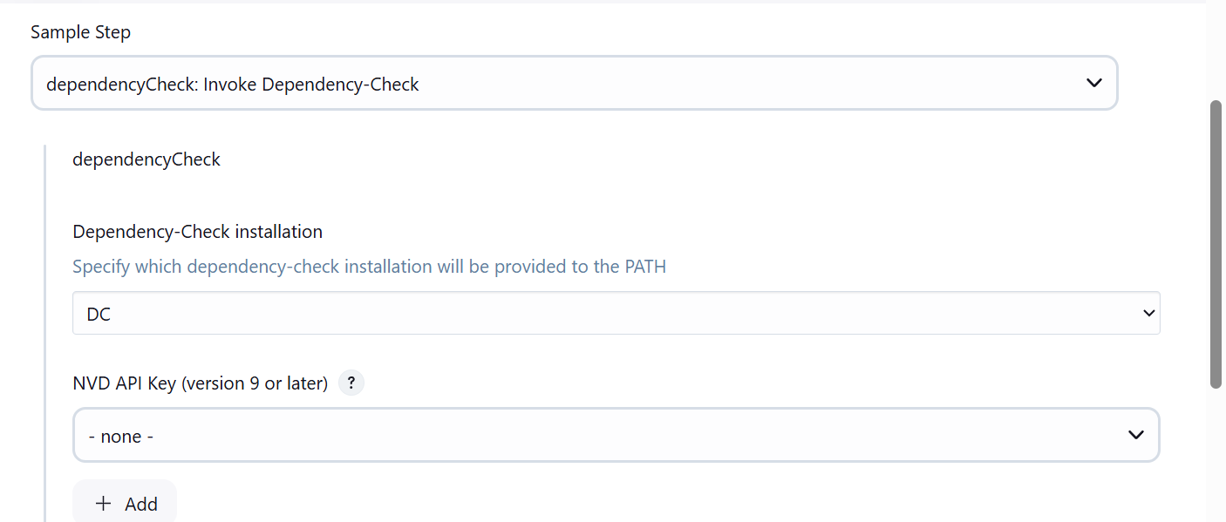  
   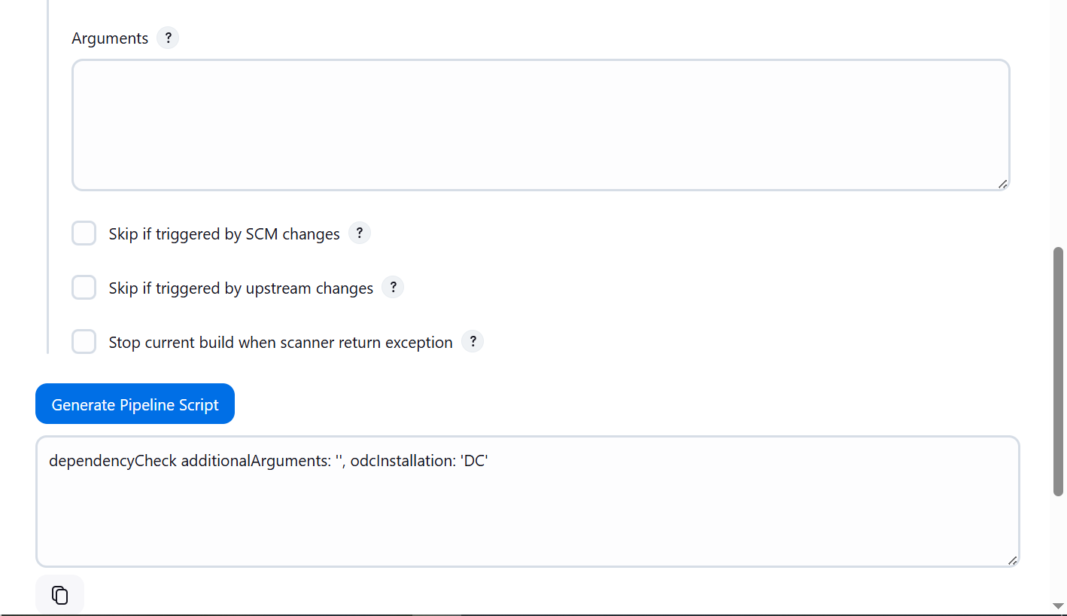
6. Add the below syntax   
   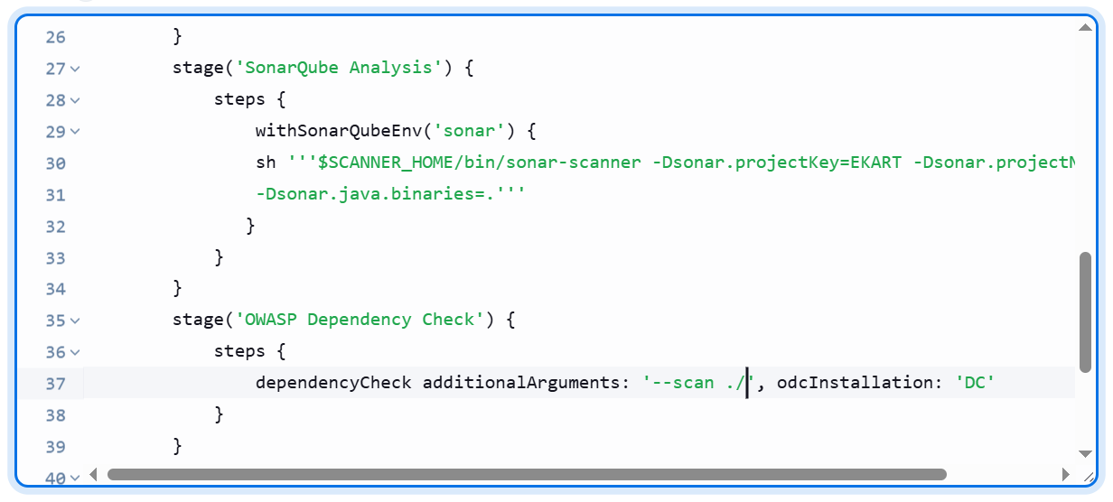
7. Add OWASP dependency check publisher from “pipeline syntax” as shown below.  
   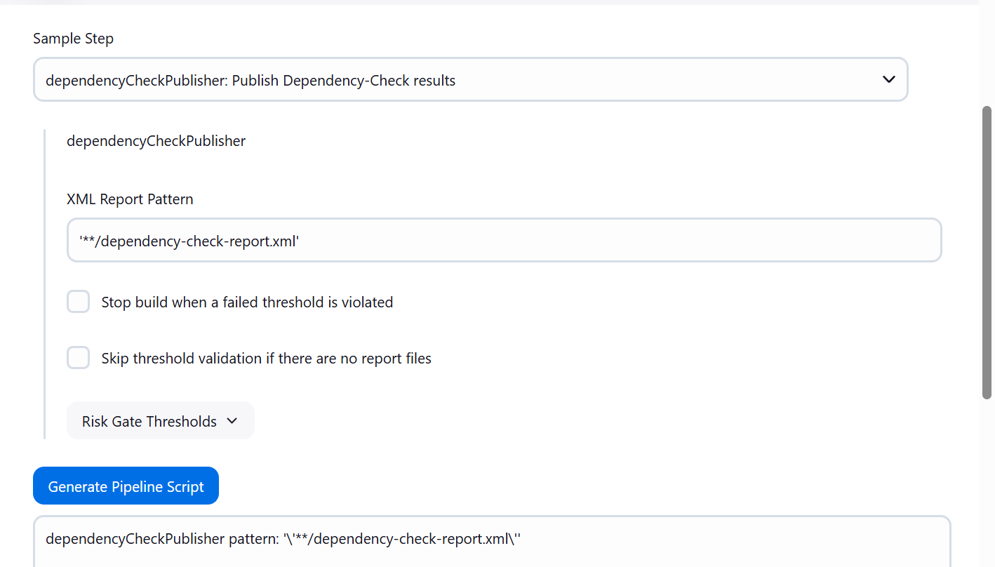
8. We need to add one more line under Dependency check as shown.  
   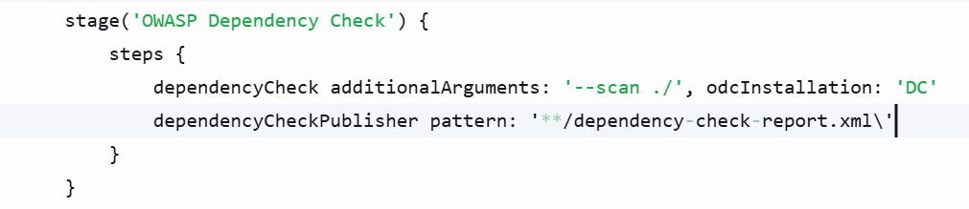
9. Now we have to run the “Build”. Make the below shown changes.
10. Add below shown details
11. We have to deploy the application artifact in Nexus Repository, so do as shown below.
12. We have to install some plugins as shown below.  
    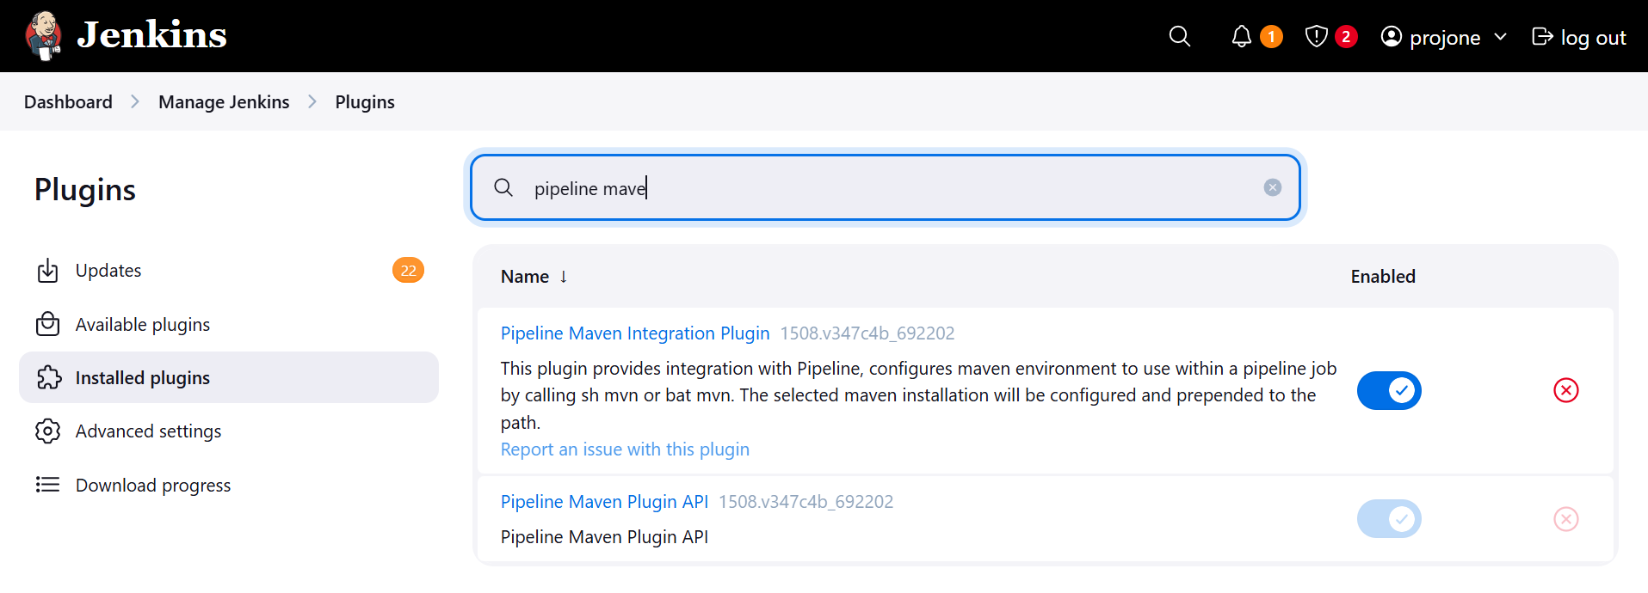
13. After this plugin “Pipeline Maven Integration Plugin” gets installed then generate syntax.
14. Inside pipeline syntax there will be one option
15. Continue from here…..  
    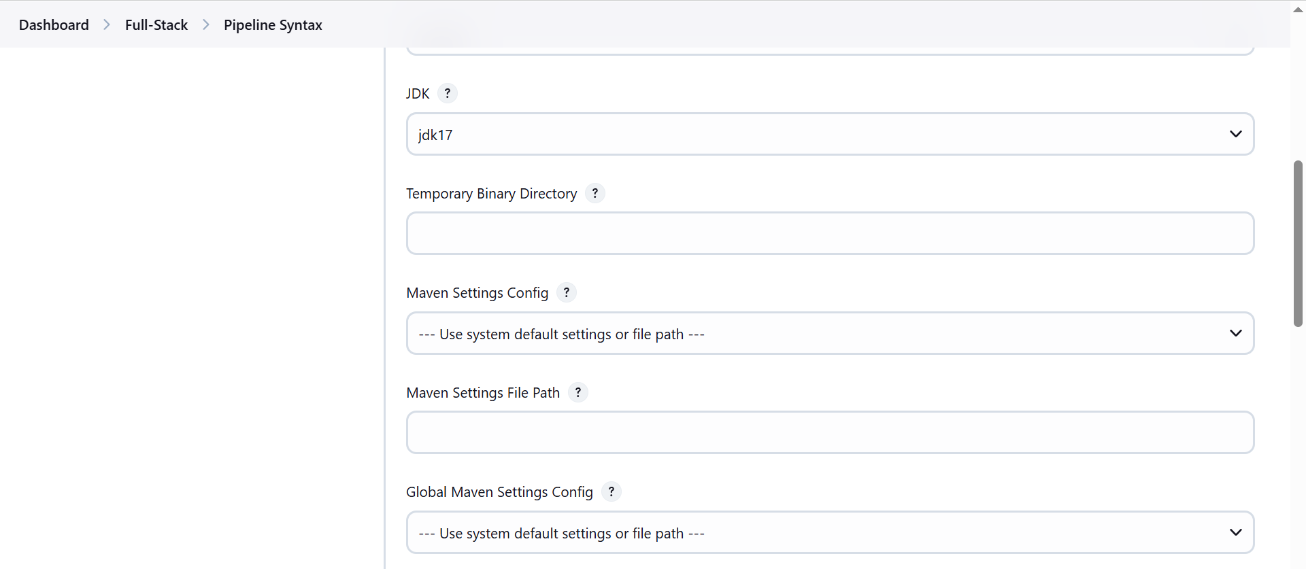
16. MyGlobal Settings is not appearing under “Global Maven Settings Config”  
      
    In Jenkins below was the URL defined as Jenkins URL so I changed it. Below Is backup  
    <http://ec2-3-90-185-173.compute-1.amazonaws.com:8080/>
17. Some corrections needs to be done as shown below everytime we stop and start EC2 instance
    1. **Update the Maven Releases and Maven Snapshots URLs in the settings.xml file  
       Jenkins > Manage Jenkins > Managed Files > settings.xml >Edit file and update URLs**
    2. **Jenkins > Credentials > Global Credentials > Update SonarQube password**
    3. **Login to SonarQube > Administration > Security > Users > Token > Generate pwd.**
    4. **Use the same password and update under Global Credentials > SonarToken.**
    5. **Edit pom.xml file in Github > Update Maven-Releases & Maven-Snapshots URLs.**
18. Now, when we run the Pipeline, we will see that the artifact is now uploaded in Maven-Snapshots repository.
19. This happens because in pom.xml file we have defined repo name as Maven-Snapshots.

**K8s: Installation, Setup & Configurations**

1. We will create 3 separate VMs. 1 Master and 2 Worker Nodes.
2. We will launch EC2 instances with below shown specifications.

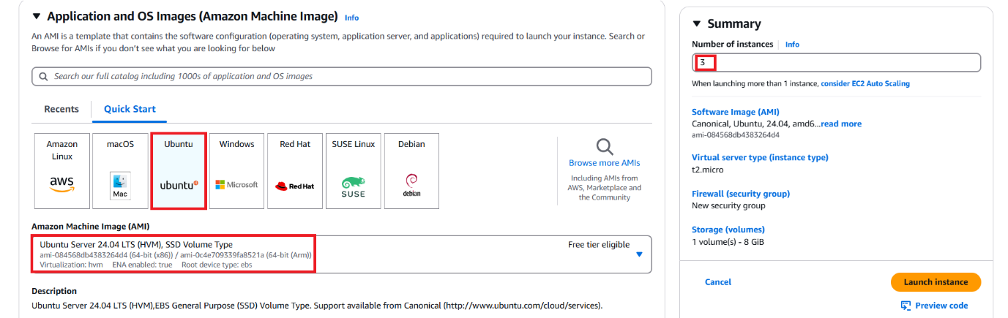  
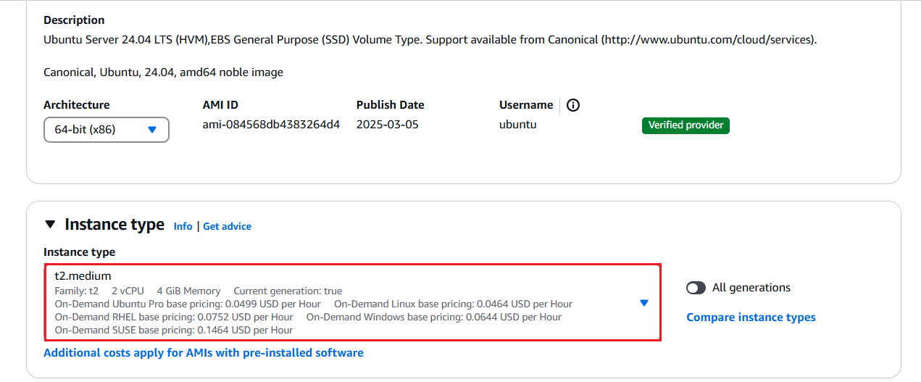  
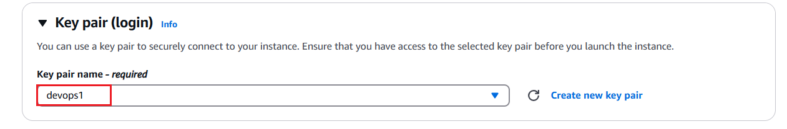  
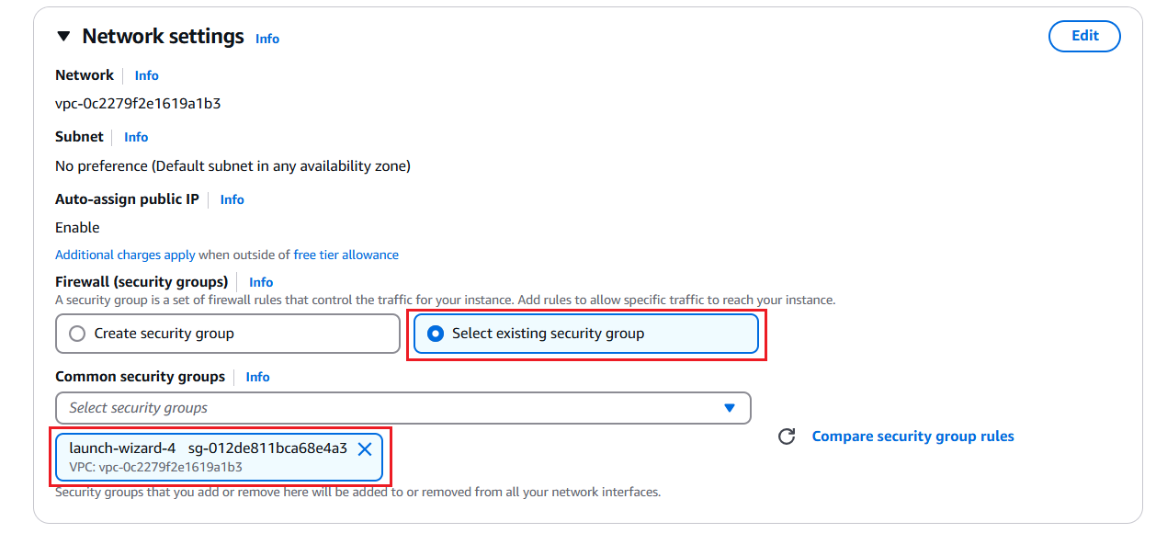  
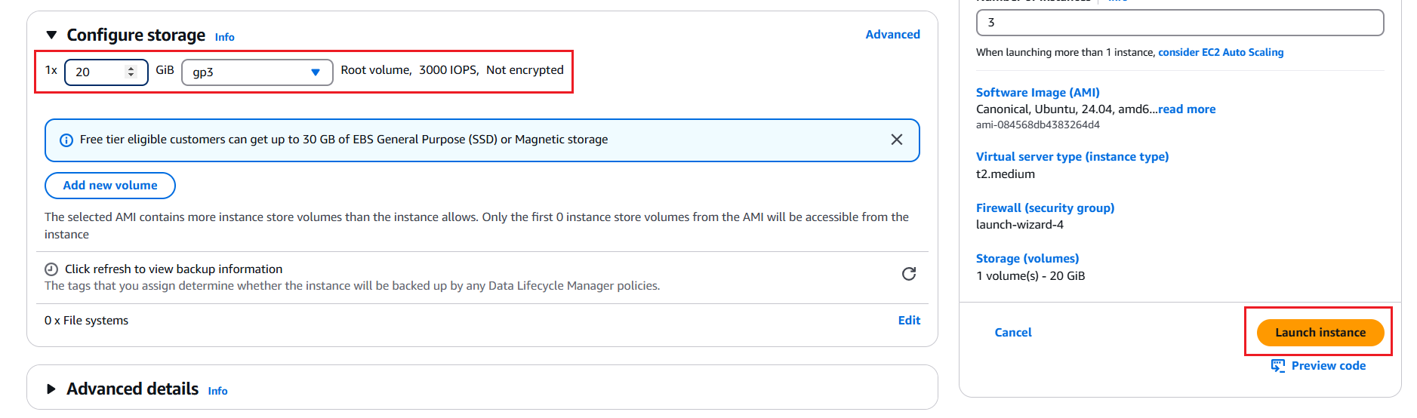

NOTE: K8s is not having compatibility with Ubuntu 24.04 LTS which I used in the above screenshot to create VMs for K8s Master and Worker Node. The installation and setup was failing.  
  
To resolve this issue, I deleted 3 VMs I created using Ubuntu 24.04 LTS and then re-created them using Ubuntu 22.04 LTS and then ran the below shown series of commands in both Master and Worker nodes.

1. Once 3 instances are up and running. Configure them in MobaXterm as shown below.  
   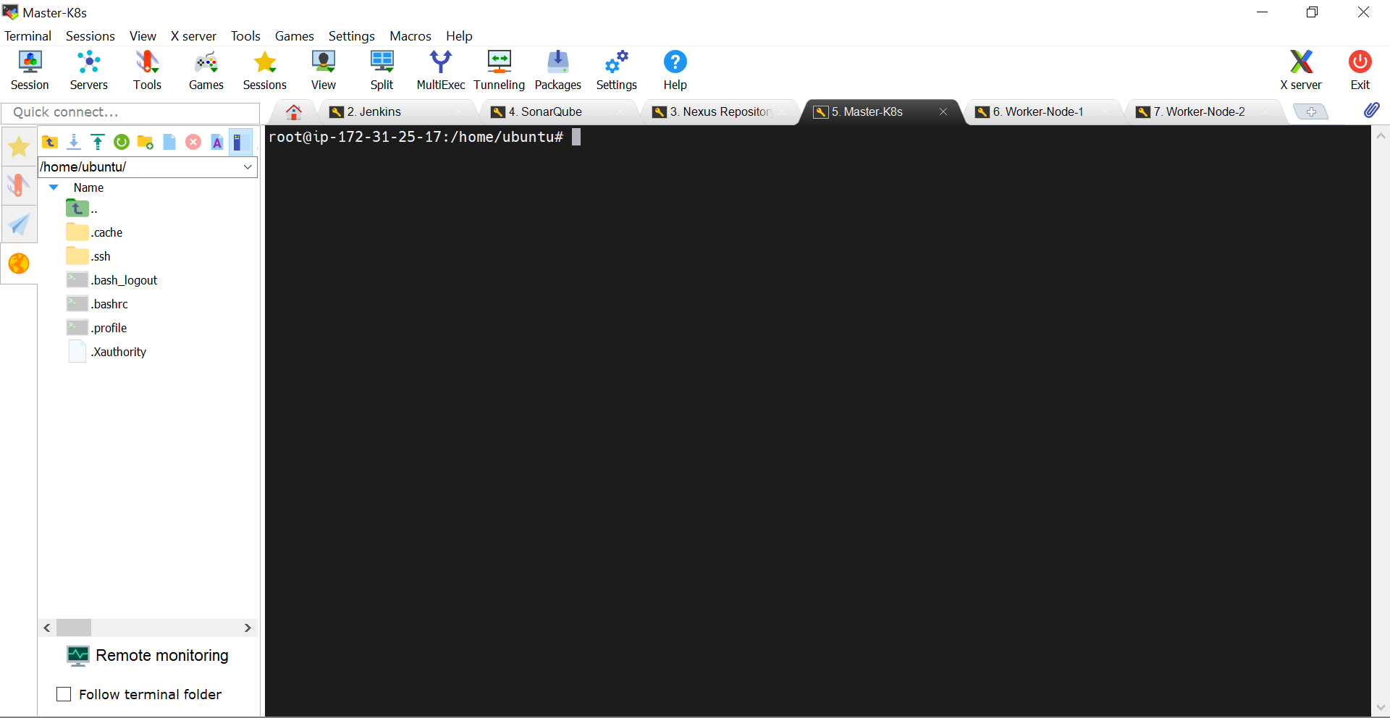
2. Refer the setup and configure in the previous steps showed at beginning of the document.
3. Run the below commands in all 3 servers Master-K8s Worker-Node-1 & Worker-Node-2
   1. sudo apt update
   2. Clear screen by running “clear” command
   3. Change to “root” user in all 3 servers. Command: sudo su
4. Now, we will first configure K8s Master as well as in Worker Node.
5. Run the below shown command in Sequence.  
     
   On Master and Worker Nodes both  
     
   sudo apt update  
   sudo apt-get install docker.io -y  
   sudo service docker restart  
   **# 1. Create the keyrings directory**
6. sudo mkdir -p /etc/apt/keyrings
7. **# 2. Download and store the GPG key**
8. curl -fsSL https://pkgs.k8s.io/core:/stable:/v1.29/deb/Release.key | \
9. sudo gpg --dearmor -o /etc/apt/keyrings/kubernetes-apt-keyring.gpg
10. **# 3. Add the Kubernetes apt repository**
11. echo "deb [signed-by=/etc/apt/keyrings/kubernetes-apt-keyring.gpg] https://pkgs.k8s.io/core:/stable:/v1.29/deb/ /" | \
12. sudo tee /etc/apt/sources.list.d/kubernetes.list > /dev/null
13. **# 4. Update apt sources**
14. sudo apt-get update
15. **# 5. Install kubelet, kubeadm, and kubectl**
16. sudo apt-get install -y kubelet kubeadm kubectl
17. **# 6. Prevent them from being upgraded automatically**
18. sudo apt-mark hold kubelet kubeadm kubectl

**Explanation of Commands**:  
  
Absolutely! Let's break down **why** you run each command during Kubernetes installation — and how it's different for the **Master** and **Worker nodes** — using simple explanations and examples.

## Goal:

Set up a Kubernetes cluster using **kubeadm**, with:

* One **Master node** (control plane)
* One or more **Worker nodes**

## What Each Command Does (for BOTH Master & Worker Nodes)

### ✅ 1. Create keyring directory

sudo mkdir -p /etc/apt/keyrings

**Why**: This folder securely stores the key used to verify Kubernetes packages.

### ✅ 2. Add GPG Key for Kubernetes

curl -fsSL https://pkgs.k8s.io/core:/stable:/v1.29/deb/Release.key | \

sudo gpg --dearmor -o /etc/apt/keyrings/kubernetes-apt-keyring.gpg

**Why**: This key ensures that the Kubernetes software you're installing is trusted and hasn't been tampered with.

### ✅ 3. Add Kubernetes APT Repository

echo "deb [signed-by=/etc/apt/keyrings/kubernetes-apt-keyring.gpg] https://pkgs.k8s.io/core:/stable:/v1.29/deb/ /" | \

sudo tee /etc/apt/sources.list.d/kubernetes.list > /dev/null

**Why**: This tells your system **where** to find the Kubernetes packages.

### ✅ 4. Update package index

sudo apt-get update

**Why**: Refreshes the list of available software from all repositories — including the new Kubernetes repo.

### ✅ 5. Install Kubernetes Components

sudo apt-get install -y kubelet kubeadm kubectl

**Why**:

* kubeadm – tool to bootstrap the cluster
* kubelet – runs on every node, talks to the API server
* kubectl – command-line tool to manage the cluster (usually used on the Master node)

### ✅ 6. Hold packages

sudo apt-mark hold kubelet kubeadm kubectl

**Why**: Prevents these core packages from being accidentally upgraded, which can break cluster compatibility.

## 🧠 How It’s Used Differently on Master and Worker Nodes

| **Command** | **Master Node** | **Worker Node** |
| --- | --- | --- |
| kubeadm init | ✅ Run this to create the cluster | ❌ Do NOT run on workers |
| kubeadm join <token> | ❌ Not needed | ✅ Use this to join the cluster |
| kubectl | ✅ Used to manage the cluster | Optional (usually not used) |

### 🧪 Example

* On **Master Node**:
* sudo kubeadm init --pod-network-cidr=192.168.0.0/16

Initializes the control plane.

* On **Worker Nodes**:
* sudo kubeadm join <master-ip>:6443 --token <token> --discovery-token-ca-cert-hash sha256:<hash>

Joins the worker to the Master node.

**Explanation of below command**  
  
kubeadm init --pod-network-cidr=192.168.0.0/16  
  
  
Yes, let's break it down in a **very simple way**.

## Command:

kubeadm init --pod-network-cidr=192.168.0.0/16

### 🔧 What this command does:

This command **initializes the Kubernetes Control Plane** (a.k.a. Master Node) and prepares the cluster.

## Why we run kubeadm init?

It’s like setting up the **"brain" of your Kubernetes cluster**.  
It creates:

* The Kubernetes **API Server**
* The **Scheduler**
* The **Controller Manager**
* **Certificates and tokens** for cluster authentication
* A **Join command** for workers to connect to this cluster

Think of it as:  
🧠 "Hey Master node, start acting as the boss of a new Kubernetes cluster!"

## Why use --pod-network-cidr=192.168.0.0/16?

This option **sets the IP address range** for **Pods** in your cluster.

### Example:

If your Pods are tiny applications like:

* pod-A (nginx)
* pod-B (mysql)

Then this range (e.g., 192.168.x.x) is how they talk to each other **inside** the cluster.

You must set this **to match your CNI plugin** (Container Network Interface) later — for example:

* **Calico**, **Weave**, or **Flannel** expect --pod-network-cidr=192.168.0.0/16

## Is this command common to all K8s Master setups?

* **Yes**, it's commonly used for all master nodes.
* The **--pod-network-cidr** value may **change** depending on which **network plugin** you choose.

## In short:

| **Part** | **Purpose** |
| --- | --- |
| kubeadm init | Creates the Kubernetes Master Node |
| --pod-network-cidr=192.168.0.0/16 | Reserves a private IP range for Pods to communicate |

Once the above command completes, we will see one command as output as shown below which is highlighted.  
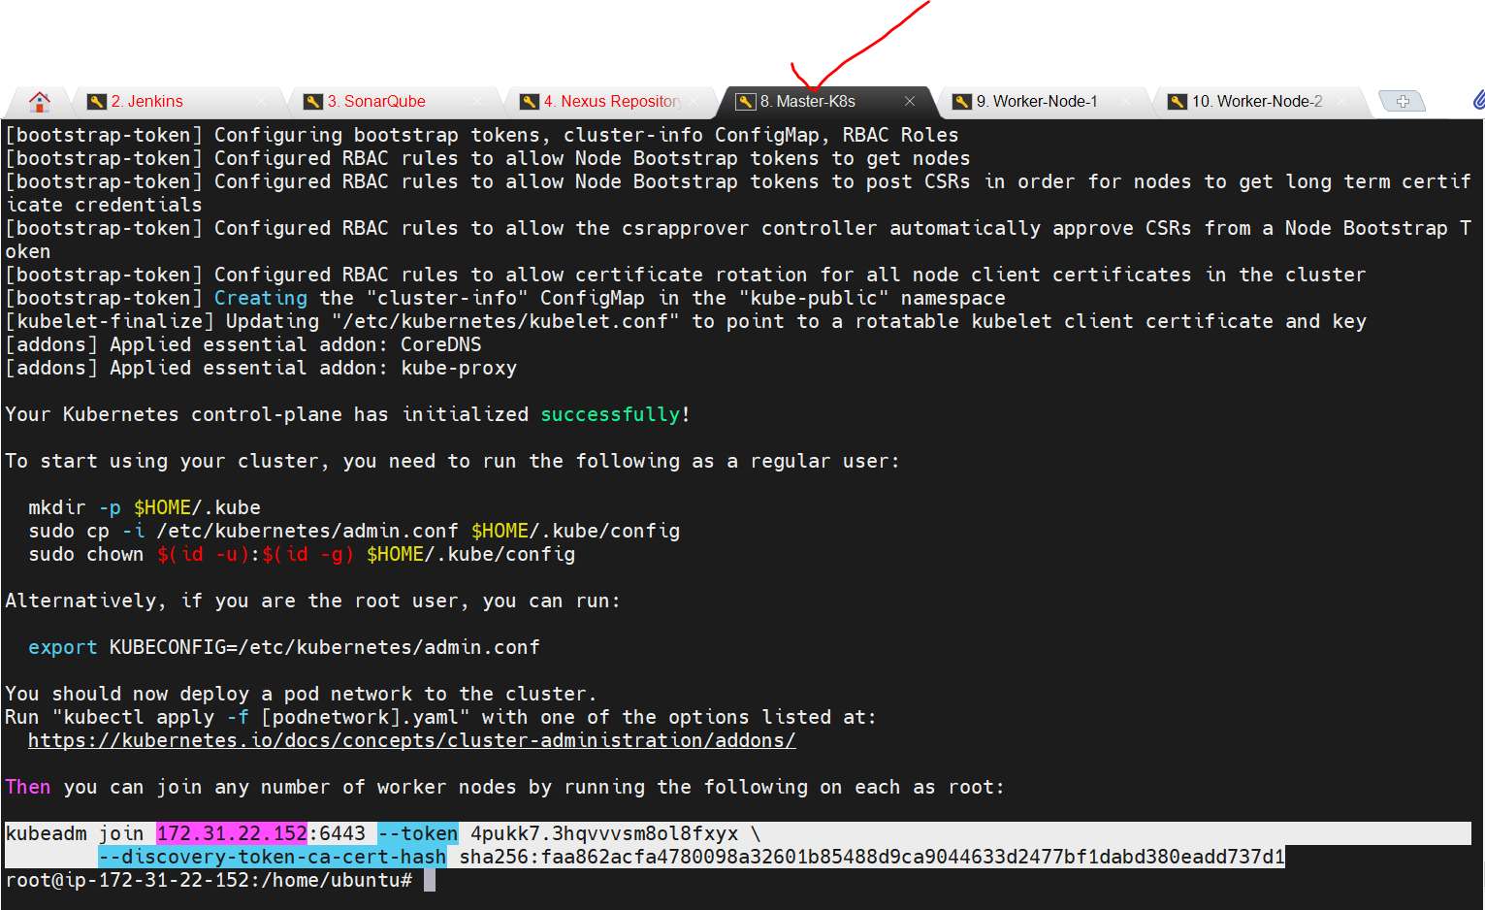

Absolutely! Let's break this down into an easy explanation:

## 🧩 Command:

kubeadm join 172.31.22.152:6443 --token 4pukk7.3hqvvvsm8ol8fxyx \

--discovery-token-ca-cert-hash sha256:faa862acfa4780098a32601b85488d9ca9044633d2477bf1dabd380eadd737d1

## 🎯 What does this command do?

This command is used to **join a Worker Node to the Kubernetes Master (Control Plane)**.

## 🧠 Think of it like:

You're setting up a team.

* The **Master node** is the **Manager (Boss)**.
* The **Worker node** is a **New Employee**.
* The **Join command** is like giving the new employee:
  + An **Access ID** (--token)
  + The **Manager's contact info** (172.31.22.152:6443)
  + A **security fingerprint** to verify the Manager is real (--discovery-token-ca-cert-hash)

## 🔍 Breakdown of each part:

| **Part** | **Meaning** |
| --- | --- |
| kubeadm join | Command used to add a node to the cluster |
| 172.31.22.152:6443 | IP and port of the Master (Control Plane) |
| --token ... | Temporary token used for authentication |
| --discovery-token-ca-cert-hash ... | Verifies the Master node’s identity for security |

## 📦 In Simple Example:

1. You set up a **Kubernetes Master node**.
2. You want to add a **Worker node**.
3. On the Worker node, you run the kubeadm join command.
4. That node will:
   * Contact the Master
   * Use the token to authenticate
   * Verify the Master’s identity using the certificate hash
   * Successfully join the cluster

## 🔐 Why the --discovery-token-ca-cert-hash is important?

It protects you from accidentally joining a **fake or incorrect Master server**.  
It's like checking the **digital fingerprint** of the boss before trusting them.

## ✅ Final Summary

The kubeadm join command securely connects a worker node to your Kubernetes cluster using a token and a certificate hash, so they can start running workloads managed by the master node.

Now, we need to run the above command in both the Worker Nodes since we have to connect them with Master K8s.  
  
kubeadm join 172.31.22.152:6443 --token 4pukk7.3hqvvvsm8ol8fxyx \

--discovery-token-ca-cert-hash sha256:faa862acfa4780098a32601b85488d9ca9044633d2477bf1dabd380eadd737d1  
  
So the bottom line is that, if we want any worker node to connect/join master node then we have to run the above kubeadm command i.e. kubeadm join……  
  
Make sure either you are in root or run with sudo command, the above command in worker nodes.  
After running the command on Worker nodes, it will display the below messages.

After running command in K8s master, you need to follow the instructions shown.  
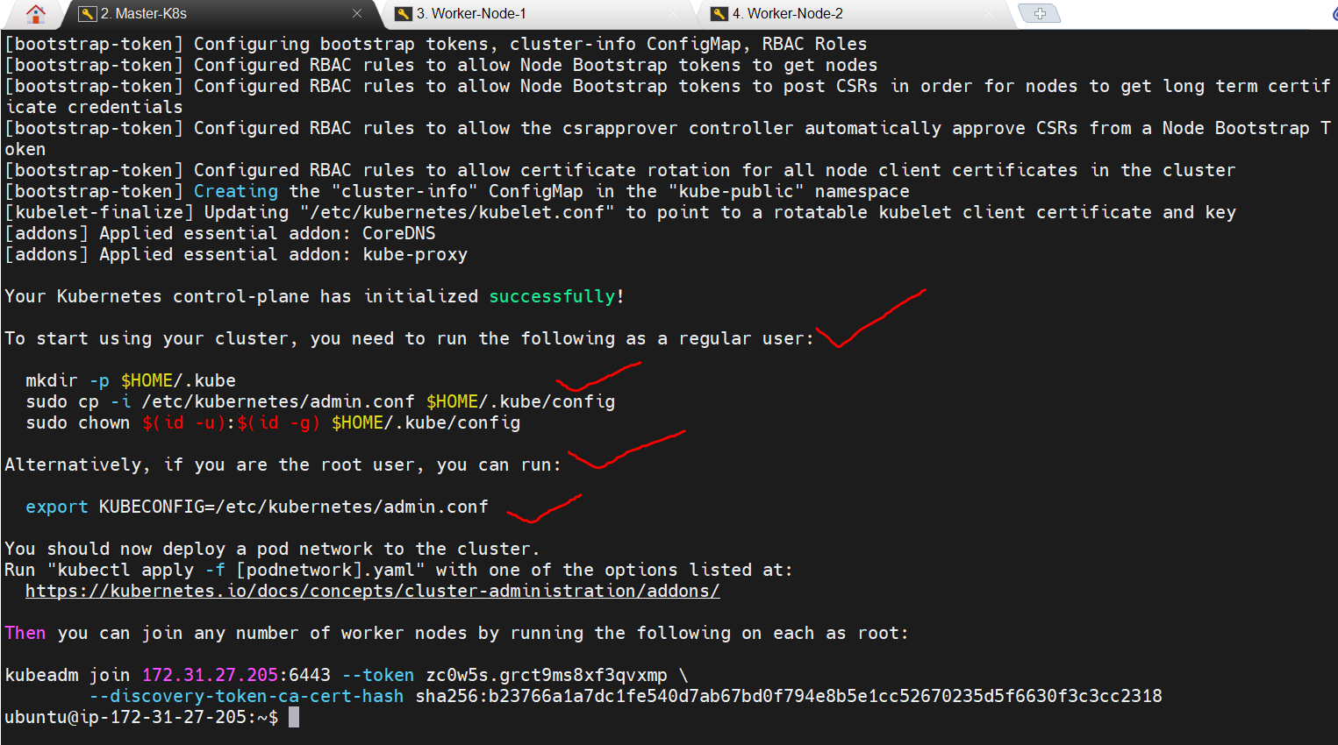

To start using your cluster, you need to run the following as a regular user:

mkdir -p $HOME/.kube

sudo cp -i /etc/kubernetes/admin.conf $HOME/.kube/config

sudo chown $(id -u):$(id -g) $HOME/.kube/config

Alternatively, if you are the root user, you can run:

export KUBECONFIG=/etc/kubernetes/admin.conf

You should now deploy a pod network to the cluster.

Run "kubectl apply -f [podnetwork].yaml" with one of the options listed at:   
  
https://kubernetes.io/docs/concepts/cluster-administration/addons/  
  
Now, you can join any number of worker nodes by running the following on each as root:

kubeadm join 172.31.27.205:6443 --token zc0w5s.grct9ms8xf3qvxmp \

--discovery-token-ca-cert-hash sha256:b23766a1a7dc1fe540d7ab67bd0f794e8b5e1cc52670235d5f6630f3c3cc2318  
  
Refer below image:  
  
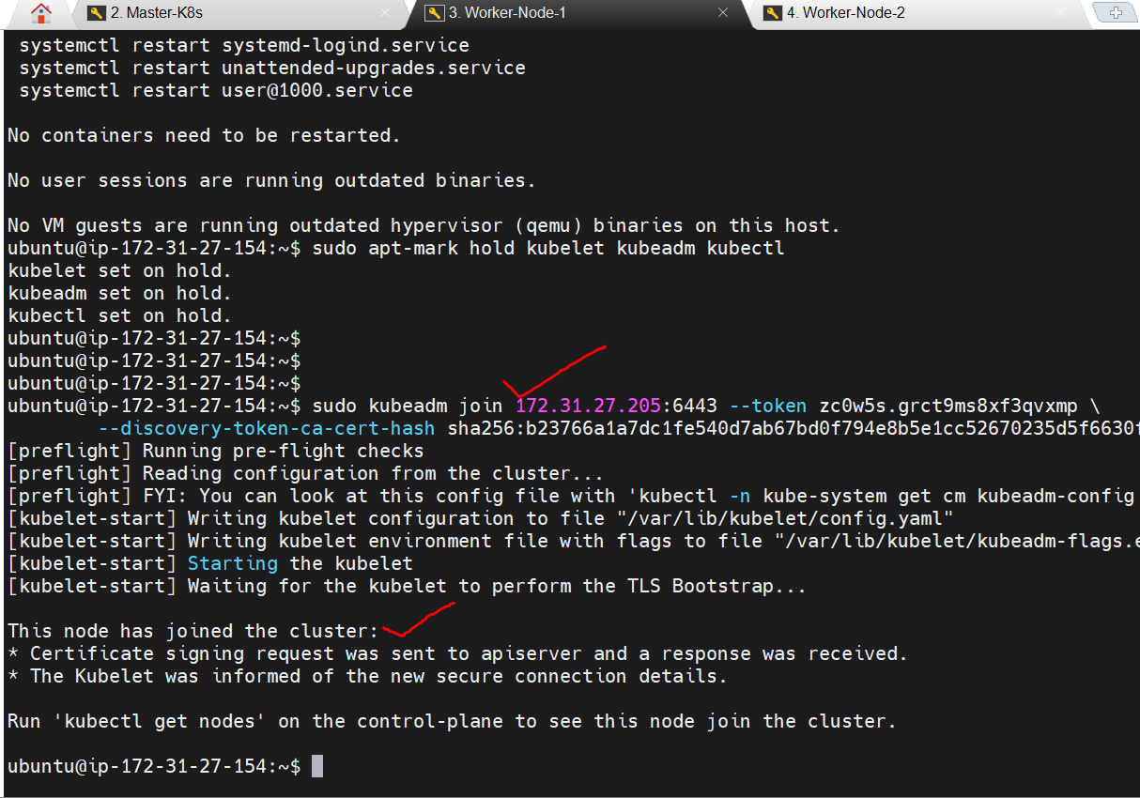

Run these commands only on Master K8s only:

* 1. kubeadm init –pod-network-cidr=192.168.0.0/16
  2. mkdir -p $HOME/.kube
  3. sudo cp -I /etc/kubernetes/admin.conf $HOME/.kube/config
  4. sudo chown $(id -u):$(id -g) $HOME/.kube/config

